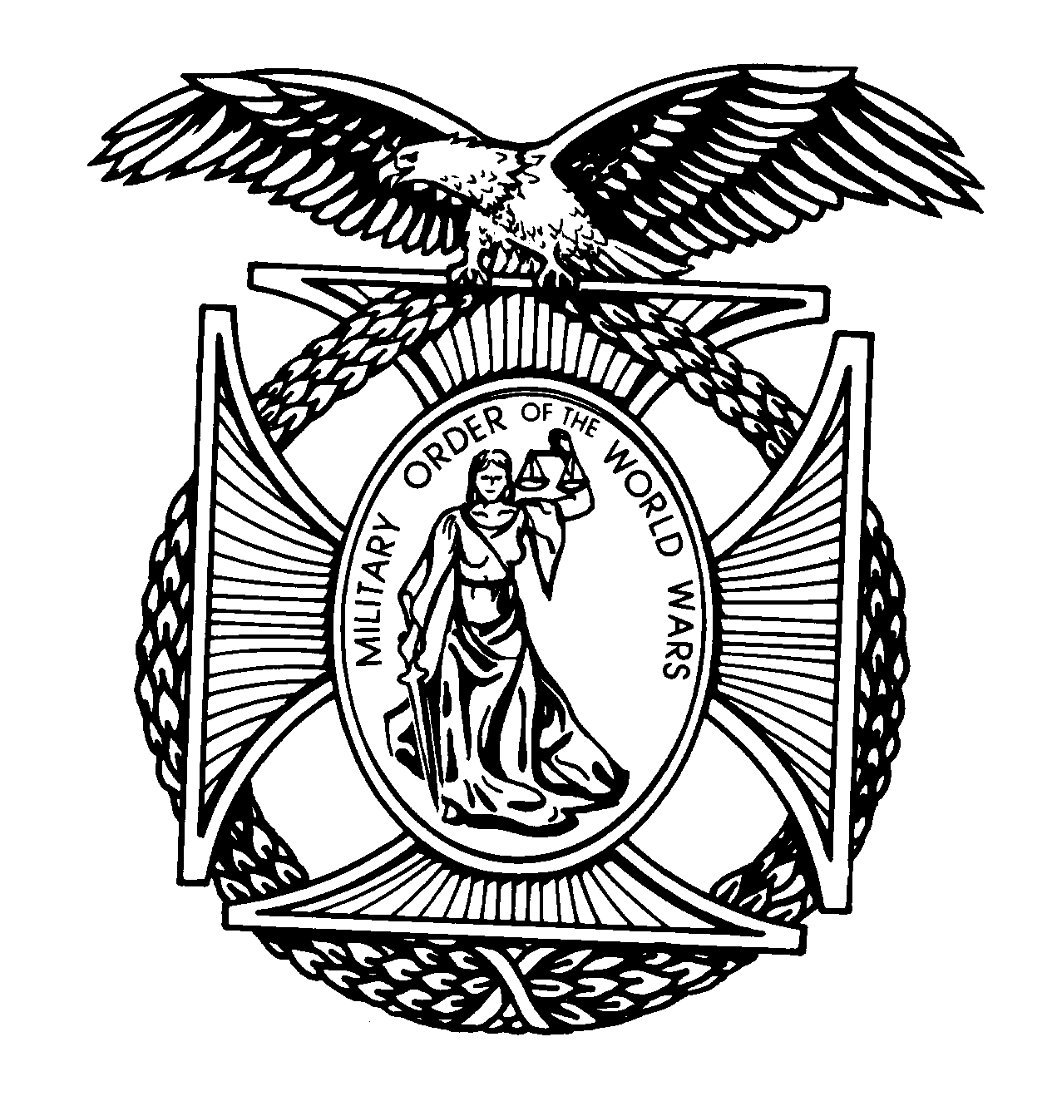
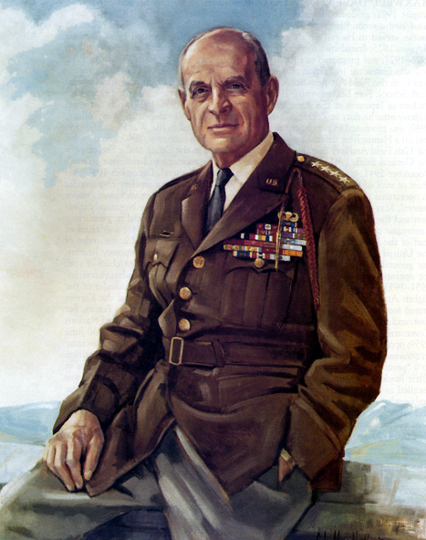

General Matthew B. Ridgway

Pittsburgh Chapter

THE MILITARY ORDER OF

THE WORLD WARS
(Website: http://mowwpgh.wixsite.com/mowwpgh)

BG Peter C. Bellisario
Commander
COL Robert L. Reese
Vice Commander & Adjutant
MG George V. Bauer
Chief of Staff & Treasurer

LTC Samuel Wilson
ROTC Awards
Colonel Paul A. Platek
Historian & Chaplain
Cpt Daniel McBride
Homeland Security
CAPT Karl D. Ludwig

Surgeon
LTC Gary Roberson
Scouting Programs
COL Richard Latshaw
Veterans Affairs
CAPT Paula Bozdech-Veater

Deployed Troops
LTC William Pentecost
Judge Advocate
MAJ John Skovran
Youth Ldrshp Prog

BULLETIN #109 LUNCHEON MEETING September 2018
Tuesday, September 18, 2018
Place: Scoglio’s Greentree Restaurant, Foster Plaza Building #7
Arrival Time: 11:30 a.m., Lunch to be served at 12:00 p.m.
Cost of full course meal, including gratuity, tax and guest speaker: $26.00

MENU: Broiled Spots English Style. Chicken Romano will be available upon request for members not wishing to eat fish. Must specify upon making reservation.

SPEAKER: Anthony "Tony" Ficarri, National Commander of the Italian American War Veterans of the US will speak about his organization.

RESERVATIONS: It is ESSENTIAL that we advise the restaurant in advance of the number of meals. Please call or e-mail your reservation into Col Bob Reese at (412) 884-0208 or e-mail rlreese@comcast.net NLT SATURDAY the 14th of September. Significant others and guest are always welcome.

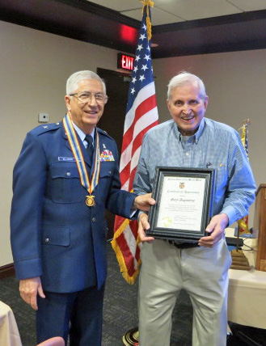
JUNE SPEAKER: Once again Gary Augustine put on an outstanding Power Point Program dealing with the evacuation of Dunkirk during the early years of World Word II. The ability of the British and French to evacuate 338,000 military personnel from Dunkirk within a few weeks proved to be a major turning point in the war against the German forces. The code name of the evacuation was "Operation Dynamo" and it involved over 800 boats many of which were provided by civilian patriots from England. Although, the evacuation was a success, the German Army did capture 80,000 English and French troops. The German Army made a strategic error when on May 23rd, 1940 a halt order was issued by German General Rundstedt, Commander of Army Group A, with Hitler's approval. Rundstedt was concerned about the vulnerability of his flanks and the question of supplies to his forward troops. He was also concerned about the marshy ground around Dunkirk, which was unstable for tanks. General Goring's Luftwaffe was giving the assignment to finish the British. The evacuation took place during the period May 27th to June 4th.

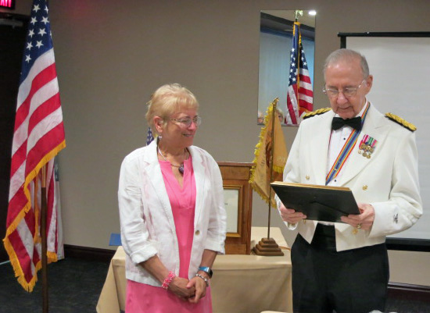
SPECIAL AWARD: Joan Bellisario was the recipient of an award authorized by the Region III Commander and presented by the Region III Vice Commander, COL Reese, which contained the following citation:

"For having preformed the duties of the Chapter Adjutant during his incapacitation by authoring, publishing and distributing the Chapter Monthly Bulletin and assisting the Chapter Commander in many administrative matter in an outstanding manner, without reservation or hesitation."

Pittsburgh Chapter of MOWW Monthly Bulletin #109, September 2018.

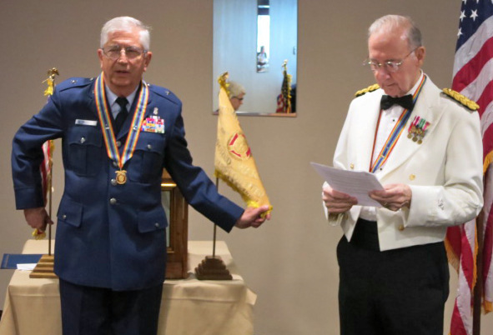
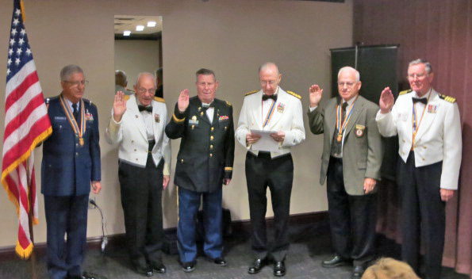
INSTALLATION OF CHAPTER COMMANDER AND STAFF: COL Reese, as Region III Vice Commander, had the honor of installing BG Peter Bellisario as Chapter Commander for the program year beginning July 1st, 2018. This represented BG Bellisario's fifth term as Chapter Commander and he will be the 70th commander to serve. In addition, COL Reese installed himself and chapter staff officers for another term. BG Bellisario was presented with an "Assumption of Command" Certificate signed by the Region III Commander, LTC Michael Wilgen.
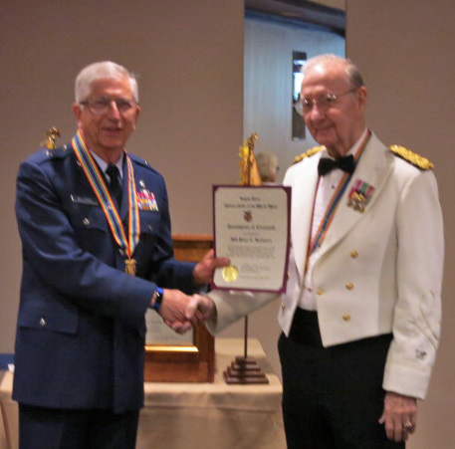
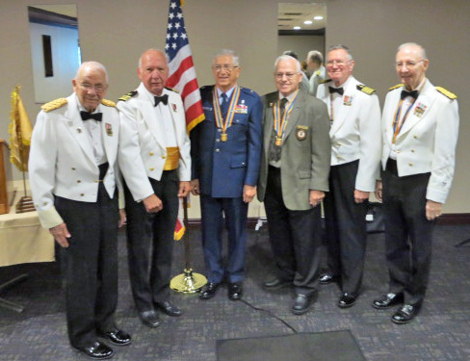
PAST COMMANDERS: Of the 13 living Past Commanders we were able to picture seven at our June luncheon. They were MG Bauer 1990, LCDR Erdodi 2006, BG Bellisario 2014/19, LTC Wilson 2010/11, CAPT Ludwig 1997/98 and COL Reese 2003/05 and 2008/09. Not pictured is COL Platek 1992 and Capt McBride 2007. Not available were LTC Ladley 1989, COL DiPernia 1993, LTC Schaughency 1999/00, COL Schano 2001/02 and COL Perry 2012/14.

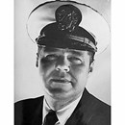
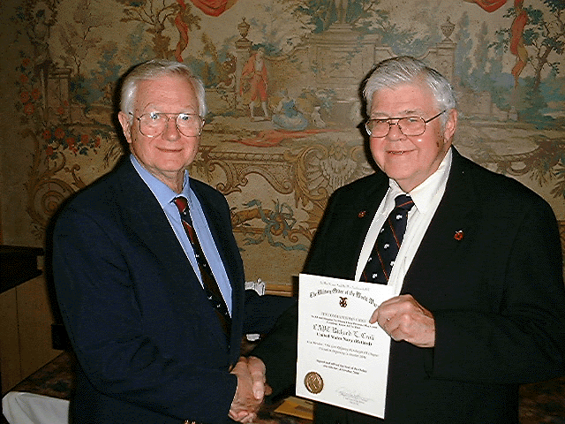
PASSING OF MEMBER: With regret we wish to inform you that CAPT Richard L. Croll, age 84, passed away on June 25th , 2018. Dick was a Perpetual Member of our Chapter since October 2004 and during the Program Year beginning in July of 2006 he served as Vice Commander. He was Dean of Instruction at Community College Allegheny County, South. For those of us who knew Dick, he was a mild manner officer who always had something nice to say about people he knew and always had a positive attitude. He was admired by all of his fellow officers. Dick is pictured in 2004 with CDR Bob Store, his sponsor, accepting his Certificate of Membership in our Chapter. Dick's wife, Ruby, predeceased him. He was buried at the Cemetery of the Alleghenies with full military honors.

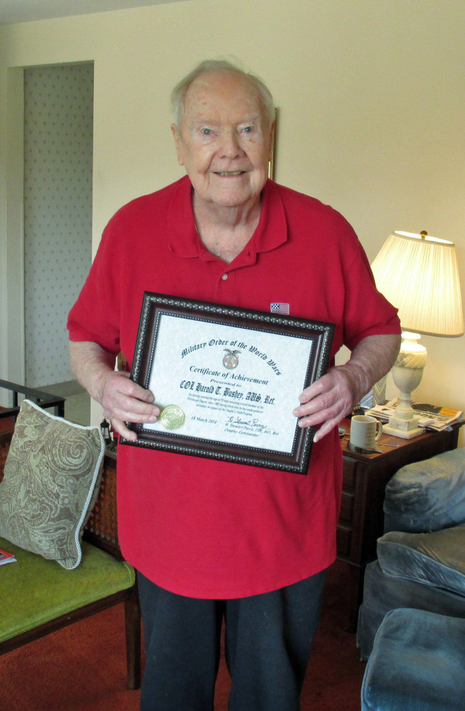
PASSING OF MEMBER: We are saddened to report that COL Harold T. Bushey, USA, Ret. passed away on July 13, 2018 at the age of 98. He joined our Chapter as a Perpetual Member in 1985 and is pictured holding a "Certificate of Dedication" having completed 25 years of service to the MOWW in 2010. A native of Harlem New York he was drafted into the US Army in 1941 and attained the rank of Sergeant Major while serving with the New York Port of Embarkation aboard the Queen Mary and Queen Elizabeth, which ships were used to transport troops to Europe. He received his BA and MBA from the University of Pittsburgh and was an Adjunct Professor at Pitt's Graduate School of Public and International Affairs. In 1945 he joined the Pittsburgh Regional Office of the VA and ultimately became Regional Director of that office in 1971, a position he held until his retirement in 1997. He ended his Military career as G-1 with the 99th ARCOM.

Pittsburgh Chapter of MOWW Monthly Bulletin #109, September 2018.

ATTENDEES AT OUR JUNE LUNCHEON:

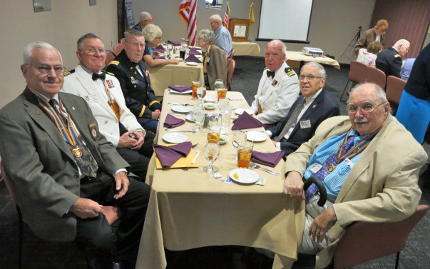
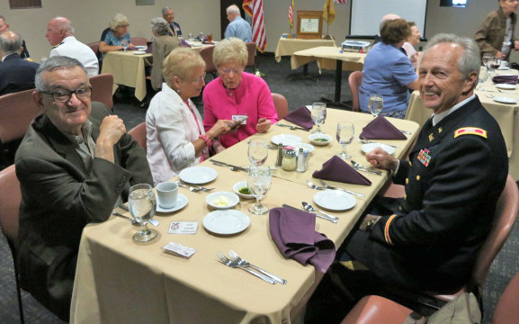

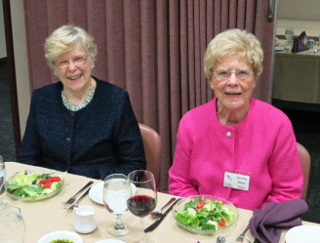

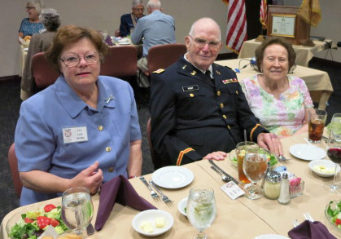

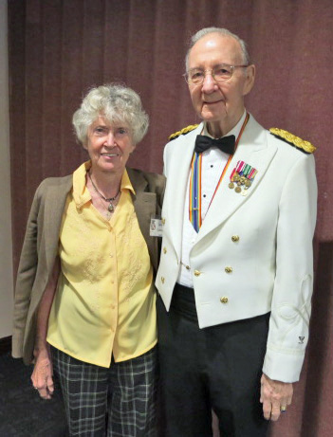
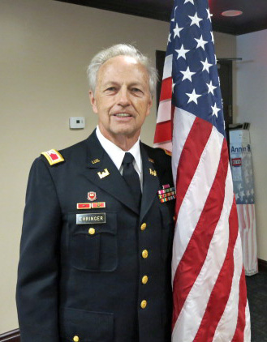
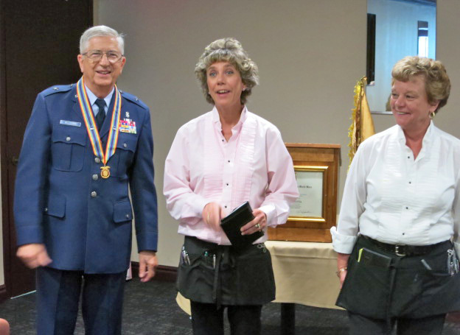

The following luncheon meetings have been scheduled for the remainder of the program year 2018-19:
(Meetings are scheduled on Tuesdays and are held at Scoglio’s Greentree Restaurant, unless changed)
Oct 16, 2018, Nov 20, 2018, Dec 2018 thru Feb 2019 No meetings, Mar 19, 2019, April 30, 2019, May 21, 2019 (Installation of Officers)

