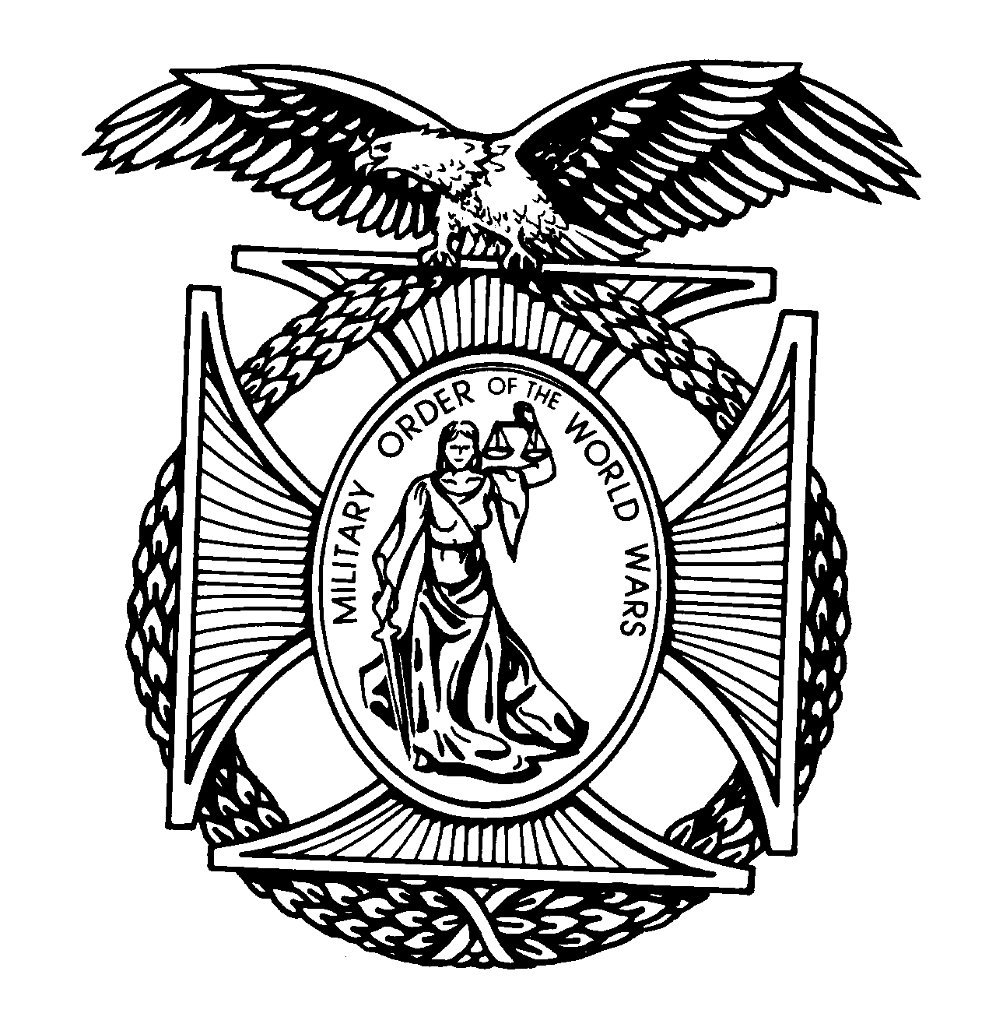
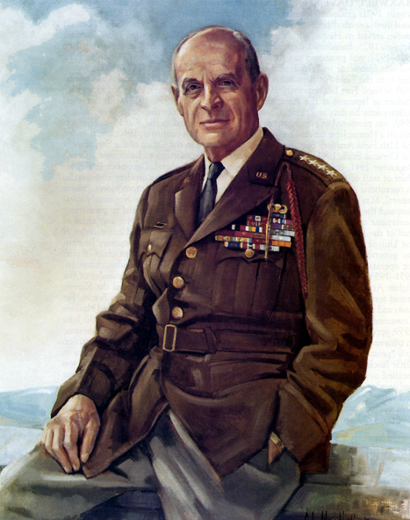

General Matthew B. Ridgway

Pittsburgh Chapter

THE MILITARY ORDER OF

THE WORLD WARS
(Website: http://mowwpgh.wix.com/mowwpgh)

BG Peter C. Bellisario
Commander
COL Robert L. Reese
Vice Commander & Adjutant
MG George V. Bauer
Chief of Staff & Treasurer

LTC Samuel Wilson
ROTC Awards
Colonel Paul A. Platek
Historian
LTC Paul W. Schaughency
Chaplain
Cpt Daniel McBride
Homeland Security
CAPT Karl D. Ludwig

Surgeon

LTC Donald Ladley
Public Relations
LTC Gary Roberson
Scouting Programs
COL Richard “Jack” Latshaw
Veterans Affairs
CAPT Paula Bozdech-Veater

Deployed Troops
LTC William Pentecost
Judge Advocate

BULLETIN #99 LUNCHEON MEETING December 2016
Tuesday, December 20, 2016
Place: Scoglio’s Greentree Restaurant, Foster Plaza Building #7
Arrival Time: 11:30 a.m., Lunch to be served at 12:00 p.m.
Cost of full course meal, including gratuity, tax and guest speaker: $26.00

MEAL PAYMENT: It is suggested that attendees pay by check or have the exact cost of the meal or meals available in order to expedite in processing and lesson the burden of giving change. Thanks in advance for complying with this practice.

SUGGESTED DRESS: It is suggested that military members wear their Mess Dress Uniform or other uniform.

MENU: Breaded Chicken Breast Valdostana.

SENIOR HEADQUARTER'S VISITATION: We will have as our guest at our December 20th luncheon, LTC John Hollywood, National Vice Commander in Chief having oversight responsibility for MOWW Regions I, II, III and IV. Also, in attendance will be LTC Michael Wilgen, Region III Commander, who has direct staff responsibility over our Chapter. Each of these Commanders will bring us up-to-date on current matters dealing with the accomplishments of MOWW & its Chapters.

RESERVATIONS: It is ESSENTIAL that we advise the restaurant in advance of the number of meals. Please call or e-mail your reservation into Col Bob Reese at (412) 884-0208 or e-mail rlreese@comcast.net NLT SATURDAY the 17th of December. Significant others and guest are always welcome.
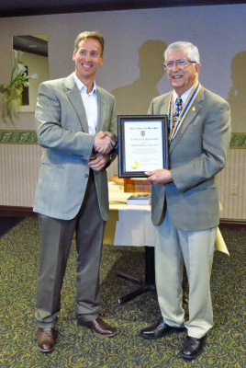
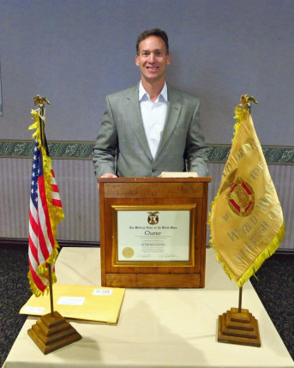
NOVEMBER SPEAKER: CDR Matt Shipley, US Naval Academy graduate and retired Navy Seal, made an outstanding presentation on "Historical American Political Parties and How They Evolved" beginning with George Washington's Presidential term. His knowledge of early American History was unlimited. He discussed a wide range of historical events such as Implied Powers, the Federalist Papers, the Kentucky and Virginia Resolutions, the Mulberry vs Adams Supreme Court case, the Bill of Rights, the Constitution, the Whiskey Rebellion, Blackstone Law and the Electoral College; which was conceived by Alexander Hamilton.

CHAPTER NEWSLETTERS/BULLETINS: Chapter members may access over the Internet previous issued of Chapter Newsletters by logging onto our chapter website at http://mowwpgh.wix.com/mowwpgh. At the bottom of the "Home" page click on "Chapter Bulletins/Newsletters", curser down and click on "Pittsburgh (PA) GEN RIDGWAY Chapter Newsletters 018" and then click on "2016" for the latest issues. The website also contains future meeting dates and pictures of members and guest.

PITTSBURGH CHAPTER MOWW MONTHLY BULLETIN #99 DECEMBER 2016

NEW MEMBERS: As previously discussed it is important that each current member attempt to solicit new members. Each member in attendance at our November luncheon was provided with two copies of a letter which may be sent to prospective members. If you need additional copies of the letter please contact COL Reese.

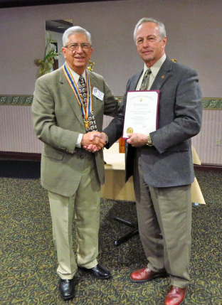
NEW PERPETUAL MEMBER: COL George Ehringer was presented with a "Perpetual Member's Certificate and Pin" by BG Bellisario at our November luncheon, having originally joined as a Social Member.
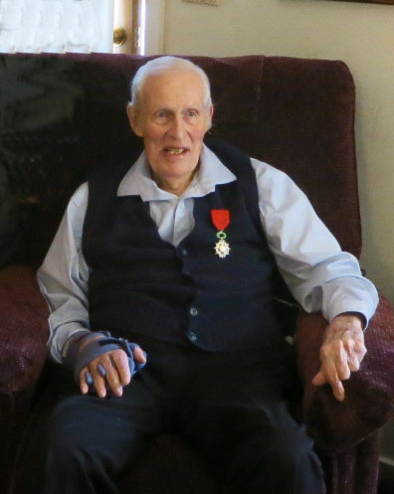
PASSING OF MEMBER: It is with regret that we must pass on to you that our dear and loyal friend, LTC Nevin Woodside, passed away on November 18, 2016. He was age 98 and had been a Perpetual Member since 1989. Among his many awards, LTC Woodside was awarded the French Legion of Honor medal for his service during World War II in helping to liberate France from German occupation. The National Order of the Legion of Honour is a French order established by Napoleon Bonaparte in 1802 and is among the highest decorations in France.

SEASONS GREETINGS: The officer staff wish to extend to each member of our chapter and their families "Best Wishes" for the holiday season. May peace, hope, joy and happiness be yours during this holiday season and throughout the New Year.

YOUTH LEADERSHIP PROGRAM: Thanks to the following members and guest we reached and slightly exceeded our goal to raise $2,000 for our Youth Program, which will enable nine high school students to attend the Freedom Foundation in April of 2017: Reese, Bauer, Boucek, DiGiacomo, Ludwig, Bellisaro, Roberson, Latshaw, Voigt, LaScala, Berkowitz, Wilson, Shirley, Platek, S. Perry, Bushey, Crock, Utley. Prazenica, Ladley and McBride. If you still want to contribute to this worthwhile cause you may sent your donation to MG Georg Bauer.
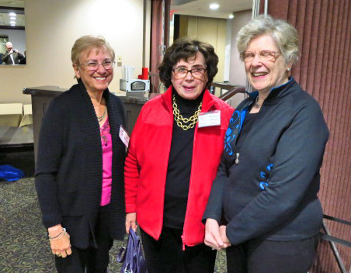
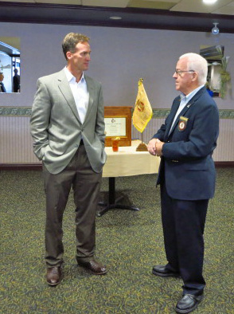
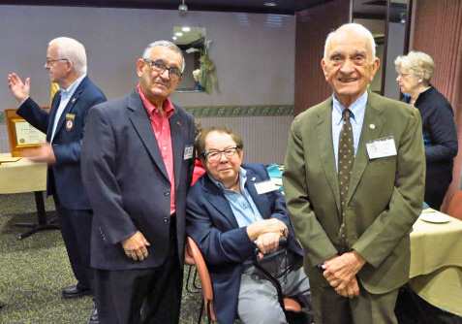

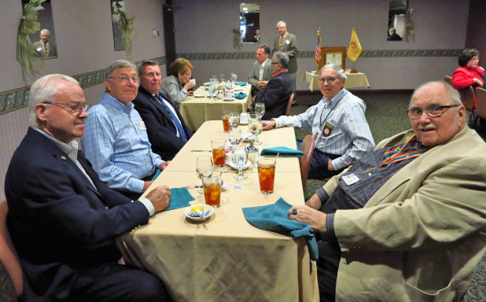
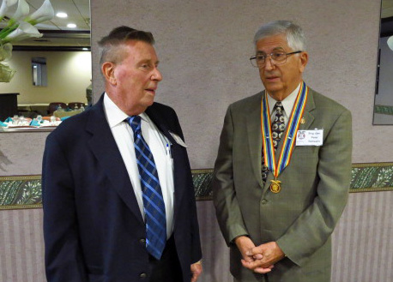

The following luncheon meetings have been scheduled for the remainder of the program year 2016-17:
(Meetings are scheduled on Tuesdays and are held at Scoglio’s Greentree Restaurant, unless changed)

Jan No meeting, Feb No meeting, Mar 21, 2017, May 2, 2017, May 23, 2017 (Installation of Officers)

