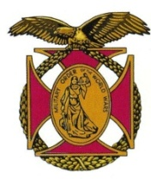

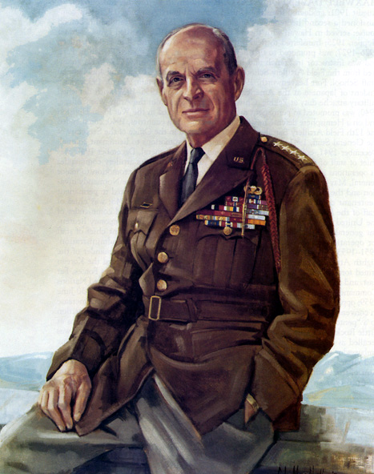

|  |
| --- |
| BG Peter C. Bellisario *Commander*  *COL Robert L. Reese*  *Vice Commander, Adjutant & Editor*  *MG George V. Bauer*  *Chief of Staff & Treasurer* LTC Samuel Wilson *ROTC Awards*  *Colonel Paul A. Platek*  *Historian & Chaplain*  *CAPT Karl D. Ludwig* Surgeon ***LTC Gary Roberson***  *Public Relations*  ***COL Richard Latshaw***  *Veterans Affairs*  ***CAPT Paula Bozdech-Veater*** Deployed Troops ***LTC William Pentecost***  *Judge Advocate*  ***MAJ John Skovran***  *Youth Ldrshp Prog*  **LTC Charles Chasler**  Scouting |

Bulletin Special August 2023

Oct 2023

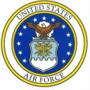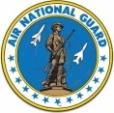

Website: https://mowwpgh.wixsite.com/moww

SPECIAL ISSUE OF BULLETIN:

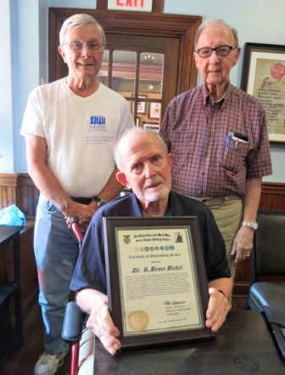OUTSTANDING SERVICE AWARD: On August 11th COL Bob Reese and Mike Sparlin attended a luncheon affair of the Martin Baker Society at which time our chapter presented Dr. R. Bruce Bickel a "Certificate of Outstanding Service". Dr. Bickel is a 1966 Naval Academy graduate who subsequently became a Navy Pilot flying missions during the Vietnam War. On one occasion his plane was shot down and he received assistance from the South Vietnamese to escape back to friendly forces. While at the Naval Academy he majored in Electrical Engineering. He retired from the Navy as a LCDR. In athletics he succeeded All-American Rodger Staubach as quarterback and he was awarded the Thompson Trophy, given to the graduating senior who contributed the most toward advancing intercollegiate sports. He is a Doctor of Theology and has founded the Transformational Leadership Group, a character-based leadership and management consulting firm. In civilian life he headed the Charitable Trust Activity at PNC Bank, as a Senior Vice President. He is truly an outstanding individual who has gained the respect and admiration from all who come in contact with him.

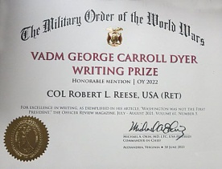WRITTING AWARD: COL Reese was awarded by National Hdqs the VADM George C. Dyer Writing Prize, Honorable Mention, certificate for excellence in writing, as exemplified in his article "Washington was not the first President' published in the Officer Review Magazine. He was awarded $500. This is the third VADM Dyer Writing Prize he received since 2015.

PERPOSED DUES INCREASE: As reported in the July-August issue of the Officer Review Magazine the National Finance Committee has proposed to the Executive Committee of MOWW that Regular Dues be increased from $40 to $60 per year and that Perpetual Membership Dues be increased from $350 to $500, effective 9/1/23. Current members will have until 12/31/23 to upgrade at the current rates. Dues increases are approved by the MOWW General Staff at the National Convention in August of 2023. Assuming the new rates will be approved, if you had in mind to recruit a new member now would be the time, if the candidate wishes to take advantage of existing rates prior to September 1st, 2023. Likewise, it would be prudent for existing Regular Members to upgrade to Perpetual Membership at this time. Our chapter will absorb $150 of the $350 Perpetual Fee. Contact COL Reese if you wish to upgrade your membership.

FUTURE LUNCHEON SCHEDULE: 9/19/23, 10/17/23, 11/14/23, 3/19/24, 4/16/24 and 5/21/24.