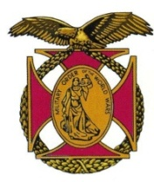

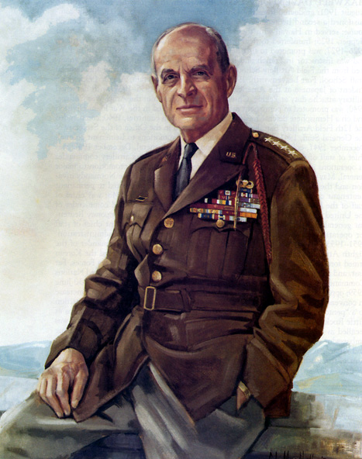

|  |
| --- |
| BG Peter C. Bellisario *Commander*  *COL Robert L. Reese*  *Vice Commander, Adjutant & Editor*  *MG George V. Bauer*  *Chief of Staff & Treasurer* LTC Samuel Wilson *ROTC Awards*  *ColCarmenDiGiacomo*  *Chaplain*  *CAPT Karl D. Ludwig* Surgeon ***LTC Gary Roberson***  *Public Relations*  ***CAPT Paula Bozdech-Veater*** Deployed Troops ***LTC William Pentecost***  *Judge Advocate*  ***MAJ John Skovran***  *Youth Ldrshp Prog*  ***LTC Charles Chasler***  *Scouting* |

Bulletin #144

May 2024

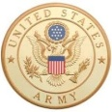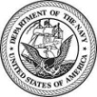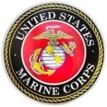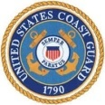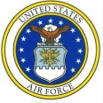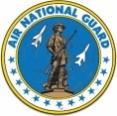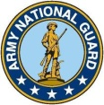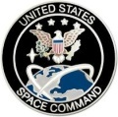

Website: https://mowwpgh.wixsite.com/moww

LUNCHEON MEETING

Tuesday, May 21, 2024

Place: Scoglio’s Greentree Restaurant, Foster Plaza Building #7

Arrival Time: 11:30 a.m., Lunch to be served at 12:00 p.m.

Cost of full course meal, including gratuity, tax and guest speaker: $30.00

MENU: Boston Scrod English Style. Chicken Ramano is available for those not wishing to eat fish. So indicate upon making a reservation.

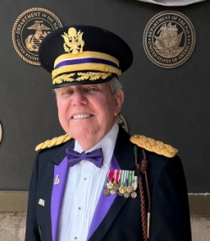VISIT BY REGION III COMMANDER: COL Joseph Kirlin, MOWW Region III Commander having oversight responsibility over five chapters located in PA, NJ, NY and DEL, is planning to visit our Chapter on the 21st of May. He is also the Philadelphia Chapter Commander. COL Kirlin is a Distinguished Member of the Civil Affairs Corps and was indicted into the Special Operations Warfare Hall of Fame, at Ft Bragg NC in 2016. He served as President of the Civil Affairs Association from 2012 to 2023 earning the three highest Awards given by that Association. He was also awarded The Department of the Army Commanders Award for Public service in 2022. COL Kirlin is the current Chairman of the MOWW National Convention to be held in Philadelphia in August of this year.

## RESERVATIONS: It is ESSENTIAL that we advise the restaurant in advance of the number of meals. Please call or e-mail your reservation into MG George Bauer at (412) 848-9302 or e-mail jordieb@verizon.net NLT FRIDAY the 17th of May. Significant others and guest are always welcome. If for some reason, at the last minute, you cannot attend the luncheon after having made a reservation please call Scoglio's at (412) 921-1062.

REVIEW OF PRIOR SPEAKER: Eric Lundblom is a Readjustment Counseling Therapist with the Pittsburgh Veterans Center. As a former Marine he participated in two Mediterranean deployments and a deployment to Panama. He also served as part of a security force to provide security of the National Guard Armory in Tallahassee after the 9/11th terrorist attack. His military career served him well to become a Behavioral Health Social Worker and his present position. He has a Master of Arts Degree in Social Work and a Bachelor of Arts in History. His presentation before our group was extremely informative. The Vet Centers were established in 1979 by Congress recognizing that a significant number of Vietnam combat Veterans were in need of counseling services. The service is available to individuals who served on active military duty in any combat theater or area of hostility as well as service in a number of military related disasters or treats to our country. The Vet Center also services family members when it benefits a veteran who qualifies for the Center's benefits to include bereavement services. Due to the high utilization of Vet Centers by Vietnam Veterans, Congress extended the life of the program and readjustment counseling was established as a life-time entitlement for eligible Veterans. Throughout the years many of the restrictions concerning eligibility were lifted and currently the Vet Centers has reached 300 facilities, 80 mobile Vet Centers as well as a 24/7 Call Center. More than 2,000 staff members stand ready to assist veterans and their families with a wide range of services, ranging from socioeconomic concerns to dealing with the trauma associated with war, sexual assault and psychological injury. For his outstanding presentation our chapter presented Eric Lundblom with a framed Certificate of Appreciation.

Pittsburgh Chapter of MOWW, Bulletin #144, 21 May 2024

## C:\Adobe Elements Photos\MOWW 2024\MOWW 2024 04 16 Spker.jpgC:\Adobe Elements Photos\MOWW Mtg 2024 04 16-5_edited-2.JPGC:\Adobe Elements Photos\MOWW Mtg 2024 04 16-1_edited-2.JPG

.

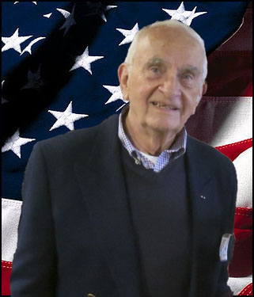PASSING OF MEMBER: It is with a great deal of sadness that we are passing on to you the passing of COL Richard (Jack) Latshaw, USA, Retired, age 96, a Regular Member of our chapter since 2008. Jack and his wife, Patricia, seldom missed a MOWW luncheon up until the time he became incapacitated. Jack began his military career when he enlisted in the army in 1945 serving a tour of duty in Germany. Upon release from Military service he attended the University of Pittsburgh and graduated from the School of Pharmacy after which he became owner and operator of the Latshaw Pharmacy, formerly owned by his father. Jack had the distinction of having served in five major engagements during his military career, which included World War II, the Korean War, the Vietnam War, Desert Shield and Desert Storm and span over 45 years. Jack also served a single term as Mayor of Emsworth. For those who knew Jack he had an infectious smile, loved to engage you in interesting conversation and had a pleasing mannerism. His family, friends and associates will truly miss him and all that he stood for.

EAGLE SCOUT AWARDS: LTC Chasler made arrangement to award five Boy Scouts with Certificates of Recognition together with a MOWW Scouting Patch at a ceremony held in December of 2023. COL Reese had the honor of making the presentation due to LTC Chasler's bout with the flue. You will find in the April - May issue of the Officer Review Magazine, page 12, the article written by COL Reese.

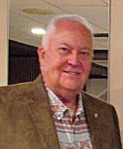GET TO KNOW YOUR COMPANION: LTC (Dr) Richard (Rick) Conwell has the distinction of having served 58 years of uniform service as the USAF Academy Deputy Liaison Officer responsible for 400 PA high schools and colleges and the USAFA Congressional Liaison Officer, which tenure is longer than any other officer who served in that position. Colonel Conwell served with the 171st Air Refueling Wing where he held a number of responsible positions which culminated in his being named Chief of Central Base Administration. Subsequently, he transferred to the 171st Medical Group where he served as the Administrative Services Flight Commander (MSC) and the Chief Administrator for Health Services. As the Deputy Commander of the 376th Expeditionary Medical Group in 2005 his unit had theatre aero medical evacuation responsibilities during Operation Enduring Freedom in Afghanistan. Colonel Conwell holds an A.A. from Point Park University, a B.A. from Edinboro University of Pennsylvania in Psychology, a M.A. from Saint Francis University of Pennsylvania in Personnel Administration, a M.A. from Saint Francis University of Pennsylvania in Labor Relations, a M.P.M. from Carnegie-Mellon University in Health Systems Management/Public Policy, and a D.B.A. from Nova Southeastern University in Business Administration. He is a graduate of the Air Command & Staff College and the Air War College. Colonel Conwell is a highly decorated officer having received over 25 medals and awards for exceptional service. In civilian life, he is a Vice President of CORPAR, LLC, a commercial storage corporation for classic automobiles, as well as employed part-time as a Test Driver for the Bobby Rahal Motorcar Company. He is twice the recipient of the Jefferson Award for Public Service for varied volunteer services throughout Pennsylvania, and was recently inducted into the Sigma Beta Delta Fraternity, which is the

Pittsburgh Chapter of MOWW, Bulletin #144, 21 May 2024

International Honor Society in Business, Management and Administration. Colonel Conwell is married to Cecelia Evans-Conwell. They have one son Christopher and currently reside in Cranberry Township, Pennsylvania where Colonel

## Conwell is Vice President of the Pinehurst Homeowners Association, an Advisory Board member of the Pittsburgh Business Exchange, and a recent Pennsylvania Senatorial recipient of the Cranberry Township Hometown Hero's Award.

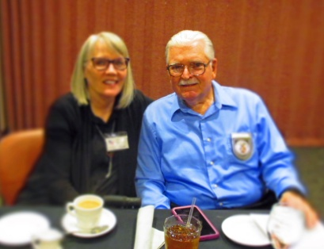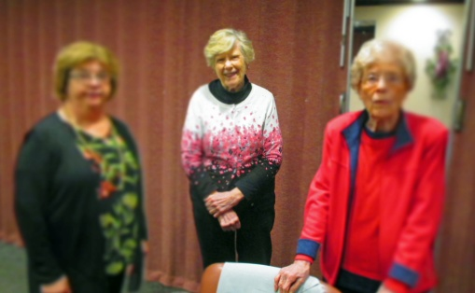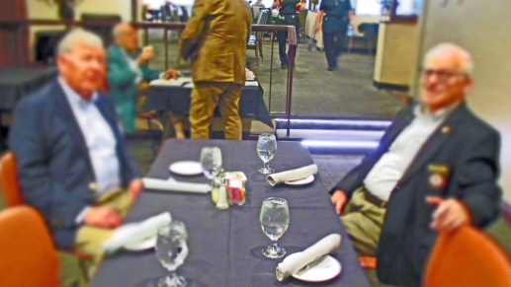ATTENDEES AT OUR MARCH LUNCHEON: