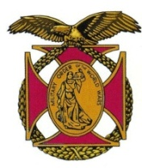

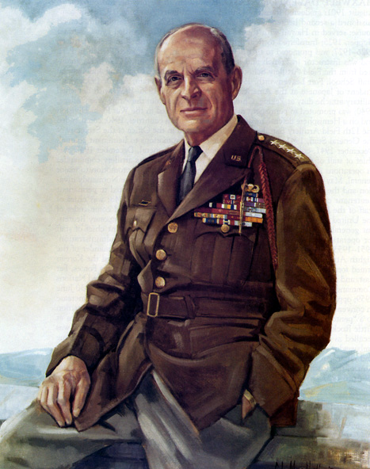

|  |
| --- |
| COL George D. Ehringer *Commander*  *COL Robert L. Reese*  *Vice Commander, Adjutant & Editor*  *MG George V. Bauer*  *Chief of Staff & Treasurer* LTC Samuel Wilson *ROTC Awards*  *COLCarmenDiGiacomo*  *Chaplain*  *CAPT Karl D. Ludwig* Surgeon ***LTC Gary Roberson***  *Public Relations*  ***CAPT Paula Bozdech-Veater*** Speakers Program ***LTC William Pentecost***  *Judge Advocate*  ***MAJ John Skovran***  *Youth Ldrshp Prog*  ***LTC Charles Chasler***  *Scouting*  ***LTC Tim Young***  *Veterans Relations*  ***Joan Bellisario***  *Photographer*  ***MAJ Mike Bonacci***  *Special Projects* |

Bulletin #156

May 2025

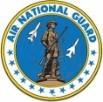

Website: https://mowwpgh.wixsite.com/moww

## LUNCHEON MEETING

Tuesday, May 20, 2025

Place: Gianna Via Restaurant & Bar in Caste Village Shopping Center

Arrival Time: 11:30 a.m., Lunch to be served at 12:00 p.m.

On average: Entree $12.80, Soup $2.99, beverage $3.15, Desert $3.50, gratuity (20%) $4.49, sales tax (7%) $1.57 and Speaker's assessment $1.50 equals total cost $30.00

MENU SELECTION: Attendees will have the option to select one of two Entrees each of which include Wedding Soup, Coffee, Tea or Soda and Ice Cream, as follows:

A. Fettuccine Alfredo, garlic alfredo sauce & baby spinach with fettuccine.

B. Grilled Chicken Bacon Swiss Sandwich, with tomato, lettuce & red onion on brioche bun.

## RESERVATIONS: We must advise the restaurant in advance of the number and kind of meals. Please call or e-mail your reservation into MG George Bauer at (412) 848-9302 or e-mail jordieb@verizon.net NLT FRIDAY the 16th of May. Significant others and guest are always welcome. If for some reason, at the last minute, you cannot attend the luncheon after having made a reservation please call the restaurant at (412) 882-6500, COL Reese at (412) 312-9833 or General Bauer.

MAY SPEAKER: Jacqueline Cavalier, a History Professor with the Community College of Allegheny County, will speak to us on "Pittsburgh; Past, Present and Future."

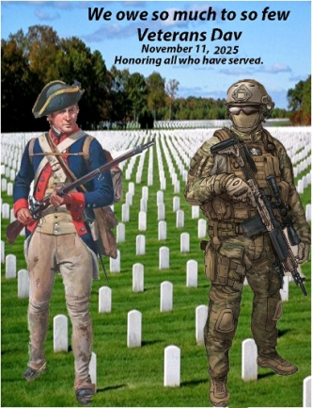

VETERANS DAY POSTER*:* The VA and the Veterans Day National Committee have officially opened submissions for the 2025 National Veterans Day Poster Contest. The winning design will be featured prominently across VA facilities, military installations, and community events nationwide. It will also grace the cover of the official program for the Veterans Day National Observance at Arlington National Cemetery on November 11, 2025. Last year 150 contestants participated in the contest. COL Reese, on behalf of our chapter submitted the poster illustrated. The poster depicts the evolution of the fighting soldier during the past 2 and ½ centuries when a relatively few colonist took up arms against the British and the modern day soldier standing among those who have given their lives so that the masses of the United States population may live in a free environment.

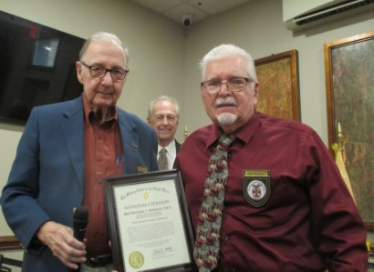MOWW PITTSBURGH CHAHPTER BULLETIN #156, MAY 2025

NATIONAL CITATION: Major Michael Bonacci was the recipient of this year's MOWW Ntional Citation for his contribution to the Wreaths Across America a National program of placing wreaths in Military Cemeteries in remembrance of those military personnel who have pass on. At the Bethel Park Cemetery Major Bonacci, who is a Vietnam Veteran, served as Keynote Speaker and Master of Ceremonies.

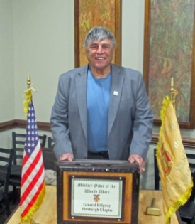

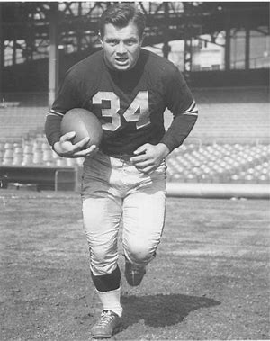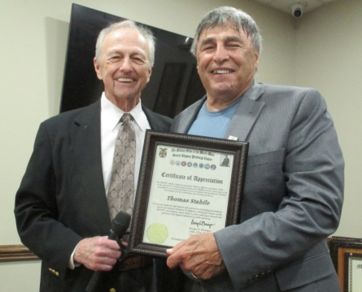 APRIL SPEAKER: Thomas Stabile, a National Football League Referee, shared with us what it was like to be a NFL Referee and rule upon a controversial play. His philosophy was once you rule upon a play in Football you are stuck with that decision and no amount of criticism should cause you to change your ruling, to do so would place into question your future rulings. Tom got to know Fran Rogel a running back for the Steelers during the early to mid 1950s. Tom gained a great deal of respect for Fran Rogel and shared with us an interesting story about Rogel. No doubt many of you have heard the nursery rhyme "Hey Diddle, Diddle" It was this rhyme that became synonymous with Fran Rogel. Rogel was a full back for the Steelers for seven years and on the first play of nearly every game he started he carried the ball up the middle. That one play became known as "Hi-diddle-didle, it's Rogel up the middle", which was originated by sportswriter Bob Drum. Fans began chanting it at the start of every game. The Steeler's Coach, Walt Kiesling, stuck to his guns and ran the play anyway even though the Steeler's opponents quickly caught on that Rogel was going to run up the middle their first play. Art Rooney met with Kiesling and ask him to try a pass on their first play of the game. Kiesling responded with a "no, you don't throw the ball on the first down". However, Rooney got his wish the next game, when he told Bob Drum and the remaining press corps to expect a pass play to open the game. Drum replied "I'll believe it when I see it". On the first down when the Steeler's had the ball Jim Finks, the Steeler's Quarterback, faked a handoff to Rogel and completed a pass to Goose McClaren who ran 80 yards for a touchdown.

## ELECTION OF CHAPTER OFFICERS: Upon majority vote of the members present at our May 2025 meeting the below named candidates will seek election for the Chapter positions indicated, for the Program Year beginning 7/1/25. Any member wishing to run against any of these candidates or fill the position of Senior Vice Commander should make his or her availability known, whereupon a vote by the members shall govern the election results. All other Staff Officer Positions listed above shall remain in effect at the pleasure of the Chapter Commander.

COL George D. Ehringer........... Chapter Commander

TBN ........................................ Senior Vice Commander

COL Robert L. Reese .............. Vice Commander, Adjutant and Editor

MG George V. Bauer .............. Chief of Staff and Treasurer

MOWW PITTSBURGH CHAHPTER BULLETIN #156, MAY 2025

PICTURES OF ATTENDEES AT APRIL LUNCHEON:

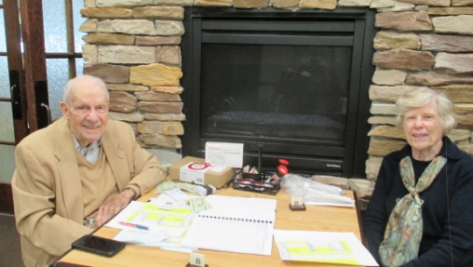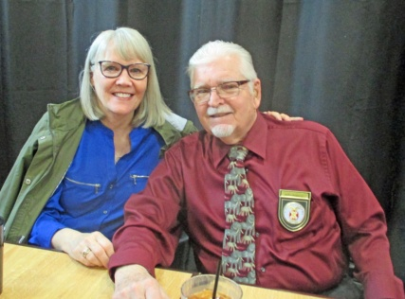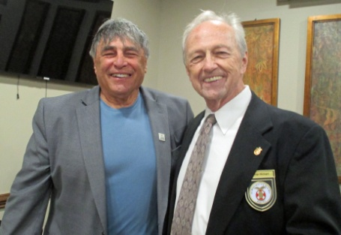

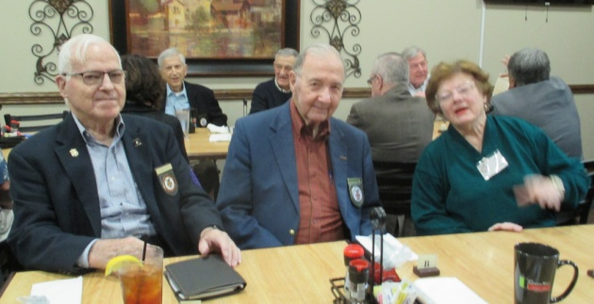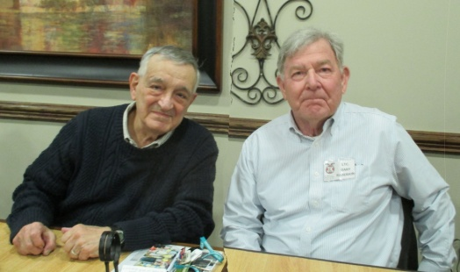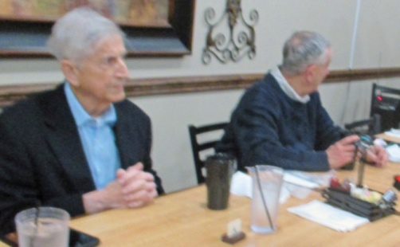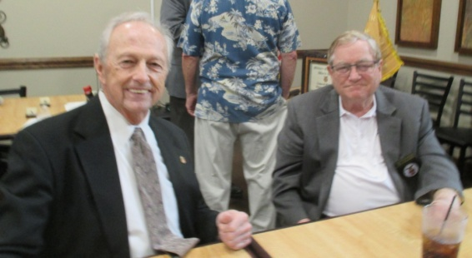

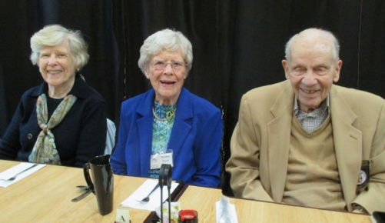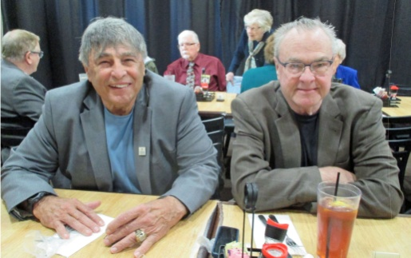

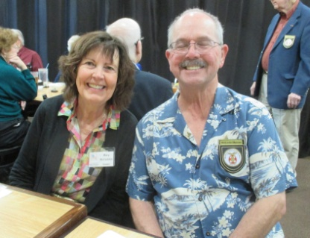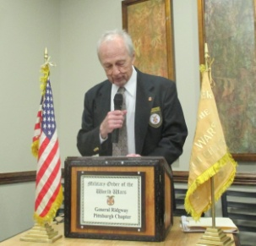

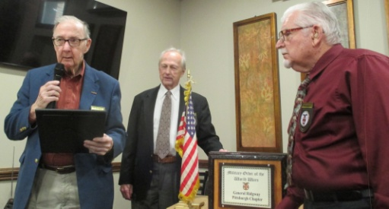

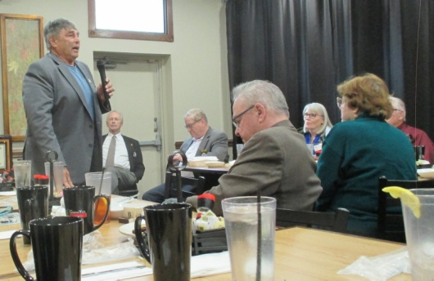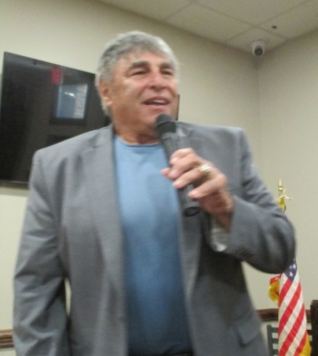

FUTURE MEETINGS: The Chapter's next meeting will be in September of 2025, as announced in its bulletin.