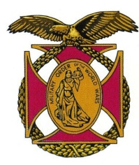
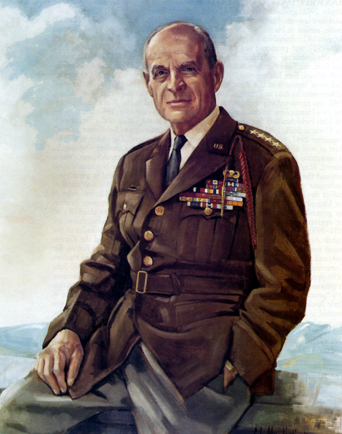
The Military Order of the World Wars
Gen Ridgway Pittsburgh Chapter

BG Peter C. Bellisario
Commander
COL Robert L. Reese
Vice Commander & Adjutant
MG George V. Bauer
Chief of Staff & Treasurer

LTC Samuel Wilson
ROTC Awards
Colonel Paul A. Platek
Historian & Chaplain
CAPT Karl D. Ludwig

Surgeon
LTC Gary Roberson
Scouting Programs
COL Richard Latshaw
Veterans Affairs
CAPT Paula Bozdech-Veater

Deployed Troops
LTC William Pentecost
Judge Advocate
MAJ John Skovran
Youth Ldrshp Prog

Bulletin #122
November 2020
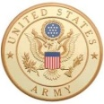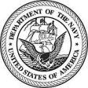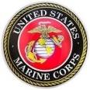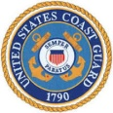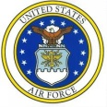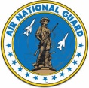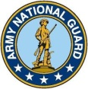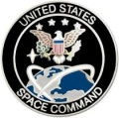

Website: http://mowwpgh.wixsite.com/mowwpgh

LUNCHEON MEETING
Tuesday, November 17, 2020
Place: Scoglio’s Greentree Restaurant, Foster Plaza Building #7
Arrival Time: 11:30 a.m., Lunch to be served at 12:00 p.m.
Cost of full course meal, including gratuity, tax and guest speaker: $26.00

MENU: Broiled Spots English Style. Chicken Romano will be available upon request for members not wishing to eat fish. Attendees must specify upon making reservation.

SPEAKER: CDR Christine Brashear, Commander of the US Navy Operations Support Center, will speak on the mission, function and task of the Support Center.

RESERVATIONS: It is ESSENTIAL that we advise the restaurant in advance of the number of meals. Please call or e-mail your reservation into Col Bob Reese at (412) 884-0208 or e-mail rlreese@comcast.net NLT SATURDAY the 14th of September. Significant others and guest are always welcome. If for some reason you cannot attend a luncheon after you have made a reservation please call Scoglio's at (412) 921-1062.

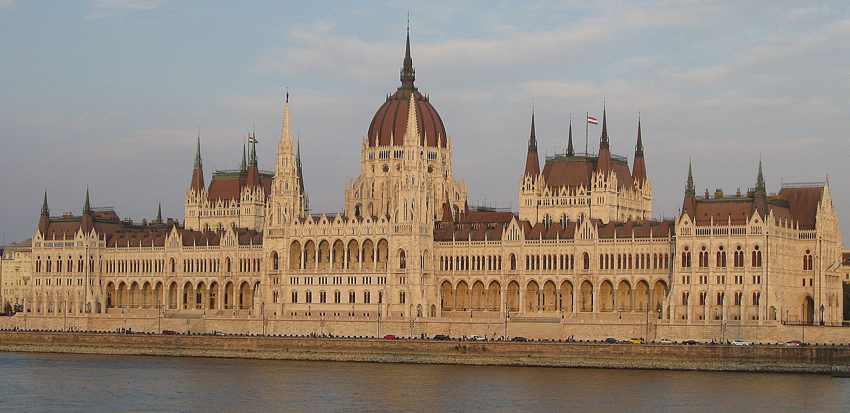
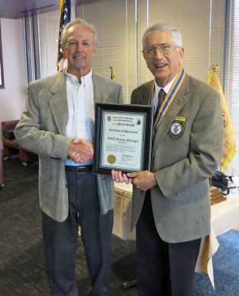
OCTOBER SPEAKER: COL George Ehringer gave an outstanding slide presentation on the life and career of Lester Banos who served as a spy in the German SS for the Allied Forces during World War II. He covered his early childhood, his schooling, how he became affiliated with the Hungarian Resistance as well as several incidents where Banos faced life threatening situations. COL Ehringer explained how Banos saved countless Jewish lives by helping them escape Budapest thereby consequently avoiding being sent to concentration camps. He described Banos's relationship with key Resistance figures, such as Raoul Wallenberg, a Swedish Diplomat who saved thousands of Jewish lives and Julian Schweiger, a Hungarian Resistance Leader. As a chauffeur for the German Military he escorted such notables as Adolf Eichmann, a high ranking German SS Officer who sent many Jews to their death and LTC Otto Skorzeny, the German Officer who retrieved Benito Mussolini, dethroned Prime Minister of Italy, from captivity. COL Ehringer visited Budapest a few years ago and was able to share with us photos of places where Banos was known to spend his time during WW II as well as historic locations, such as the Parliament Building. Some of us will recall that Banos spoke before our group on two prior occasions. He passed away in 2012 at the age of 88.

YOUTH PROGRAM: Since we did not send students to the Freedom Foundation in 2020 we will not be requesting donations from members this year. Previous donations will be used for the 2021Youth Program, provided the Coronavirus pandemic subsides. Likewise, we returned the $5,000 McLaughlin grant received for the 2020 program and will have to reapply if we elect to send students to the Freedom Foundation in 2021.

PITTSBURGH CHAPTER MOWW, NOVEMBER 2020 BULLETIN #122

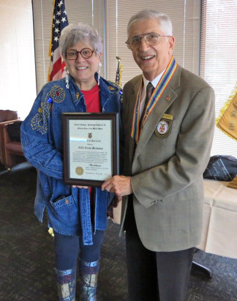
QUARTER CENTURY INDUCTEE: LTC Elaine Berkowitz was the recipient of a retroactive Quarter Century "Certificate of Dedication" for having completed 25 years of membership in our chapter in 2017. LTC Berkowitz has been a strong supporter of our Awards Program having participated in the presentation of awards to JROTC and ROTC Cadets for a number of years.

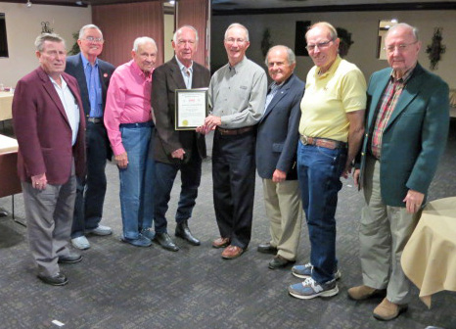
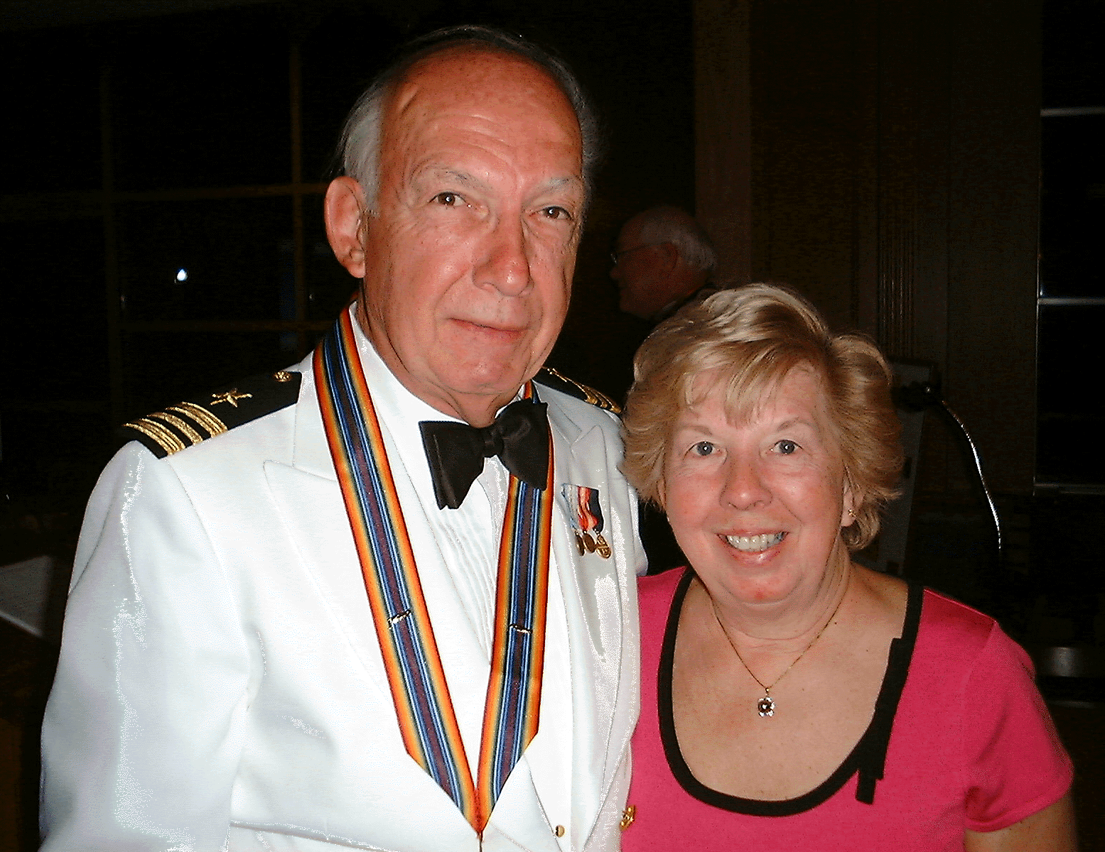
RELOCATION OF MEMBER: LCDR David Erdodi and his wife Nancy have decided to move to California to be close to their two daughters and granddaughter. Dave served as our chapter commander in 2006 and annually visited Carnegie Mellon University to present medals to Navy ROTC Cadets. He was recently honored by the Pittsburgh Chapter of ROA at a luncheon held on October 14th and awarded a ROA Certificate of Recognition for his many years of serving as its Treasurer and Secretary. Although we were not able to present Dave and Nancy with a MOWW Certificate of Gratitude in person we were able to mail it to them prior to their departure on November 4th. Both Dave and Nancy will be truly missed and we wish them smooth sailing on their journey West. They may be reached by US mail at 1520 Mission Avenida, Morgan Hill, CA 95037.

HOLLIDAY SEASON TIDINGS: Your Officer Staff wishes that you and your family have a fruitful Thanksgiving, a Prosperous Merry Christmas and a Happy New Year that brings you good health and good fortune.

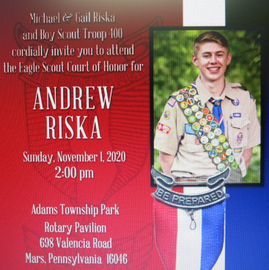
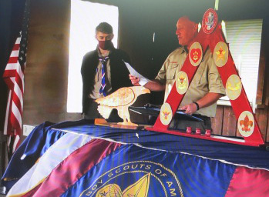
MOWW EAGLE SCOUT AWARD: Scout Andrew Riska was elevated to the rank of Eagle Scout at a ceremony that took place on Sunday the 1st of November at Adams Township Park Rotary Pavilion in Mars, Pennsylvania. On behalf of our Chapter Scout Master Ackerman had the honor of presenting to Andrew a MOWW Certificate of Recognition for his accomplishment. Andrew has a keen interest in Military history and was exceptionally pleased to have received an award from a Military organization such as the MOWW.

ATTENDEES AT OCTOBER LUNCHEON:
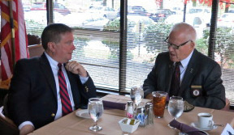
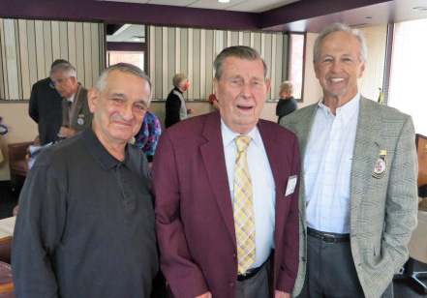

PITTSBURGH CHAPTER MOWW, NOVEMBER 2020 BULLETIN #122

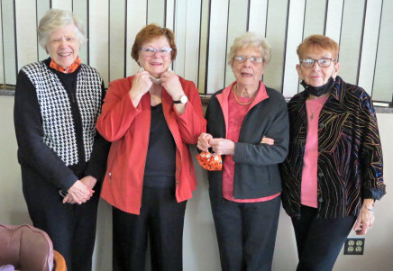
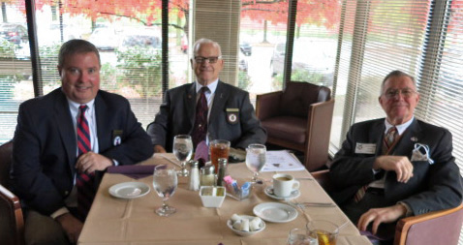

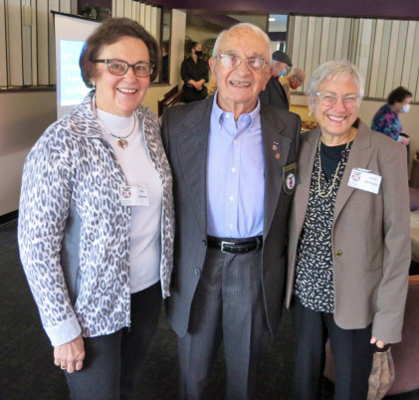
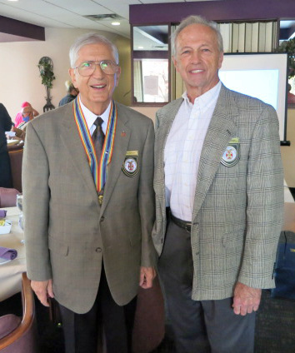
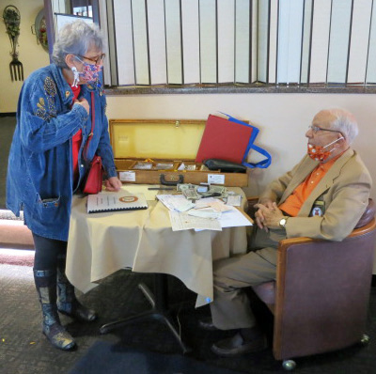

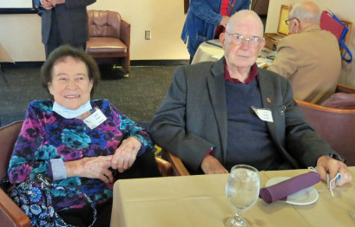
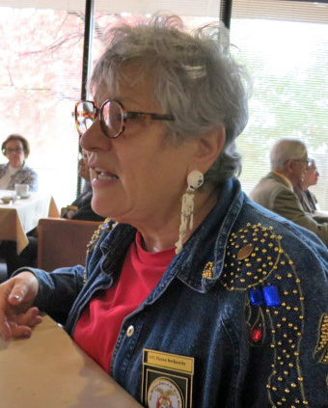

The following luncheon meetings have been scheduled for the remainder of the program year 2020-21:
(Meetings are scheduled on Tuesdays and are held at Scoglio’s Greentree Restaurant, unless changed)
Dec 2020 thru Feb 2021 No meetings, Mar 16, 2021, April 20, 2021, May 18, 2021
(Installation of Officers)

