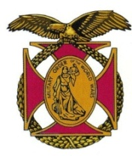

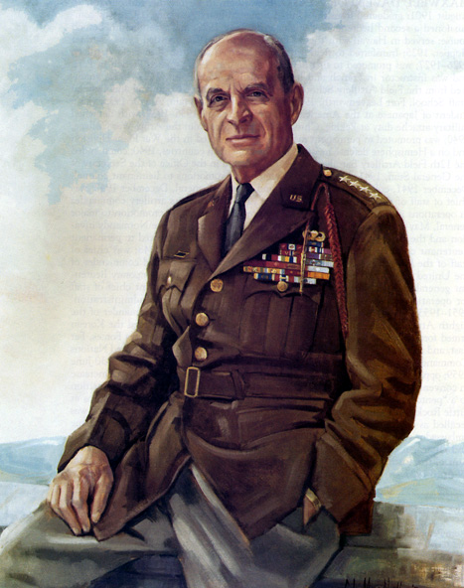

|  |
| --- |
| COL George D. Ehringer *Commander*  *COL Robert L. Reese*  *Vice Commander, Adjutant, Editor & Co-Treasurer*  *MG George V. Bauer*  *Chief of Staff*  ***LTC Tim Young***  *Co-Treasurer* LTC Samuel Wilson *ROTC Awards*  ***MAJ John Skovran***  *Youth Ldrshp Prog*  *COLCarmenDiGiacomo*  *Chaplain*  ***LTC Gary Roberson***  *Public Relations*  ***CAPT Paula Bozdech-Veater*** Speakers Program ***LTC William Pentecost***  *Judge Advocate*  ***LTC Charles Chasler***  *Scouting*  ***Joan Bellisario***  *Photographer*  ***MAJ Mike Bonacci***  *Special Projects* |

Bulletin #157

September 2025

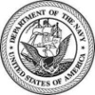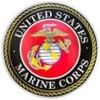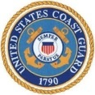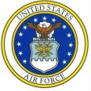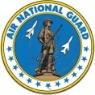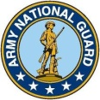

Website: https://mowwpgh.wixsite.com/moww

## LUNCHEON MEETING

Tuesday, September 23, 2025

Place: Vitale Restaurant, Building #7, Foster Plaza

Arrival Time: 12:00 p.m., Lunch to be served at 12:30 p.m.

Registration Fee: $25.00 for Sandwich or Salad and $29 for all other meals.

MENU SELECTION: Attendees will have the option to select one of two Entrees each of which include a cup of Wedding Soup and beverage. Waitress will take beverage orders in advance of main meal.

A. Grilled Chicken Cordon Blue Sandwich.

B. Chef' Salad.

## SEPTEMBER SPEAKER: Nicole Gallagher, Community Engagement & Partnership Coordinator for the VA Pittsburgh Healthcare System will speak to us about military suicide prevention.

## RESERVATIONS: We must advise the restaurant in advance of the number of meals. Please call or e-mail your reservation into LTC Tim Young at HP (412) 489-5766 or CP (814) 931-8744 or e-mail twypitts@aol.com NLT FRIDAY the 20th of September. In order for the waitress to know the attendee's meal selection, attendees will be provided upon payment of the Registration Fee with an "A" or "B" meal ID Card, representing a Sandwich (A) or Salad (B), which should be displayed at their seat. Significant others and guest are always welcome. If for some reason, at the last minute, you cannot attend the luncheon after having made a reservation please call the restaurant at (412) 481-8000, COL Reese at (412) 312-9833 or LTC Young.

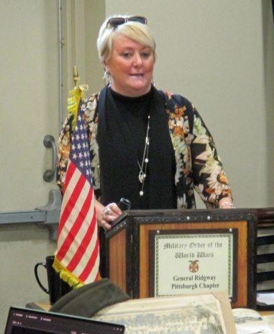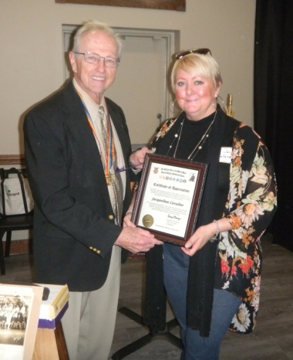MAY SPEAKER: Jacqueline Cavalier, History Professor with the Community College of Allegheny County, focused on historical monuments when presenting her speech before our group on the 20th of May. She was presented with a Certificate of Appreciation for an outstanding presentation on "Pittsburgh, then, now and in the future". She began, assisted by Major Skovran, by displaying a current photo of Pittsburgh after which she explained the history surrounding a number of statutes, places that aren't there anymore, historical events, influential

PITTSBURGH CHAPTER BULLETIN #157, SEPTEMBER 23, 2025

persons and industries that have faded away. A few of the areas she covered are set forth below.

Professor Cavalier began by explaining that prior to the 1763 Treaty of Paris, which ended the French and Indian War, there was tension between the British and the American colonists.  As a result of the Treaty, France lost to Britain both Canada and all of its North American territory, thus Pittsburgh became under British rule. The treaty also facilitated peace between Native Americans and Americans. Fifteen years after the treaty, French bitterness over the loss of their colonial empire contributed to their intervention on the side of the colonists during the Revolutionary War.

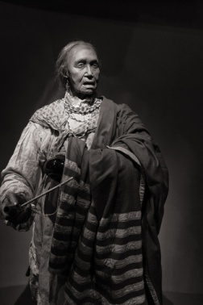Professor Cavalier explained that Queen Aliquippa and her tribe were among the first to live around the Pittsburgh area. Little is known about Queen Aliquippa's early life. It is estimated that she was born around 1670. By the 1740s, she was the leader of a band of Mingo Seneca Indians living along the three rivers, the Ohio, the Allegheny and the Monongahela. By 1753, she and her band were living near what is now known as McKeesport. The city of Aliquippa, PA was named in her honor by the Pittsburgh & Lake Erie Railroad.

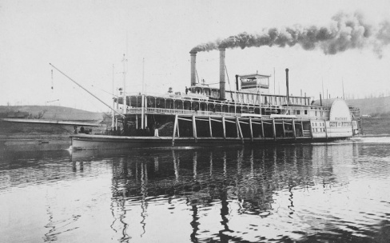The New Orleans was the first steam-powered boat on the Ohio River and it was built in Pittsburgh in 1811 by Nicholas Roosevelt, a partner in the firm of inventor Robert Fulton. The steamboat's machinery was fabricated in New York and transported in pieces over the Allegheny Mountains. The New Orleans voyage from Pittsburgh to New Orleans marked a turning point in the Transportation Revolution.

Cavalier explained that the glass industry in Pittsburgh, PA has a long history, [dating back to the 1800s. It began with small factories making windowpanes and hand-blown bottles, and eventually evolved into large mechanized plants using sophisticated technology. By 1920, 80 percent of the glass made in the country was coming from the Pittsburgh area, with hundreds of factories in the region. Today, there are still a few glass factories and companies in the area, including the Pittsburgh Plate Glass Company (PPG) and the Pittsburgh Glass Center](https://www.bing.com/ck/a?!&&p=a96015666c74ecaa8a418dd0543dcc6bea75206ddf365e1f38330f1c23afbf02JmltdHM9MTc1MDg5NjAwMA&ptn=3&ver=2&hsh=4&fclid=3092661b-d178-683d-1866-700cd0d56914&u=a1aHR0cHM6Ly93d3cud2VzYS5mbS9hcnRzLXNwb3J0cy1jdWx0dXJlLzIwMTMtMDctMTYvdGhlLWdsYXNzLWNpdHktcGl0dHNidXJnaHMtaGlzdG9yeS1hcy10aGUtY2VudGVyLW9mLXRoZS11LXMtZ2xhc3MtYnVzaW5lc3M&ntb=1).

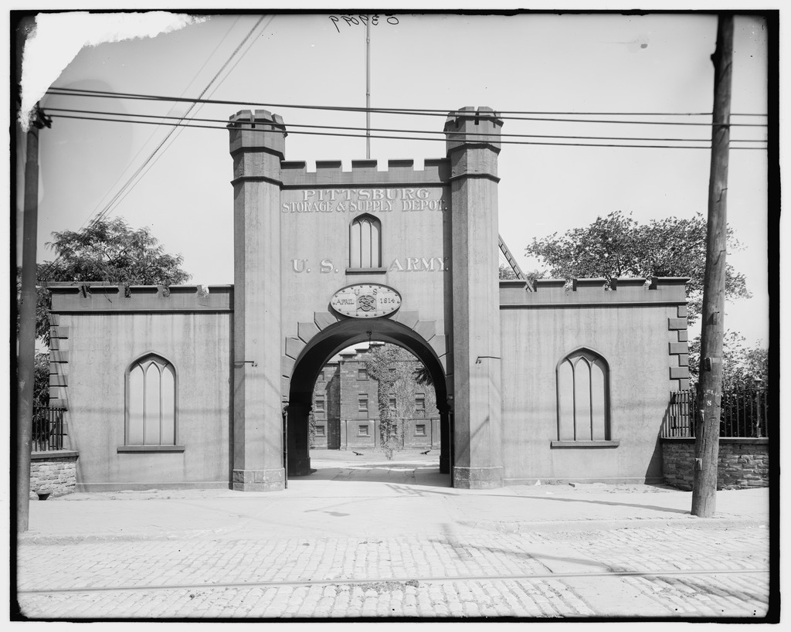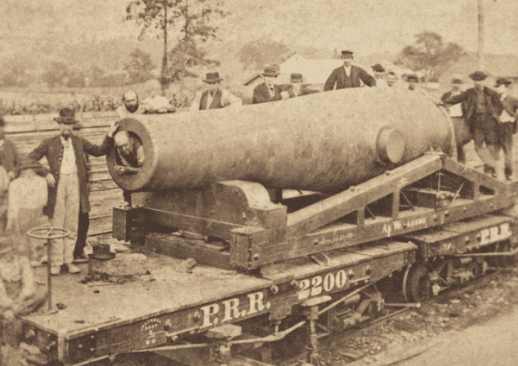The five years of the Civil War are considered a period of ordnance and artillery experimentation. The work of one man led to the casting of one of the biggest guns ever built, even to the present day--a monstrous muzzle-loader that fired a 1,000-pound solid shot. In 1844 Lieut. Thomas Jackson Rodman, a young Ordnance officer only three years out of the military academy, began a long series of experiments aimed at overcoming the principal difficulty in casting an extremely large iron cannon . In 1860 the War Department authorized the casting of a 15 inch smoothbore canon which was a gun bigger than anything the world had ever seen. The first canon, known as "The Lincoln Gun", was made under Rodman's personal supervision at the Fort Pitt Foundry.

The Allegheny Arsenal was established by the U.S. Army Ordnance Department near Pittsburgh in 1814. The arsenal served as a supply and manufacturing center for the troops in the West. Its peak years came during the Civil War,

PITTSBURGH CHAPTER BULLETIN #157, SEPTEMBER 23, 2025

especially when the manufacture of paper cartridges for rifles became a high priority. Civilian employment at the arsenal increased from a pre-war total of 308 to over 1100 workers. One of the busiest facilities was the main lab, which employed 158 workers, the majority of whom were women engaged in the making of cartridges. On Wednesday, September 17, 1862, around 2 pm, the arsenal exploded. The explosion shattered windows in the surrounding community and was heard in Pittsburgh, over two miles away. At the sound of the first explosion, Col. John Symington, Commander of the Arsenal, rushed from his quarters and made his way up the hillside to the lab. As he approached, he heard the sound of a second explosion, followed by a third. Firefighting equipment as well as a bucket brigade tried to douse the flames with water. The volunteer fire company from Pittsburgh arrived and assisted in bringing the fire under control. By the time the fire was put out, the lab had been reduced to a pile of smoldering rubble. Seventy-eight workers, mostly young women, were killed. Fifty-four bodies were unidentified, and were buried in a mass grave in the nearby Allegheny Cemetery.

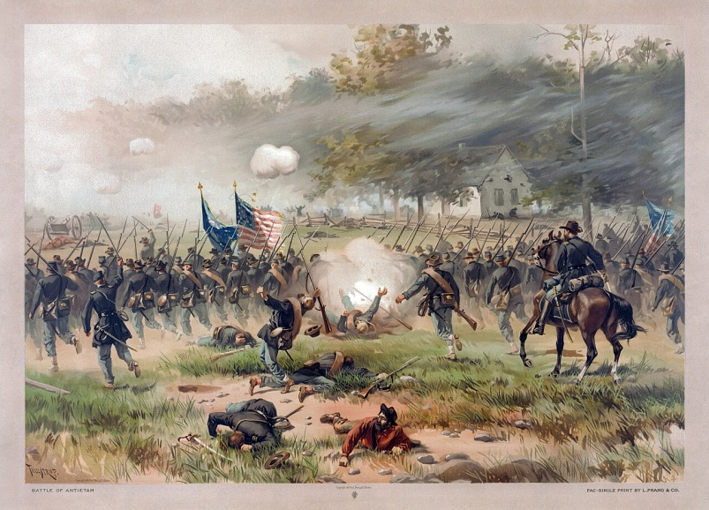

The Battle of Antietam also called the Battle of Sharpsburg, particularly in the Southern United States, took place during the American Civil War on September 17, 1862, between Confederate General Robert E. Lee's Army of Northern Virginia and Union Major General George B. McClellan's Army of the Potomac near Sharpsburg, Maryland, and Antietam Creek. The Maryland Campaign, was the first field army–level engagement in the Eastern Theater of the American Civil War to take place on Union soil. It remains the bloodiest day in American history, with a tally of 22,727 dead, wounded, or missing on both sides. Although the Union Army suffered heavier casualties than the Confederates, the battle was a major turning point in the Union's favor.

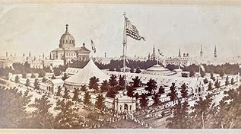

The Pittsburgh Sanitary Fair of 1864 was a significant event in the history of the American Civil War, aimed at raising funds for the care of Union soldiers. It was held in June of 1864 and raised more than $300,000 for the care of Union soldiers. The fair's success was a testament of citizens to support the Union cause during a time of great conflict. It was one of the most profitable fundraising events held in the wartime North.

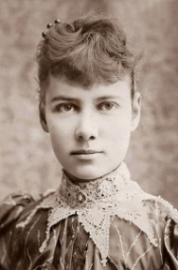

Elizabeth Cochrane Seaman, born Elizabeth Jane Cochran on May 5, 1864 and died on January 27, 1922 was better known by her pen name Nellie Bly. She was the first American journalist who was widely known for her record-breaking trip around the world in 72 days in emulation of Jules Verne's fictional novel. She worked undercover to report on a mental institution from within and pioneered her field by launching a new kind of investigative journalism.

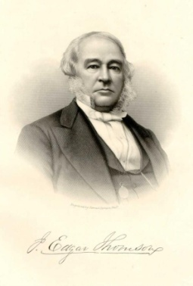

John Edgar Thompson was an American Civil Engineer and industrialist. An entrepreneur best know for his leadership of the Pennsylvania Railroad from 1852 until his death in 1872, Thompson made it the largest business enterprise in the world and a world-class

PITTSBURGH CHAPTER BULLETIN #157, SEPTEMBER 23, 2025

model for technological and managerial innovation. Previously the railroad's first chief engineer, he became its third president.

NEW MEMBERS: The Pittsburgh Chapter was able to add four new Regular Members during the current Operating Year, which ended on 6/30/25. Following is a brief bio on each of the new members:

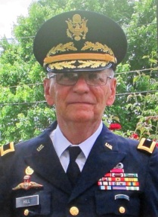BG PAUL HILL graduated from Duquesne University with a BA in Psychology in 1970. He also received a Masters of Public Management Healthcare from Carnegie Mellon University. Having been enrolled in the ROTC program at Duquesne upon graduation he was designated a Distinguish Military Graduate and commission a 2nd Lt in the Infantry Corps. Upon entering active duty he served in the 82nd Airborne as a Platoon Leader and in the Special Forces as an A Team Commander in Thailand and Vietnam. Upon relief from AD he entered the Army Reserves and subsequently became Commander of the 307th MP Company in New Kensington, the 336th MP Battalion in Oakdale, the 367th MP Group in Wilkes Barre, Comptroller in the 99th ARCOM Headquarters and Commandant of the 2073rd USAR School in Pittsburgh. In May of 1999 he took command of the 800th MP Command in Long Island, NY and was promoted to Brigadier General. Following the 9/11 attack on the World Trade Centers in NY in 2001 his organization was activated and deployed to Kuwait and then to Operation Iraqi Freedom. In 2005 he retired from the Army after 35 years of service. He was awarded the Bronze Star and Legion of Merit. In civilian life he began his career with the Veteran's Administration as a Building Management Service Intern at Coatesville, PA. He served as Assistant Chief of Service and then Chief at the Pittsburgh VA Medical Center. He subsequently became the Chief Operating Officer at the Medical Centers in Fort Wayne, Indiana, Butler, PA and in Washington DC. He retired from the VA in Washington, DC and currently serves as an Arbitrator for the Financial Industry Regulatory Authority (FINRA).

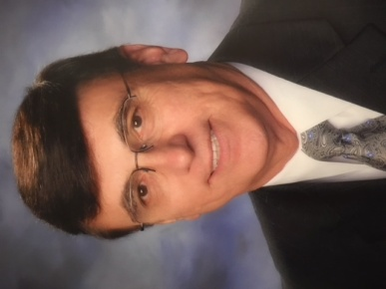COLONEL FRANK PRAZENICA, JR. has held a variety of positions in the 99th ARCOM. He was Chief of Operations & Readiness Division within the Deputy Chief of Staff Operations (G3). He served as the Commander of the 389th Personnel & Administration Battalion and Chief of Plans & Movement Division for the Deputy Chief of Staff Logistics (G4). He held a number of positions in the 308th Engineer Group which culminated in his being named Hdqs Company Commander. He also commanded the 300th Transportation Group in Butler, PA from 1993 to 1996 after which he served as State Emergency Preparedness Liaison Officer STARC Hqs until his retirement in 2000. He received his Bachelors of Science Degree in Education from Indiana University, a Master of Education Degree from the University of Pittsburgh, a second Masters Degree from Westminster College and a Doctor of Philosophy Degree from the University of Pittsburgh. In his civilian career which covered over 4 decades he served as a High School Mathematics Teacher, High School Principal, Assistant Superintendent and Superintendent of South Butler Schools.

FORMER CAPTAIN JAMES JENKINS is a graduate of Georgetown University where he received a Degree in Physics and having been enrolled in their ROTC program he was commission a 2nd Lieutenant in the US Army. He was trained as a Helicopter Pilot and few combat missions during the Vietnam War. He is retired from the "On Time Trucking Company" where he served as President. On Time Trucking, Inc is a licensed and DOT registered trucking company running freight hauling business from Farmingdale, New York.

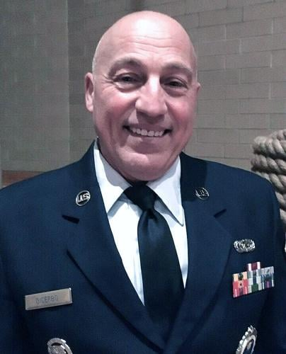SMSGT OTIS DICERBO is a retired JROTC Instructor from West Mifflin Area High School where he managed a highly respected JROTC program. During his 25 year tenure with West Mifflin Area High School he coordinated with the Pittsburgh Chapter of MOWW the sending of 60 Cadets to the Freedom Foundation for a four day Youth Conference. He is currently engaged in the management of real estate. As a result of a 2024 amendment to the Order's Bylaws and Constitution authorizing

PITTSBURGH CHAPTER BULLETIN #157, SEPTEMBER 23, 2025

membership to senior NCOs in the grades of E-7 through E-9, SMSgt Dicerbo will have the honor of being the first Senior NCO to become a member of the Pittsburgh chapter.

RECRUITING: Recruiting is a high priority within the MOWW. The Region III Commander, LTC Paul Farinella, as evidenced by his comments below, was very pleased with the results as displayed in the chart below.

*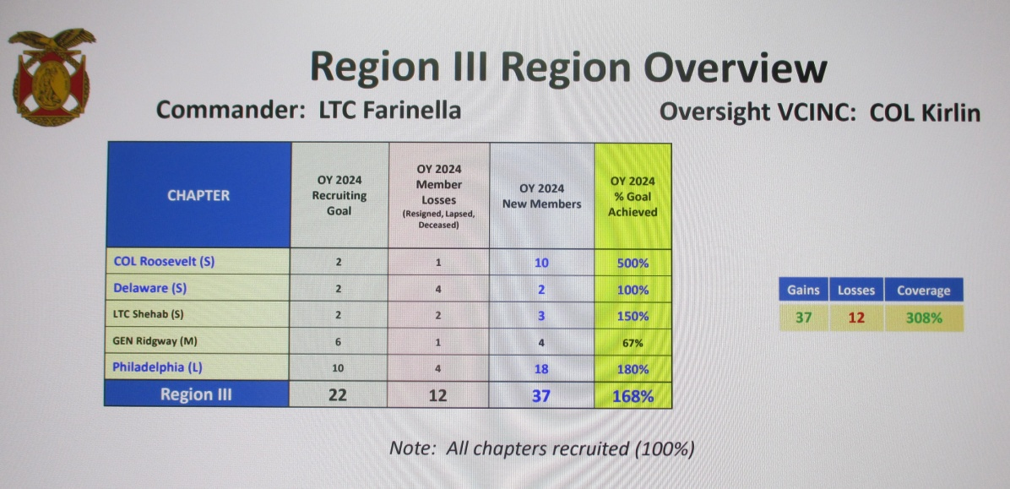" I cannot be happier after looking at this 27 June RECRUITING REPORT that just was posted. Thank you all for the effort you put in getting new Companions and putting REGION III on top of the ORDER.  Now, when we get to NATCON 2025 we can be proud knowing that few if any other Regions have the determination and perseverance we do in achieving  success.  I will prepare for all the Chapter Cdrs  a newly created Region Certificate of Appreciation.*

*( You earned it)  Feel free to reward companions in your chapters who have gone over and above too.  How many NEW REGION Commanders with only a few months on the job can feel super proud as I do! Thank you all, The BEST is yet to COME!"*

WRITTING AWARD: COL Reese received the VADM George Dyer Writing Honorable Mention Award together with $500 for his article on the Doolittle Raid on Tokyo during the early stage of World War II. This was COL Reese's fifth award of this nature.

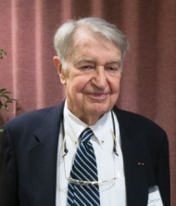

PASSING OF MEMBER: We are sad to report that COL Jerry Kintigh, a perpetual member since 1983, passed away on May 2, 2025. He was Chairman of the Board for Western PA Coalition for Job Retention of Military personnel and active in having the Commissary and Post Exchange relocated from Oakdale to Moon Township. He also played a role in the retention of the 171st Air Wing.

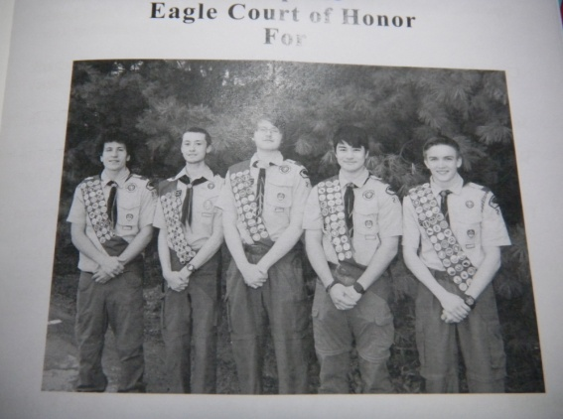

EAGLE SCOUT COURT OF HONOR: On June 1st LTC Chasler and COL Reese participated in an Eagle Scout Court of Honor wherein five Boy Scouts from Troop 215 were promoted to Eagle Scout. They were Alexander Donihi, George Danchik, Jack Harrie, Fred Toshihiko Mach and Zachary Kucharik. The scouts were presented with a Certificate of Accomplishment and a scout patch, which was designed and produced by LTD Paul Farinella, Region 3 Commander.

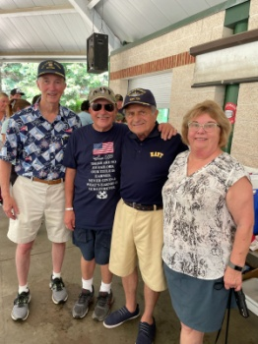

VA HOSPITAL PICNIC: CAPT Polly Bozdech-Veater, who is a member of the Navy League as well as our chapter, was among several Navy Volunteers who hosted a picnic for the patients of the VA Hospital in July. The picnic has been an annual affair for a number of years sponsored by the Navy League. The patients were provided with a beverage and a hot dog.

CHANGE IN MEMBERSHIP ELIGIBILITY: LTC Paul Farinella, Region III Commander, advised us shortly after the Delegates to the MOWW National Convention voted in favor of opening membership in the MOWW to all Military Personnel. Previously, membership was limited to officers and at the 2024 National Convention membership was

PITTSBURGH CHAPTER BULLETIN #157, SEPTEMBER 23, 2025

expanded to include Senior NCOs in the grades of E-7 to E-9. As it stands now membership will be available to all officers and enlisted personnel regardless of rank. Members must first get the candidate to agree to join our chapter after which he or she may refer the candidate to COL Reese (rlreese@comcast.net) for membership processing. It will cost a new member $30 for the first year's Regular Membership fee, since our chapter will pick up $30 of the first year's fee.

PHOTOS FROM OUR MAY 20, 2025 LUNCHEON:

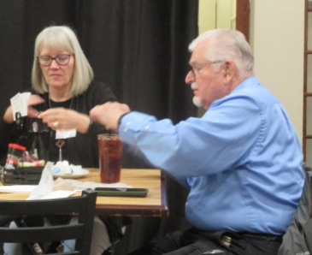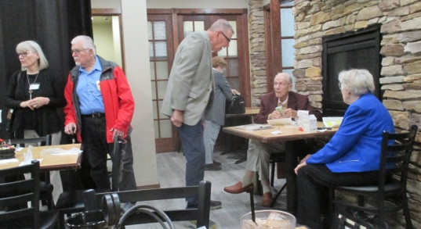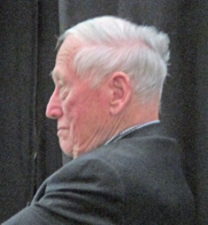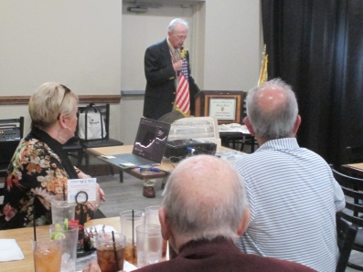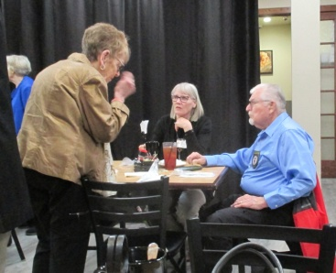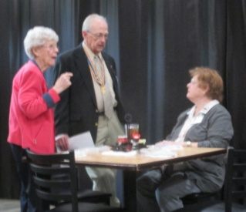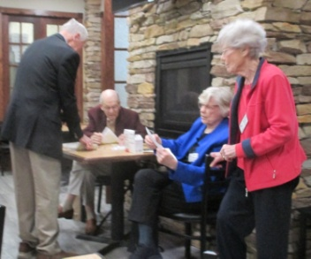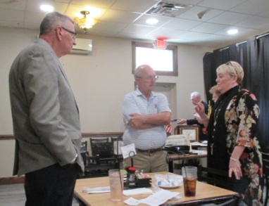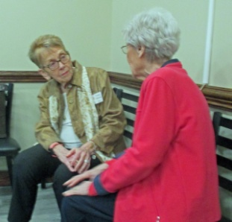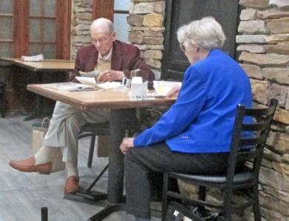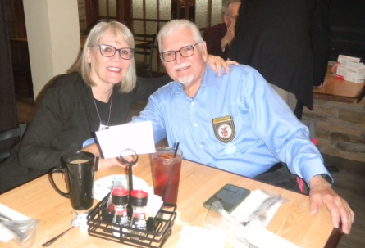

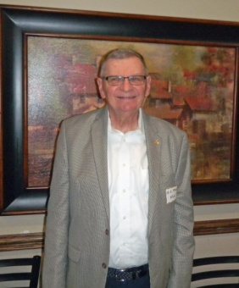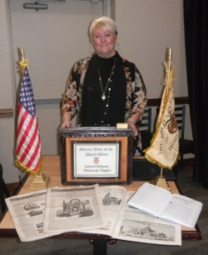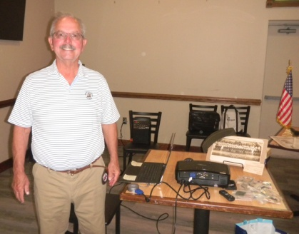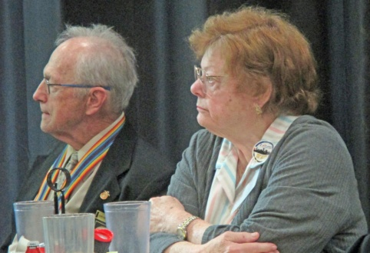

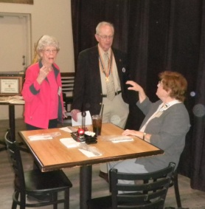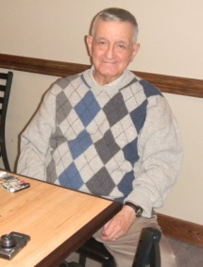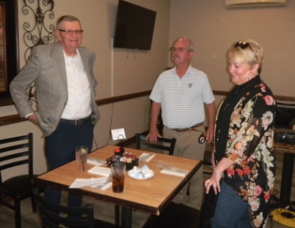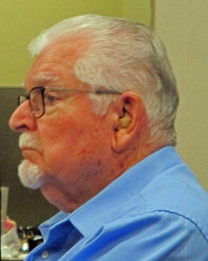

FUTURE MEETING: The Chapter's scheduled meetings, 10/21/25, 11/18/25, 3/17/26, 4/21/26 and 5/19/26.