**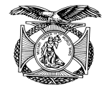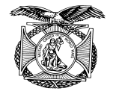General Ridgway - Pittsburgh Chapter of MOWW History**

(c:\MyDoc\Word\MOWW History\Pgh Chapter Cmdrs History.docx)

It is appropriate upon the occasion of the Pittsburgh Chapter of the MOWW having reached its one century anniversary to look back at some of its outstanding leaders and give a brief explanation of their careers. A history of the men and women who served as Chapter Commanders of the Pittsburgh Chapter turns up some fascinating facts about their backgrounds and accomplishments in military and civilian life. Commanders have taken time away from their civilian careers to advance the goals of the chapter as promulgated in its preamble. Out of the seventy officers who have served as Chapter Commanders the author was only able to obtain information and photographs on thirty two commanders who make up the content of this history. The exclusion of the remaining commanders does not in any way detract from their accomplishments. The objective of this history is to acquaint the reader with the high caliber of officer who has served as a Chapter Commander.

***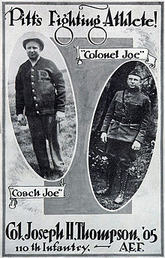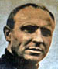COL Joseph H. Thompson*** was the 1st Commander in 1920 and 1921. The century began upon the chartering of the Pittsburgh Chapter in 1920 and the election of COL Joseph Thompsonas it first commander. COL Thompson's credentials were above those of the average officer, since he was a highly decorated World War I officer in addition to being an Attorney at Law and having served as a Pennsylvania State Senator. While attending Pitt he played football during the 1904 season where he captained the football team that won all ten games, allowing just one touchdown. His coaching career at Pitt encompassed the years 1908 to 1912 where his record was 22 - 11 -1. The highlight of his career was in 1910 when Pitt was designated "National Champions" and won all of it games outscoring its opponents 282 to 0. He received a law degree from the University of Pittsburgh in 1909 and practiced law in Beaver Falls. COL Thompson served on active duty with the 110th Infantry, 28th Division and was awarded the Medal of Honor, having been wounded four times. He died in 1928 at the age of 56. In 1971 he was inducted into the college football hall of fame.

***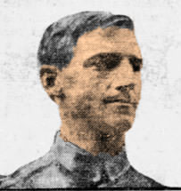COL Herbert A. Gidney***, the 4th Commander in 1926, was an accomplished athlete while attending high school and excelled in the high jump, reaching a height of 6 feet 2 & 1/4 inches. He was selected to participate in the Olympic Games by the BAA organization and served as that organization's Secretary of the Board. He served as Chief of Finance for the US Ordnance Department. Beyond his athletic and military accomplishments in the business world he rose to the position of Executive Vice President of Gulf Oil Corporation in Pittsburgh.

C:\Adobe Elements Photos\MOWW Pgh Hist Cherringer_edited-1.jpg***COL George H. Cherington***, the 10th Commander in 1943, after serving overseas during WW I he became associated with Brown & Zortman Machinery Company and the Standard Machinest Supply Company as President and General Manager of each. He was also President of the Associated Machine Tool Dealers of America and Director and VP of the William Penn Trust Company. As a Reserve Officer he became Commanding Officer of the 308th Calvalry. He passed away in 1945 at the age of 61.

***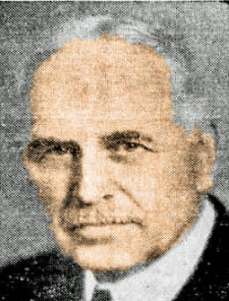LTC Frederick P. Schoonmaker*** was the 11th Commander in 1944. He was the Federal Judge of Western Pennsylvania District Court while residing in Pittsburgh. He attended college at Alfred University, the University of Minnesota and Cornell University where he graduated in 1891. He practiced law in St Paul Minnesota upon obtaining his law degree. He died in 1945 at the age of 75.

***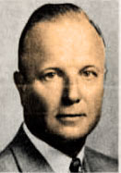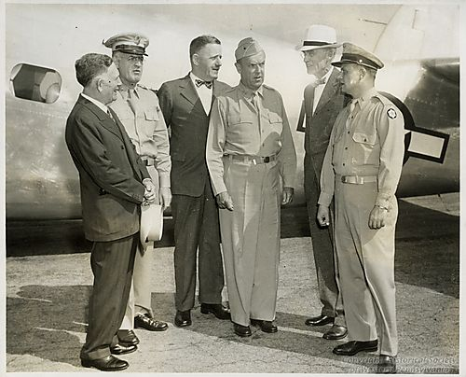Colonel Robert C. Downie***, the 14th Commander in 1947, was a graduate of Monmouth College, Ill in 1927 and from the University of Pittsburgh Law School in 1932. He served as general counsel and Assistant Secretary of Dravo Corporation prior to joining Peoples-Pittsburgh Trust Company in 1938. Shortly after being elected President of Peoples-Pittsburgh Trust Company, in January of 1944 at the age of 38, he was granted a leave of absence to serve as Chief of the Pittsburgh Ordnance District. He was an Assistant Professor with the University of Pittsburgh and Duquesne University. The Junior Chamber of Commerce in 1950 named him "Pittsburgh's Man of the Year". LTC Downie, pictured on right, confers with the President of J & L Steel and other senior officers involved in munitions production. J & L's McKeesport Works, one of the nation's largest munitions facilities produced shells and bombs for the war effort.

***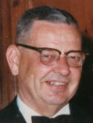COL Malcolm Hay*** was the 18th Commander in 1951. He graduated from Phillips Academy in 1925, from Yale University in 1930 and from the University of Pittsburgh's School of Law in 1933. During WW II he served on active duty for five years in Europe and North Africa. During his early affiliation with the Reserves, COL Hay served as Commander of the 227th, First Infantry Training Division. Concurrently, while serving as MOWW Chapter Commander in 1951 he and fellow officers organized the 2073rd USAR School in Pittsburgh, whereupon he was named its first Commandant. During his many careers he was a practicing attorney, served as Allegheny County Treasurer, became an Orphans' Court Judge and was appointed The PA State Adjutant General and retired as a Lieutenant General. He died in 1972 at the age of 65.

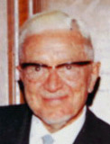

***LTC Willard F. Rockwell***, ***Sr***. was the 22nd Commander in 1955. He was an American Engineer businessman who founded what became the Rockwell International Company, which produced a wide range of products for the automotive and aviation industries. As a young man he attended the Massachusetts Institute of Technology. He died in 1978 at the age of 90.

***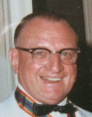COL Vincent P. Lupinacci*** was the 25th Commander in 1958. Vincent Lupinacci, affectionately referred to as "Lupe" was a graduate of the University of Pittsburgh after which he began a 39 year career with Bell Telephone Company, eventually retiring as a Sales Supervisor. He entered the military in 1940 and became an artillery officer who in due course commanded several Artillery Battalions. He became a highly decorated officer honored for disguised service at the siege of Bastogne in the Battle of the Bulge and at the Remagen bridgehead. Among his many medals he was awarded the Bronze Star. Upon discharge from active duty he continued his Military career in the Reserves commanding the 218th Antiaircraft Artillery around Pittsburgh. He died in 1996 at the age of 91.

***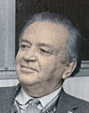LCDR William S. Rahauser*** was the 27th Commander in 1960. He attended Washington & Jefferson College and Duquesne University School of Law after which he was admitted to the Allegheny County Bar in 1933. He served in the US Navy during World War II aboard a submarine. In 1946 he became a State Senator and in 1947 he became an Allegheny County District Attorney. In 1961 he was appointed an Orphans Court Judge and he served in that position until 1971. Judge Rahauser died in 1990 at the age of 88.

***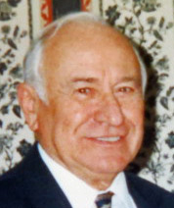MAJ John G. Brosky*** was the 31st Commander in 1964. John G. Brosky received his law degree from the University of Pittsburgh, where he was Captain of the Track Team and honored as a Varsity Letterman of Distinction. Upon graduating from Pitt in 1942 he entered the service and spent 39 months as an artillery officer on a number of islands in the South Pacific. Upon returning from the service he joined the Air National Guard, where he rose to the rank of Major General over his 20 year career. He was also awarded the PA Distinguished Service Medal and the Air Force Legion of Merit Award. In 1965 he was cited by a resolution of the PA House of Representatives for developing outstanding programs in Americanism. During the early 1950s he served as assistant solicitor of Allegheny County and in 1956 was appointed a Judge of the Allegheny County Court. In 1960 he was appointed to the Court of Common Pleas of Allegheny County, where he became the Administrative Judge in 1970, after having been elected to two ten year terms. Following his election to the Superior Court he served until 1989, when he chose not to run for retention; however, he continued to serve as a senior judge until his mandatory retirement in 2002. During his long career as a judge he has received numerous civilian and military awards. On two occasions he was designated "Man of the Year in Law". As the first President of the Scott Township School Board (1946-56) he was responsible for merging four school districts into what is known as the Chartiers Valley School District. He served as co-chairman of the World War II Veterans of Allegheny County Memorial Committee to build a memorial in Pittsburgh to honor WW II Veterans from Allegheny County. He passed away in 2010 at the age of 90.

***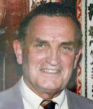COL J. Milnor Roberts*** was the 32nd Commander in 1965. James Milnor Roberts was an Army combat veteran of World War II who participated in the Normandy invasion and the Battle of the Bulge. He served in five campaigns as an aide to Major General Leonard T. Gerow. After the war, he became president of Sykes advertising company in Pittsburgh and also became the first Commanding General of the 99th ARCOM in 1967. He settled in the Washington area after being named Chief of the Army Reserve in 1970. From 1975 to 1984, he was executive director of the Washington-based Reserve Officers Association. Afterward, he was president and director of High Frontier, an advocacy group that promoted legislation for missile defense. He held leadership positions in other organizations supporting veterans and national defense.  In 1975, Maj. Gen. Roberts was inducted into the Reserve Officers Association’s Minuteman Hall of Fame — the organization’s highest honor. He passed away in 2009 at the age of 90.

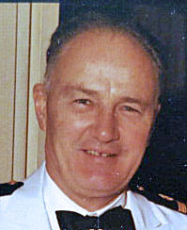***CDR Robert Van der voort*** was the 33rd Commander in 1966. Before establishing his own law firm and being elected to the bench, Robert Van der Voort worked for his father inspecting lumber yards. Subsequently, after a stint as an assistant district attorney, Van der Voort served 25 years as a judge, 15 of them on Common Pleas Court, and 10 on the Superior Court. Judge Van der Voort died in 1993 at age 84.

***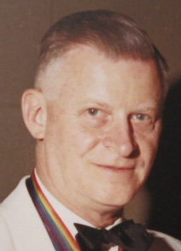COL Hiram A. Carpenter*** was the 35th Commander in 1968. Hiram Carpenter was a World War II veteran who was among a small group of officers who established the 2073rd USAR School in Pittsburgh in 1950, which included COL Malcolm Hay, COL Karl W. Showalter, LTC James R. Bowser and LTC Martin L. Brotemarkle. LTC Carpenter was designated S-1. He subsequently became the Assistant Commandant in 1951 and Commandant in 1961, a position he held until 1965. He was an executive with Pittsburgh Coke & Chemical Company.

***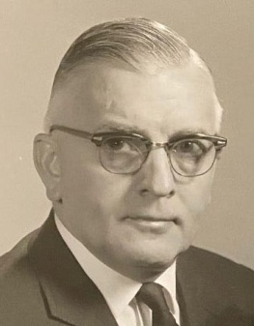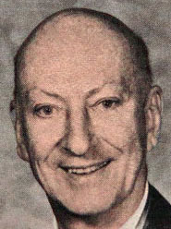CDR J. Paul Sheetz*** was the 37th Commander in 1970. CDR Sheetz was born in 1908 in Wycote, PA. He graduated from the University of Missouri in 1929 from its School of Journalism. He started his own business publishing a weekly news magazine in Pittsburgh called The Bulletin Index, which he sold in 1942 upon entering the Navy as a Lieutenant. He previously served in the ROTC program at the University of Missouri. He served as a Public Relations Officer on the staffs of Admirals in Europe and the Far East until his discharge in 1946, having attained the rank of Commander. He then joined Rust Engineering Company as International Vice President and member of the Board. During his 24 year career he was responsible for seven subsidiaries of Rust and the acquisition and management of two companies. Scheetz was also involved in a number of community organizations, such as the Pressley Ridge School, the Arts and Crafts Center, the Pittsburgh Chamber of Commerce, the Foreign Policy Association and the University Club. In 1974, at the Order's Annual Convention held in Miami, Florida, CDR J. Paul Sheetz was elected to the MOWW's highest office, the 44th Commander in Chief. During his tenure as CINC he visited 49 out of 110 Chapters located in 28 states.

***Cpt Roger N. Knickerbocker***  was the 38th Commander in 1971. He was a graduate of Penn State (Mechanical Engineer), commissioned thru OCS, served with the 253rd AFAB during WW II and was President of A.C. Knickerbocker Engineer firm. During the 1970 MOWW National Convention held in Pittsburgh he served as Convention Chairman.

***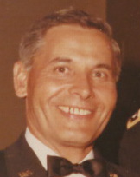MG Willie E. Dixon*** was the 40th Commander in 1973. Dixon entered the military in 1940 and had a wide variety of assignments from platoon leader on up while serving in Europe and Asia. As a Reserve general he commanded the 99th US ARCOM from 1970 to 1977 and also commanded the 79th ARCOM out of Philadelphia, the only general to command two ARCOMs. He was a Department of the Army Civilian employee who supported the ARCOMs. He earned the *Distinguished Service Medal*, two *Legion of Merit*, a *Bronz Star Medal* and many other decorations. He passed away in 1994 at the age of 71.

***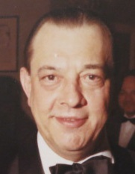RADM Horace Douglas Moulton*** was the 41st Commander in 1974. H. Douglas Moulton was a Naval Academy graduate, class of 1931. He was a highly decorated Naval Officer who served on Admiral William "Bull" Halsey's staff during World War II. He was awarded the Silver Star having participated in the attack on the Marshall and Gilbert Islands, raids on Wake and Marcus Islands and the Battle of Midway. He was awarded the "Gold Star" for action during the Battle of Stewart Island. His cool determination under enemy fire contributed to the successful culmination

of this battle. He was awarded the "Legion of Merit" for outstanding service. He was awarded the "Gold Star" in lieu of a 2nd "Legion of Merit, for exceptionally meritorious conduct and again awarded a 2nd "Gold Star" in lieu of a 3rd "Legion of Merit". On 12/7/41 Admiral Halsey was at breakfast on board the Enterprise when Doug Moulton informed him that the Japanese had started the war. On 8/15/45 while Halsey was at breakfast on the Missouri, it was Moulton who brought him the word that the Japanese had ended the war. (Page 347 of Halsey's biography) In civilian life Douglas Moulton retired from US Steel Corporation as an Assistant Vice President for International Affairs.

***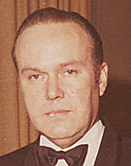MAJOR Henry Avery*** was the 42nd Commander in 1975. Mr. Avery, a 1941 graduate of the Massachusetts Institute of Technology, was renowned for his natural business acumen. A Major in the First Infantry Division in World War II, Avery distinguished himself in North Africa and at Anzio Beach, Italy, earning the Legion of Merit, Italian Medal of Valor and the Order of Lafayette for his courage and bravery. In peacetime, he served the United States Secretary of the Army for 14 years as the Civilian Aide for Western Pennsylvania, working as a liaison between the community and the military. As a leading executive in the field of manufacturing and technology, Henry Avery held key positions as a Senior Vice-President for Koch Development Company, United States Steel Chemicals Division, Pittsburgh Chemical Company and in a voluntary position, Board Chairman of Greater Pittsburgh Chamber of Commerce. As President of Avery Business Development since 1981, Avery shared his wealth of business knowledge. In conjunction with his venture capitalism, Avery founded the First Coast Venture Capital Group, Inc. in 1995. He passed away in 2008 at the age of 89.

***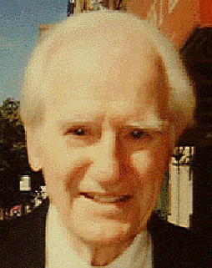LCDR George J. Miller*** was the 43rd Commander in 1976. George J. Miller, was born and raised in Braddock, PA. and attended Bucknell University where he was twice selected to represent Bucknell at the Intercollegiate Conference on Government, was elected to the Phi Sigma Alpha National Honorary Society and was a member of Kappa Sigma Fraternity. He attended the University of Pennsylvania Law School (LLB, JD), was elected to the Board of Governors, the all University Student Council and was a member of the Hare Law Club. He received his commission as an Ensign in the Navy in 1943 from Cornell University Midshipman School, served aboard the LST 1085 and the YMS 479 in the Pacific Theater and was discharged as a LTJG in 1946. He was affiliated with the law firm of Miller, Ament, Henny and Kochuba, P.C. He has represented a number of fraternal and financial institutions and his practice has involved him in some interesting cases, which necessitated his traveling to Russia to represent estate heirs involving depositions in Lithuanian, Russian and English, to Austria regarding a Wrongful death case of an American Nuclear Physicist, to Huston Texas regarding a Howard Hughes Tool Company Chief Executive and to Palm Beach County, Florida for a major fraud case which went to the Florida Supreme Court. He also served as an Allegheny Country Assistant DA in prosecuting homicide cases, during the years 1964-66. Among the Allegheny County Bar Association Committees he has served on are; the Finance, Judicial, Unauthorized Practice of Law, Realtor and Lawyer, Art, Courthouse Building and the ACBA Building Committee. His community activities involved serving on the Boards of the Braddock General Hospital and East Boro’s Council, Boy Scouts of America, Chaired the TriBoro Cancer Drive for three years, a member of the Bucknell Alumni National Board, President of the WPA Bucknell and University of Pennsylvania Alumni Association Chapter, President of the Triangle Ski Club, member of the Duquesne Club, the Pittsburgh Field Club and past member of the Pittsburgh Rotary Club for 25 years. He formerly owned J. J. Gillespie Company, the oldest Art Gallery in the U. S. founded in 1832. He passed away in 2015 at the age of 90.

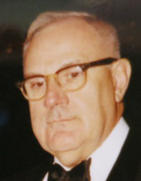***COL N. Ferguson Ferree*** was the 44th Commander in 1977. No biographical information is available. Limited obituary information available: Date of Birth: 3/18/15 and Date of Death: 7/19/92, age 77.

***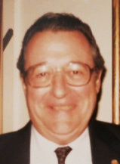LTC Robert Burkhardt*** was the 46th Commander in 1979. Robert “Bob” Burkardt, who has been a Perpetual Member since 1961 and has served as the chapter's Judge Advocate for many years. He is a graduate of the University of Pittsburgh Law School, class of 1950, a PiKA Hall of Fame Awardee and founder of the Young Lawyers Section of the Allegheny County Bar Association. He served in World War II as an Infantryman and then as a heavy bombardment pilot with the US Army Air Force. He completed 32 years service in 1972 with the USAF Reserve as a JAG officer. Burkhardt is a member of the Saint Thomas More Lawyers Guild, the American Legion, AMVETS, Knights of Columbus and various other fraternal organizations. He is past Chairman of the Board of the Pitcairn-Monroeville Sportsman’s Club, served on the University of Pittsburgh School of Law Board of Governors, is past President of the Pitt Law Alumni Association and was elected to three terms in the Pennsylvania House of Representatives. Along with these many activities he has been a Practicing Attorney. Burkhardt is noted for his sense of humor and is truly a scholar and gentlemen.

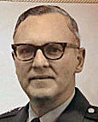 ***MG Robert Frantz*** was the 47th Commander in 1980. From grade school in Pittsburgh Frantz entered Valley Forge Military Academy from which he graduated Summa Cum Laude, winning their Honor Military School appointment to West Point in 1943. He participated in plebe track, cross country and basketball. For all three years he was a Corps Squad boxer and on the Class Ring Committee. Following Basic at Fort Knox, he served in the 18th Cavalry in Puerto Rico from l947-1950. A year after his return to Fort Knox, Frantz was selected to attend the Harvard Law School where he graduated L.L.B., cum laude in 1954. He subsequently served in the Judge Advocate General Corps in the Pentagon in 1954-1955, the 24th Infantry Division (Korea) in 1955-1956, and the Judge Advocate General's School in Charlottesville, Virginia in l956-l958. In 1958 Frantz resigned from active duty and returned to Pittsburgh to continue a distinguished career in both the legal and military profession.  In 1991, after 30 years, Frantz retired from Buchanan Ingersoll and joined another distinguished firm, Raphael, Ramsden, Behers, which then added Frantz. He retired from his military career in 1980, as a major general, having commanded the 99th Army Reserve Command for some four years. For this service he was awarded the Distinguished Service Medal. He died in 1993 at the age of 67.

*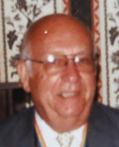COL Vincent A. Geiger* was the 50th Commander in 1983 and 1984. In early December 2006, Colonel Vince Geiger was featured on PCN Television in the program titled “WWII – In Their Own Words.” Colonel Geiger gave a detailed account of his WWII service during a 1½-hour interview. He was inducted into the service on 27 July 1942 and completed 12 weeks of basic training at Camp Croft, SC. and was subsequently selected to enter the Infantry OCS program at Fort Benning, Georgia. As a 2nd Lt. he was among the original cadre of the 75th Infantry Division who trained new recruits at Ft Leonard Wood. After the 75th Infantry Division had been activated in April of 1943 it underwent maneuvers in Louisiana and was then sent to Camp Breckenridge, KY in May of 1944. In August of 1944 he was shipped to France. After spending one month in tents he was assigned as a Platoon Leader to Company I, 377th Regiment, 95th Infantry Division and sent to a small village ten miles north of Metz, France. It wasn’t long thereafter that he assumed command of Company I. The 95th Infantry Division was attached to General Patton’s Third Army. In September of 1944 the Third Army failed to take Metz because of a lack of gasoline. It went north to Montgomery. The 95th Infantry Division finally took Metz which included Kaserne Riberpray – the German Headquarters for the defense of Metz. Lt. Geiger was the only officer available to accept the final surrender at the Kaserne (German Headquarters). General Kietel, a German General, was in an aide station in Metz and surrendered to members of Lt Geiger’s unit. It was General Kietel who gave the 95th Infantry Division the name “The Iron Men of Metz.” During the “Battle of the Bulge, the 95th Infantry Division was left in a defensive position and was given the assignment of housing enemy POWs. On January 1, 1945 1st Lt Geiger was promoted to Captain by General Patton and he continued as Commander of Company I through the end of the European action. Upon returning to the United States, then Captain Geiger was assigned to the 4th Infantry Division for a short period and then sent to IGMR for separation from the service. He continued his affiliation with the military by joining the Army Reserve program in 1950. His first Reserve assignment was with the 2073rd USAR School in Pittsburgh. He held various instructional and staff positions in the school and ultimately retired in 1974 as its Commandant. Among his many awards, Colonel Geiger was awarded the Silver Star. In civilian life he was General Manager of the Gateway Center complex for Equitable Life Insurance Company and retired as Regional Manager of owned real estate located in PA, Eastern Ohio and portions of New Jersey. COL Geiger passed away in 1993 at the age of 67.

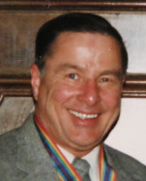 ***COL Author Edward Dunn*** was the 51st Commander in 1985 and 1986. Edward Dunn is a graduate of the University of Maryland (BS) and received a Masters Degree (MPA) from the University of Pittsburgh. He began his military career by completing basic training at Camp Breckinridge, KY in 1951. He was then selected to attend the Infantry OCS at Ft Benning, Georgia where he graduated in the top 10% of his class and received his commission as a 2nd Lieutenant. During his military career he has served as a Company Commander, S3, S4, Armor Battalion Commander, Asst Operations & Training Officer for the 99th ARCOM, DCS O&T 99th ARCOM and Commander of the 443rd Field Depot. One of his accomplishments at the Depot was to increase its assigned strength from 60% to 102%, which saved the unit from being deactivated. He spent an additional four years on active duty as an Army Reserve Advisor to the Commanding General of First Army. During this tour he also served as the USAR Recruiting Officer and developed a major recruiting drive, which resulted in over 10,400 new accessions. This was 2 ½ times the projected forecast. He is a graduate of the Army War College. He retired from the military in 1983 and was awarded his second Meritorious Service Medal. In civilian life he was hired by Time Finance Company as a Branch Manager in 1955 and subsequently changed careers to become a Department of the Army Civilian, where he retired as the Chief Training Officer for the 99th ARCOM in 1988. Ed is past commander of the ROA and AUSA. His affiliations include the National Assn Retired Federal Employees, Military Officers Assn of America, Sons of the American Revolution, American Legion and Pitt Alumni Assn. He passed away in August of 2013.

***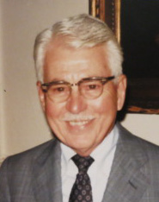LTC Paul M. Dreibelbis*** was the 52nd Commander in 1987. Paul Dreibelbis was born in 1910 at his ancestral farm in Emlenton, PA. He served in World War II and upon discharge joined the Army Reserves. His last assignment was that of S-1 and Detachment Commander of the 2073rd USAR School in Pittsburgh. In civilian life he was a teacher in the Pittsburgh Public School District until his retirement in 1976. The Pittsburgh Chapter recognized LTC Dreibelbis with an “Award of Appreciation” upon his reaching his 100th birthday on September 15, 2010. He passed away in 2014 at the age of 104.

***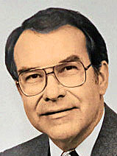COL Wesley E. Blaha*** was the 53rd Commander in 1988. Wesley Blaha was the President of the Monroeville Area Chamber of Commerce and an ordained minister in the United Methodist Church. He was the founding pastor of Trinity United Methodist Church in Peters Township. He is a graduate of Penn State University and received a Master of Divinity degree from Drew University. He served on active duty during the Korean War. Wesley has served on a number of public, educational, health services and religious boards during his career to include the “Good Neighbors” Board of the United Way, the Advisory Board of the Small Business Administration (SBA) of Western PA, the Chambers of Commerce Service Corporation Board (CCSC) and the Board of the Monroeville Area Chamber Foundation, where he served as President. Among his professional affiliations he was a member of the Institute of Politics of the University of Pittsburgh, the Rotary Club of Monroeville, the Penn State Alumni Association and the Varsity “S” Club. In addition to his membership in the MOWW, he was a member of the Reserve Officers Association and the Air Force Association and was a recipient of the Legion of Merit medal. In May of 2001 he received a “Legends in Leadership Award” conferred by the Community College of Allegheny County Education Foundation. He passed away in 2011 at the age of 80.

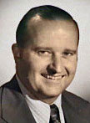 ***LTC Donald M. Ladley*** was the 54th Commander in 1989. Donald Ladley received his BBA degree and commission in the US Air Force from the University of Pittsburgh in 1957. While at Pitt he was a Pi Kappa Alpha, Gamma Sigma Chapter. After completing pilot training, he was assigned to Lincoln AFB, Nebraska as a pilot on the B-47 bomber for the Strategic Air Command. Upon leaving active duty in 1963 he entered into a family insurance business. In 1966 he joined the 911th Tactical Airlift Group as a pilot and few C-124 and C-123 planes. In 1978 he became an Admissions Liaison Officer for the Air Force Academy and AFROTC and continued that assignment 10 years beyond his retirement in 1985. He sponsored over 50 cadets. He is a life member of the Air Force Association, The Reserve Officers Association, The Military Officers Association of America, the Silver Falcon Association of the AF Academy, the 307th Bomb Wing Association and Past President of the Aero Club of Pittsburgh. He is past State President and Legislative Chairman for the Department of Pennsylvania ROA, served on the National Resolutions Committee for 11 years and served as National Chairman for three terms. In 1985 he became active with the SWPA Employer Support of the Guard and Reserve Committee and served as the State Boss Lift Chairman for 16 years. Don fully retired from his civilian insurance occupation, the D. M. Ladley Agency, in 1995. As of 2020 LTC Ladley is the Pittsburgh Chapter's longest serving member with 41 years.

***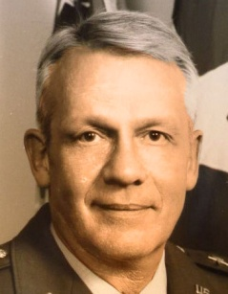MG George V. Bauer*** was the 55th Commander in 1990. General Bauer enlisted in the Organized Reserve Corps in April 1950 and was assigned to the 336th M.P. Bn. He was commissioned in 1953 as a Military Police Officer upon graduation from Duquesne University. He was detailed to Field Artillery where he served as an Armored Field Artillery Officer at Fort Knox, KY and Fort Sill, Oklahoma. Upon release from active duty in 1955 he became active in the Reserve program where he held various command positions at company level as well as staff positions at battalion level, culminating in his appointment as Commander of the 336th MP Battalion. In 1972 he was assigned to the 99th ARCOM where he held positions as Provost Marshal, Assistant Deputy Chief of Staff P&A and later to Deputy CoS P&A and Chief of Staff. In September of 1982 he was named Deputy Commander of the ARCOM and promoted to the rank of Brigadier General. In December of 1984 he assumed Command of the ARCOM and was promoted to Major General, where he served until April 1989. During this tenure he also served as the Primary member from US First Army to the Army Reserve Forces Policy Committee for a three-year period.  He is a graduate of C&GSOC, SRCOC #22 of the Army War College, National Security Course, Installation Management Course for General Officers and the Program for Senior Executives in National & International Security at JFK School of Government, Harvard University. He is the recipient of a number of medals including the Distinguished Service Medal. He is past president of the PA ROA, served on the PA ESGR Committee for more than 20 years and is Life member of MOAA & AUSA. He began his civilian career with Bennett Lumber & Manufacturing Company in 1950, a third generation family owned business, where he served as Estimator, Salesman and Treasurer. In 1966 he joined Busy Beaver Building Centers as Vice President of Purchasing and Merchandising. In 1983 he became a private consultant for industry warehouse management systems and in 1986 he joined Premiere Business Products as Vice President of Operations and Administration. In 1989 he was elected President of Premiere Business Products until his retirement in 1996.

***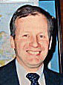BG John E. McAllister*** was the 56th Commander in 1991. John McAllister received a bachelor's degree in history at Gannon University and also earned a Masters Degrees in public administration and urban planning, plus a Ph.D. in education at the University of Pittsburgh. He also attended the U.S. Army War College, Senior Officer Studies program in 1986 and the John F. Kennedy School of Government at Harvard University. After serving in Vietnam and being the recipient of the Bronze Star, Ranger Tab and Legion of Merit he joined the 2073rd USAR School as an Instructor. His next assignment was with the 99th ARCOM and after serving in a number of staff positions was appointed the Deputy Commander and promoted to Bridger General. He held a number of key positions in civilian and military organizations, such as a member of the board of trustees, Scotland School for Veterans' Children; a representative on the board of trustees for Cambria County Area Community College; PA Minority Business Development Authority Board; PA Emergency Management Agency Committee; Chairman, Defense Education Foundation, National Reserves Officers Association; and the Advisory Committee, Pittsburgh Vietnam Veterans Leadership Program. John's life was cut short, at age 53, on May 25, 1999.

***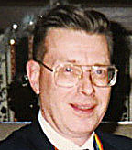COL Paul A. Platek*** was the 57th Commander in 1992. Paul Platek is a Distinguished Military Graduate from Duquesne University’s ROTC program and was commission a 2nd Lt. in the Finance Corps in 1963. He earned a Masters of Liberal studies form DQE university in 1982.   After completing the Finance School at Ft Benjamin Harrison he served as a Finance Officer and Automatic Data Processing Program Coordinator at Aberdeen Proving Ground, during his 2 ½ years of active duty. After being release from active duty he became affiliated with the Army Reserve program in 1967, became a Quartermaster Officer and served in various company and higher level units. During his military career he served as DCS Personnel & Administration and DCS Resources Management for the 99th ARCOM and Commandant of the 1036th US Army Reserve School in Farrell after which he commanded the 475th QM Group in Farrell. He is a graduate of the C&GSOC and the Army War College. He is the recipient of the Meritorious Service Medal with three Oak Leaf Clusters and the Legion of Merit in addition to other medals. Colonel Platek is a life member of the ROA and served as its President during 1990-91. During his affiliation with the ROA he also served as its Historian and Newsletter Editor where he was awarded five Sword & Pen Awards. He is a life member of the US Army Association of Quartermasters, the Senior Army Reserve Commanders Association, the US Army War College Alumni Association, Treasurer of the Association of the US Army, President of the Associates of the 99th Infantry Division, Senior Vice Commander and President of the Federation of Allegheny County War Veterans Societies and a member of MOAA, the Catholic War Veterans and the Korean War Veterans. Colonel Platek also serves on the Board of Directors and is Treasurer of the Soldiers & Sailors Memorial Hall. Paul retired from US Steel Corporation in 2003 after completing almost 38 years of service. At retirement he held the position of Staff Supervisor of US Steel Headquarters General Accounting Department. Previous cost and general accounting positions were performed at the Clairton Works, the Saxonburg Plant, the Christy Parks Works, the USX Engineers & Consultants Division and the USS Chemicals Division.

***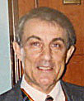COL F. Dennis DiPerna*** was the 58th Commander in 1993. After serving in Vietnam he joined the 2073rd USAR School in Pittsburgh and Served as its S-3 Operations Officer. He started his own security company, Point Security Company, where he served as President and CEO. Fifty percent of the company's uniformed security officers are military veterans or serving members of the Guard and Reserves. DiPerna was a member of the SWPA Employer Support of the Guard & Reserve Committee and served as its Ombudsman.

***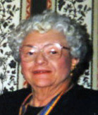LTC Marion E. Jones*** was the 59th Commander in 1994 and 1995. Marion was born and raised in Glenshaw, PA.  She was a person of many interests. Hers was a life filled with service to others and her presence was felt in church, military and professional areas.  Marion was a graduate of Hood College and served to retirement as a Dietician for the Veterans Administration.  She was also the Chief Dietician at the 339th General Hospital. She was an elder in the Glenshaw Presbyterian Church. She preformed overseas service in Panama and other countries. Her military affiliations included the Reserve Officers Association and the Military Order of World Wars, where she served as Adjutant from 1983 to 1991. Socially she was very devoted to the Daughters of the American Revolution, served as a Regent for the Massy Harbison Chapter of the DAR and as President of Both the North Hills Women Club and the American Dietetic Association.  She passed away in 2004 at the age of 84.

***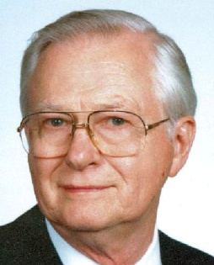CDR Robert A. Stoehr*** was the 60th Commander in 1996. Robert Stoehr joined the Naval Reserve while an undergraduate at Hiram College, where he majored in physics and mathematics. Following graduation and OCS in 1952 he was commissioned an ensign and served on active duty until the end of 1954. He served as a Communications Officer on a destroyer engaged in anti-submarine warfare activities. CDR Stoehr retired from the military in 1976. He is Past President of the Department of PA ROA and a member of the Pittsburgh Council of the Navy League. Dr. Stoehr has been a member of the Materials Science and Engineering faculty at the University of Pittsburgh since 1968. He taught in the areas of process metallurgy, solidification, transport phenomena and the relationship between materials and manufacturing processes. He has more than 20 publications in the field. Dr. Stoehr was designated Professor Emeritus when he retired from active teaching in 1999. Before joining Pitt’s faculty, he worked as a metallurgical engineer for Reactive Metals, Inc and as a research scientist at the Alcoa Research Laboratories in New Kensington. He earned his MS and Ph. D. degrees in Metallurgical Engineering and Materials Science from Carnegie Mellon University in 1965 and 1969, respectively. He is a Registered Professional Engineer, a member of TMS-AIME and past Chairman of the Pittsburgh Chapter of ASM. He passed away in 2005.

***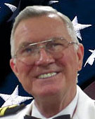CAPT Karl D. Ludwig*** was the 61st Commander in 1997 and 1998. Dr. Ludwig first pursued an education with Saint Vincent College, where he obtained a Bachelor of Arts in biology in 1952. He continued his education with Pennsylvania State University, completing postgraduate coursework from 1952 to 1953, and he completed further coursework with Saint Mary's Seminary and University from 1953 to 1954. He subsequently earned a Doctor of Medicine with the University of Pittsburgh in 1960. He then joined the United States Naval Hospital for an internship from 1960 to 1961. He later held a residency in psychiatry with Eastern Pennsylvania Psychiatric Institute from 1961 to 1964 and a fellowship in psychiatric research and teaching with the Sidney Kimmel Medical College at Thomas Jefferson University from 1964 to 1966. Dr. Ludwig was the director of inpatient psychiatry at Sewickley Valley Hospital from 1981 to 1995 and an assistant medical director of the Staunton Clinic from 1990 to 1995. Prior to obtaining these roles, he was the superintendent of Dixmont State Hospital from 1980 to 1981 and a clinical director of the Northeast Community Mental Health Center from 1973 to 1980, where he was previously the chief of outpatient services in 1973. Earlier in his career, he was a consultant for the Coatesville VA Hospital from 1968 to 1970, a staff psychiatrist at Haverford State Hospital from 1964 to 1971, and a research psychiatrist and the director of the alcoholism program at Friends Hospital from 1966 to 1973. Dr. Ludwig's military career began when he served in medical service of the Army of the United States from 1954 to 1956, and worked in the chemistry labs of the Fort Knox Army Hospital in 1954 to 1955, and the Fort Eustis Army Hospital from 1955 to 1956, and was discharged from active duty as a PFC. He was commissioned as an officer in the Medical Corps of the United States Navy in 1957 and served as a commissioned officer for 33 years working in hospitals and abroad ships and Naval installations in the United States, Spain, and Italy. CAPT Ludwig served as President of the Philadelphia Navy Chapter of ROA (1975/76), President of the Department of PA ROA (1978/79) and President of the Navy League of the US, Pittsburgh Council (1998). He is also a member of the American Legion and the Association of the Military Surgeons of the US. He retired in 1990 with the Rank of Captain. In 2019 the Marquis Who's Who, the world's premier publisher of biographical profiles, presented Karl David Ludwig, MD, with the Albert Nelson Marquis Lifetime Achievement Award.

***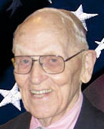LTC Paul Schaughency*** was the 62nd Commander in 1999 and 2000. It was the beginning of World War II in September of 1939 when PAUL SCHAUGHENCY received a scholarship to attend the University of Pittsburgh. He decided to join the ROTC program at that time. Cadet Schaughency entered the Advanced ROTC program in December of 1941. In June of 1943, after graduation, Paul spent a few weeks at Ft. Eustis, VA. in basic training. He receiving his commission in November of 1943 after completing the Coast Artillery OCS program. Lt Schaughency’s first assignment was with a Coast Artillery Battalion headquartered at Ft Hancock, N.J., which was part of the harbor defenses of New York City. Shortly thereafter he was headed to Ft. Lawton in Seattle, Washington, the Port of Embarkation for Alaska. Paul’s Battalion Hdqs was located on Kodiak with units located in the Aleutian Islands at Adak (air base center of the chain of islands), Amchitka and Kiska. By January of 1944, when Paul arrived, the Japanese had been driven from Attu and Kiska. Lt Schaughency was asked to lead a search party, which was instrumental in locating nurses who became lost in a blizzard. He and his search party received a Letter of Commendation for their efforts from the Commanding General. After several battery officer assignments Paul was assigned as the Battalion Personnel Officer. However, it proved to be a career-altering move, since he pursued Personnel Management positions after his release from active duty. From Battalion he moved to Post Headquarters as Post Personnel Officer and after being promoted to Captain he later became Post Adjutant. Upon release from active duty Paul returned to the University of Pittsburgh and received a Masters Degree in Personnel Management in 1948. He began his civilian career with Pittsburgh Plate Glass, later renamed PPG Industries, where he served as Plant Director at two glass plants, one in Ohio and the other in Missouri. While in Ohio and Missouri, he joined Civil Affairs Reserve units. He retired as a Lieutenant Colonel in 1981. In 1970 he returned to Pittsburgh at PPG Headquarters in the Glass Group as Human Resources Manager, Management Development and then as Director, Personnel Services. In 1987 Paul Retired from PPG Industries.

***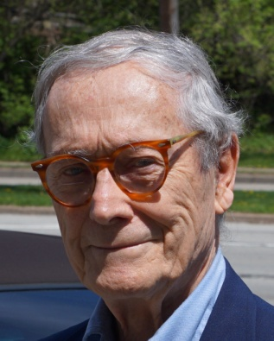COL John F. Schano*** was the 63rd Commander in 2001 and 2002. After earning the degree of Doctor of Law (J.D.) from the University of Pittsburgh, serving two years on active duty as a Procurement Officer during the Korean War and several years in Law School administration, Schano decided upon a career in non-judicial dispute resolution. In 1962 he accepted an offer to join the American Arbitration Association, the world’s largest non-governmental dispute resolution agency. He served successively as a Professional Associate, Regional Manager, Regional Director and Vice President. After 37 years of service he retired in 1999 and has since served as a consultant to the legal profession and as a board member of a number of professional organizations. Colonel Schano received his officer's commission in the QM Corps from the ROTC program at the University of Pittsburgh. He is a graduate of the Army Command and General Staff College, the Air War College and the Industrial College of the Armed Forces. He also completed a number of specialized courses including faculty training courses with the First Army Instructor School and the Command & General Staff College Certification Course for Instructors. His Reserve assignment was with the 2073rd USAR School, which offered a full range of qualification courses for officers, NCOs and Military Occupational Specialties. He served as a C&GSOC Instructor, Assistant Commandant and Commandant. His final assignment was with the Headquarter, 99th Army Reserve Command where he served as the Deputy Chief of Staff for Personnel (G-1) and briefly as the Chief of Staff. Following his transfer to the Retired Reserves in 1982, Colonel Schano served for 15 years as the SWPA Chairman of the Employer Support of the Guard and Reserve (ESGR) Committee, a Department of Defense volunteer activity.

***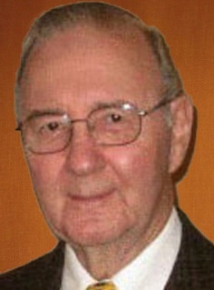COL Robert L. Reese*** was the 64th Commander in 2003, 2004 and 2005. COL Reese is a 1955 graduate of the University of Pittsburgh having majored in accounting and Business Administration. He received his commission in the QM Corps upon graduating from the Pitt ROTC program. After completing the Basic Officers Course at Fort Lee, Virginia and an assignment with the Richmond Army Depot he was relieved from active duty and entered the Reserve program where after a few years he became the Company Commander of the 858th QM (GR) Company. He gained employment with the Fidelity Trust Company as a Manager in its Trust Securities Department, dealing with Capital Changes and then managing a technical phase of trust administration known as the "Pennsylvania Rules of Apportionment". In 1961 he was called on active duty during the Berlin Crisis, as the S-1 Detachment Commander of the 316th QM Battalion, for a one year period at Fort Lee, Virginia. Upon his return to Pittsburgh National Bank, the successor to Fidelity Trust, he assumed accounting responsibilities; which, lead to his becoming the Vice President and Controller of the Private Bank in Pittsburgh. Among his responsibilities he authored the Division's Policy & Procedures Manual, the Trust Compensation Manual, the Trust Data Input Manual and the Sales & Incentive Manual. He retired in 1999 after 43 years. He continued his career in the Reserves as a member of the 2073rd USAR School, serving as its S-4, Secretary S-1, Assistant Commandant and ultimately the Commandant of the School for four years. During his tenure the School conducted active duty tours at two different Army posts and a college campus, not previously accomplished, since the school normally had multiple year assignments at the same post. The highlight of his tenure with the school was conducting the Command & General Staff Officers Course at Wesley College in Dover Delaware. The college facility provided an outstanding teaching environment for the faculty members and contributed toward the student's learning experience. The school's staff could not have functioned more efficiently. COL Reese is a graduate of the Command & General Staff Officers Course. He is the recipient of two Army Meritorious Service Medals. COL Reese, also served as Vice Chairman of the SWPA Employer Support of the Guard & Reserve Committee for ten years beginning in 1984. During his affiliation with the MOWW Pittsburgh Chapter he accomplishments a number of major tasks to include writing its Bylaws, updating its database of members, reviving its awards program, writing the chapter's history and biographical sketches of chapter commanders and submitting them to the Hoover Institute via the MOWW Historian General, authoring eight articles which were published in the Officers Review Magazine, annually preparing six to seven newsletter, each year raising funds to send nine JROTC cadets to a three day youth conference at the Freedom Foundation and complying with the mandates of National Headquarters. He has received multiple awards from MOWW for his efforts. In 2020 COL Reese was appointed Treasurer of the Pittsburgh Chapter of ROA.

***LCDR David J. Erdodi*** was the 65th Commander in 2006. David Erdodi is a graduate of the University of Dayton. While at Dayton he received an Associate Degree in Industrial Engineering, a BS in Personnel Management and an MBA in Management & Finance. Upon receiving his MBA in 1967 he was commissioned Ensign in the US Navy at Newport RI. During his tour with the Navy he served as a Signal Officer, Radio Officer, Division Officer, Communication Officer, Officer of the Deck and Combat Information Watch Officer aboard the USS Albany CG-10 with homeports in Boston and Mayport, FL. He made several deployments to the Mediterranean and Caribbean. He transferred to the Naval Reserves in 1971 and completed four tours as Commanding Officer of various Operational Detachments that included the USS Vulcan, USS Yellowstone, Tele-Communication Station Iceland and Weapons Station Earle. He attended the US Naval War College to sturdy Defense Economics and completed the US Navy Electronics and Communications Systems School in Newport. He also was assigned to CINCUSNAVEUR IN London and COMSURFGRU MED in Naples. He is the recipient of the National Defense Medal, the Sea Services Medal, 4 Oversea Services, the Armed Forces Reserve Medal with hourglass and the Expert Pistol with Silver E. LCDR Erdodi is past President of the Pittsburgh Council of the Navy League, past Director of the Speakers Program for the SWPA ESGR Committee and served as Department President of the PA ROA 1996-98. In civilian life he developed and managed business training programs for the US Department of State while with R. O. Ferguson Associates, he administered standard cost, work measurement and incentive systems with Robbins and Meyers Inc. as a Process Engineer and retired from Blue Cross of Western Pennsylvania where he held various managerial positions. While at Blue Cross he published over 1,000 technical bulletins relative to health insurance, was a major contributor in organizing and developing an electronic health care claims clearing house for institutional health care providers and was involved in the development of National standard billing protocols. Dave currently volunteers as a Management Consultant for the Executive Service Corps, which serves Non Profit Organizations.

***Captain Daniel McBride*** was the 66th Commander in 2007. Daniel McBride graduated from Duquesne University in 1965 with a Bachelor of Arts Degree in Journalism and further holds a Master of Science in Education from Duquesne. He also holds a “Certificate in Secondary Guidance” conferred by the Commonwealth of Pennsylvania. McBride enhanced his mid-career education in 1981 by obtaining an Associate Degree in Business and Public Administration from the Community College of Allegheny County. After college he entered the US Air Force in 1966 and underwent pilot training at Craig AFB in Alabama. During the Vietnam Era he served over five years as an Air Force Officer and Pilot and completed 130 combat missions over Southeast Asia as a B-52 Co-Pilot and Deputy Aircraft Commander, earning the Air Medal with five Oak Leaf Clusters. He holds FAA Ratings as a Commercial Pilot, Single and Multi-Engine Land Pilot and Instrument Pilot. Most of his thirty-three year civilian career was spent in public service with the State of Pennsylvania and the Federal Department of Labor. As a Vocational Rehabilitation Counselor with the State he assisted individuals with disabilities to achieve vocational rehabilitation through assessment, counseling, physical and mental restoration training and job placement services. He also held the position of Veterans Assistance Counselor with the State and managed various programs to assist veterans ranging from educational benefits to personal guidance and rehabilitation. As a Contract Compliance Officer with the Federal Government he was involved in protecting the rights of employees of private contractors through compliance reviews, desk audits and investigations to determine a contractor’s compliance with equal opportunity laws, regulation, practices and procedures. He retired from Federal Government service in 2004. McBride served on the School Board of the South Park School District. He was active in South Park sporting activities over a 15 year period, which involved his serving as Manager, Coach and Administrator of the Little League Baseball program, girl's softball, basketball and soccer programs. He served as announcer at sporting events and produced videos about South Park Community Days for many sporting events at local High Schools as well as College basketball, baseball, football, hockey and soccer events. He is a member of the Lions Club in South Park Township and the Nativity Parish Church.

***COL Robert L. Reese*** was the 67th Commander in 2008 and 2009. COL Reese previously served as Commander in 2003. See his biographical sketch above.

***LTC Samuel F. Wilson*** was the 68th Commander in 2010 and 2011. Samuel “Sam” Wilson was raised on a farm in Washington County.  He graduated from Penn State in 1962 with a BS Degree and received his commission as a 2nd Lieutenant in the US Army Signal Corps. Lt Wilson attended the Basic Officers Course at Fort Gordon, GA. in 1962, where one half of his class was shipped to Florida as a US response to the Cuban Missile Crisis.  The remainder of the class, including Lt. Wilson, received order for overseas assignments.  Lt Wilson was assigned to the 97th Signal Battalion, 7th Army Support Battalion in Europe, where he served 3 ½ years as a Platoon Leader, Company Commander and Battalion Staff Officer.  Upon returned to the states he attended the Signal Officers Career Course at Fort Gordon.  While waiting for the course to start, he accepted an assignment to XVIII Airborne Corps, 50th Signal Battalion, where he completed Airborne School and served as a Company Commander.  Next he attended the Signal Officers Advanced Course after which he was slated for a tour in Vietnam.  He was assigned to MACV, as a Wire Engineer Advisor to the ARVN J-6.  His job was to design a communications system from providences to JGS level.  The objective was for each headquarters to have a standard set of communications, nationwide.  The system was designed, procured, and placed into operation during his tour of duty, which was a major undertaking.  Then Captain Wilson accepted a four-year tour as an ROTC Instructor at East Tennessee State University.  This assignment gave him an opportunity to earn his Master’s Degree and was a welcome assignment after serving in Vietnam.  After this teaching assignment at East Tennessee State he returned to Vietnam.  He was assigned as Plans Officer, 1st Signal Brigade.  Having gained a great deal of experience from his prior assignment in Vietnam, his job was to first determine the existing communications installed in Vietnam, develop a plan for the needs of “Nation Building” of Vietnam and remove all capacity not needed after the US departed Vietnam.  This was probably the most difficult and challenging task he ever attempted.  The US also moved a large, emergency communications capability to Thailand.  After Vietnam he was assigned to the 82nd Airborne where he served under General Robinson, the first Black four-star general, after whom a Street in Pittsburgh was named.  After the 82nd Airborne, he attended the Command and General Staff Officers Course, was selected for command and went back to Germany as a staff officer at 5th Corps. After Germany, he wanted to complete his career with an ROTC assignment.  He was still a Reserve Officer and was required to go RA to get the assignment. His last assignment was as the Professor of Military Science at Seaton Hall University.  The ROTC Program at Seaton Hall recruited from 25 Universities and Colleges in Northern New Jersey and assembled a very interesting group of cadets.  The graduating class increased by 200% during his four-year tour.  The highlight of this tour was a visit by President Ronald Reagan for the 1983 graduating class.  As the University’s Manager for this Presidential visit, he had the responsibility for arranging most of the details of the visit and was given the honor of presenting the Official University Gift to the President.  This was the culmination of a rewarding and satisfying military career, as he retired in 1984. After retirement he continued in the communications industry in training and sales.  He became affiliated with a number of companies during the 1980s and 90s, as this industry was going through a great many changes.  During his military and civilian careers he traveled nationwide, visiting all 50 states and 36 foreign countries.  Since in his opinion this industry seemed to stay in a state of turmoil, he decided to seek employment with Allegheny County and was hired as the Manager of Communications.  During his career with Allegheny County, which lasted eight years, he served as the Deputy Director of Administrative Services, which supervised communications.  He also spent two years as the Manager of Property Assessments.  Sam has two unique hobbies, which he carries on as businesses. The first is restoring antique furniture and the second is caning chairs.

***COL H. Stewart Perry*** was the 69th Commander in 2012 and 2013.H. Stewart Perry graduated from the University of Pittsburgh in 1954 with a degree in Petroleum Engineering and at the same time he was commissioned a 2nd Lt in the QM Corps. During a 2 year tour on active duty, he participated in Operation Sagebrush. After undergoing QM & Infantry training at Ft Lee, VA and Ft Benning, GA, he became Commander of a Rifle Company in the 95th Infantry Division. His career in his chosen field of Petroleum Engineering involved oil production in Oklahoma, Texas and Kansas. He was with CALTEX in Indonesia in 1966 during that country's Revolution. He changed careers and obtained a position with Moore, Leonard & Lynch Brokerage Firm as a Stock Broker. In 1980, he co-founded an NASD firm and became its CEO. The firm specialied in oil and gas Limited Partnerships and in buying and selling securies. Concurrently, with his civilian career he attended the Advance Officers Course with the 2073rd USAR School after which he enrolled in and graduated from the C&GSO Course. His final assignment in the Reserves was with the 443rd Field Depot. He served as Director of the SIPT (Security, Intelligence, Plans and Training) Directorate and as Director of Supply in the Supply Directorate. The Depot was active in Operation Cornerstone during the Cold War. COL Perry also served as a member of the SWPA Employer Support of the Guard & Reserve Committee. He retired from Stifel Nicolos Brokerage Firm in 2008. Following retirement, he traveled extensively with the 171st ARW and the 911th Airlift Wing.

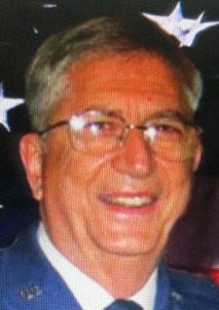***Brig Gen Peter C. Bellisario*** is the 70th and current Commander since 2014. Brig General Peter C. Bellisario received his commission from the Air Force ROTC program at Duquesne University in 1964. He earned a Masters Degree in Health Care Administration from Central Michigan University in 1978. His assignments began at the US Air Force Medical Center at Travis AFB California. He served as the Executive Officer for the 2nd Casualty Staging Flight that was the first stop for casualties returning from Vietnam to the United States on their way to a medical facility for further treatment. Also, during this assignment he was loaned to the Department of State Agency for International Development in Saigon, South Vietnam. His other assignments include the USAF Academy, Headquarters USAFE at Ramstein Air Base, Germany, Armed Forces Staff College, Malcolm Grow Medical Center Andrews AFB, administrator at Patrick AFB FL, Deputy Commander of the School of Health Care Sciences in Wichita Falls, TX, Hq AFSC at Andrews AFB MD, and Administrator, Malcolm Grow Medical Center. During this assignment he served as the Administrator of the 317th Contingency Hospital at RAF Station Bicester, England in support of Desert Shield, Desert Storm. He retired as Chief of the Air Force Medical Service Corps on September 1, 1994. His awards and decorations include the Air Force Distinguished Service Medal, Legion of Merit with oak leaf cluster, Meritorious Service Medal with three oak leaf clusters, and the Air Force Commendation Medal. After his retirement from the Air Force he became immersed in volunteer activities, including work at the VA hospital in Oakland, serving as the President of the Pittsburgh chapter of MOAA, presiding for eight years as the President of his City neighborhood organization, the Brighton Heights Citizens Federation and representing the community on several boards at Allegheny General Hospital for ten years.

Prepared by:

**R. L. Reese**

ROBERT L. REESE, COL, USA, Retired

Vice Commander and Adjutant

Gen Ridgway - Pittsburgh Chapter

September 2020