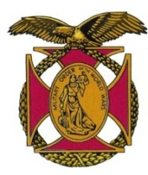
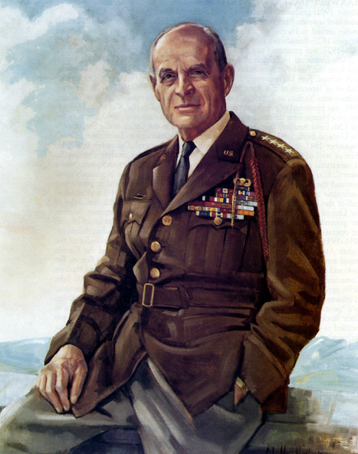

BG Peter C. Bellisario

Commander

COL Robert L. Reese

Vice Commander, Adjutant & Editor

MG George V. Bauer

Chief of Staff & Treasurer

LTC Samuel Wilson

ROTC Awards

Colonel Paul A. Platek

Historian & Chaplain
CAPT Karl D. Ludwig

Surgeon
LTC Gary Roberson
Public Relations
COL Richard Latshaw
Veterans Affairs
CAPT Paula Bozdech-Veater

Deployed Troops
LTC William Pentecost
Judge Advocate
MAJ John Skovran
Youth Ldrshp Prog
LTC Charles Chasler
Scouting

Bulletin #133
Sept 2022
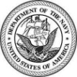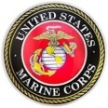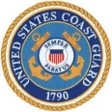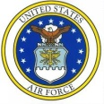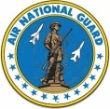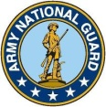

Website: https://mowwpgh.wixsite.com/moww

LUNCHEON MEETING

Tuesday, September 20, 2022

Place: Scoglio’s Greentree Restaurant, Foster Plaza Building #7

Arrival Time: 11:30 a.m., Lunch to be served at 12:00 p.m.

Cost of full course meal, including gratuity, tax and guest speaker: $30.00

MENU: Broiled Spots English Style. Chicken Romano will be available upon request for members not wishing to eat fish. Attendee must specify upon making a reservation.


SPEAKER: Former Assistant Professor of Geology at Penn State University, John Ciciarelli, will show a slide presentation and speak on the "Battle of Monte Cassino" during World War II. Monte Cassino was an Abby located south of Rome, which was occupied by the German Army in the early part of 1944.

RESERVATIONS: It is ESSENTIAL that we advise the restaurant in advance of the number of meals. Please call or e-mail your reservation into MG George Bauer at (412) 848-9302 or e-mail jordieb@verizon.net NLT SATURDAY the 17th of September. Significant others and guest are always welcome. If for some reason, at the last minute, you cannot attend the luncheon after having made a reservation please call Scoglio's at (412) 921-1062.

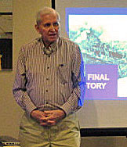
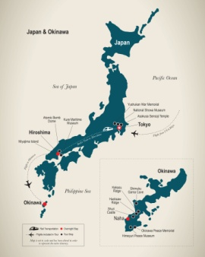
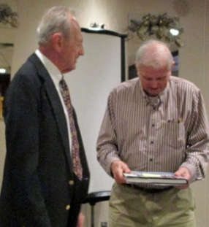
SEPTEMBER SPEAKER: Gary Augustine gave an interesting presentation on the battle for Okinawa Island the last stepping stone in the plan to invade Japan during WW II, which contained a small air strip. Taking Okinawa would provide Allied forces an airbase from which bombers could strike Japan and an advanced anchorage for Allied fleets. From Okinawa, US forces could increase air strikes against Japan and blockade important logistical routes, denying Japan of vital commodities. Okinawa was the bloodiest battle of the Pacific War. The invasion was part of Operation Iceberg, a complex plan to invade and occupy the Ryukyu Islands, including Okinawa. Though it resulted in an Allied victory, kamikaze fighters, rainy weather and fierce fighting on land, sea and air led to a large death toll on both sides. During the 1945 battle, the Imperial Japanese Army showed indifference to Okinawans' safety, and its soldiers used civilians as human shields, or outright killed them. The Japanese military also confiscated food from the Okinawans and executed those who hid it, leading to mass starvation, and forced civilians out of their shelters. Japanese soldiers also killed about 1,000 people who spoke in the Okinawan language to suppress spying. Some civilians were blown apart by artillery shells, some finding themselves in a hopeless situation were driven to suicide, some died of starvation, some succumbed to malaria, while others fell victim to the retreating Japanese troops. With the impending Japanese defeat, civilians often committed mass suicide, urged on by the Japanese soldiers who told locals that victorious American soldiers would go on a rampage of killing and raping. There were Okinawans who the Japanese Army directed to commit suicide. There were also people who were handed grenades by Japanese soldiers to blow themselves up. Thousands of civilians, having been induced by Japanese propaganda to believe that American soldiers were barbarians who committed horrible atrocities, killed their families and
PITTSBURGH CHAPTER BULLETIN #133, SEPTEMBER 2022

themselves to avoid capture at the hands of the Americans. Some of them threw themselves and their family members from the southern cliffs. Okinawans were often surprised at the comparatively humane treatment they did received from the American enemy.

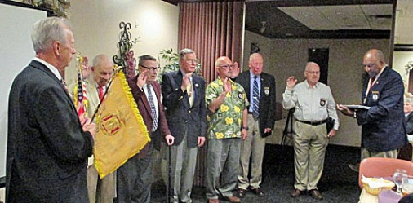
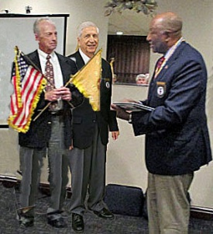
INSTLATION OF OFFICERS: On May 17th CAPT Edward Gantt, VCINC having oversight responsibility for Regions I, III and IV, had the honor of serving as the Pittsburgh Chapter's Installation Official. Brig Gen Peter Bellisario was installed absentia by having COL George Ehringer act in his stead. COL Robert Reese and MG George Bauer were installed as Vice Commander & Adjutant and Chief of Staff & Treasurer, respectively. The remaining staff members were once again appointed to their respective positions.
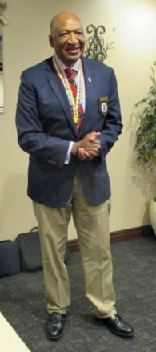

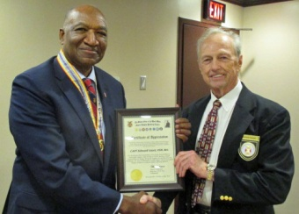
VCINC AWARD: CAPT Edward Gantt, VCINC, travelled from the Washington, DC area to be with our chapter and for his efforts our chapter presented him with a "Certificate of Appreciation" containing the citation below. CAPT Gantt made it a point to introduce himself to each member and guest in attendance.

"For having provided outstanding service to the General Ridgway - Pittsburgh Chapter, while serving as VCINC having oversight responsibility over Region III and its chapters, he travelled from the Washington DC area to
Pittsburgh to install chapter officers and update chapter members
on national matters affecting MOWW"

RECRUITING: During the next server months members are encouraged to solicit new members to our chapter. Our next scheduled luncheon at Scoglios will be on Tuesday the 20th of September, which is ideal for introducing candidates to our chapter. Our chapter will pick up the $20 of the $40 first year's Regular annual dues. As for a perpetual membership we will absorb $150 of the $350 one time fee.

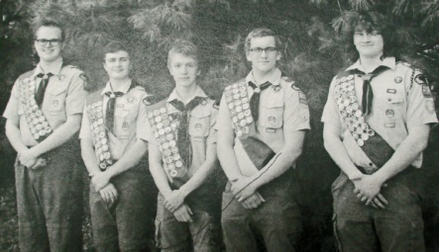
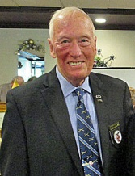
SCOUTING PROGRAM: In May of 2022 our chapter, represented by LTC Charles Chasler, Program Scout Manager, presented Certificates of Recognitions and Scouting Patches to five members of Troop 215 who were elevated to the rank of Eagle Scout. Pictured left to right are Matthew Kurtz who designed and built a bench for children to sit on while waiting to get picked up by a relative, Justin Wrubel who designed a covered bench for the Montour Trail, Aidan Allridge who expanded a small garden bed and created a bench for the Mingo Creek Cemetery, Thomas Donihi who designed, built and installed a Free Book Library Kiosk on one of the walking trails on Bethel Green Property and Joshua Zahniser who constructed a bus shelter at First Bethel United Methodist Church. If any member knows of any Scouting Troop planning to elevate a Boy Scout to the rank of Eagle Scout or a Girl Scout to the rank of Gold Scout, please bring that information to the attention of LTC Charles Chasler.

OFFICER REVIEW: If you have not already reviewed the Officer Review Magazine "Washington was not the First President?" is the title of an interesting article which appears on page 19 of the magazine. The article was written by COL Reese and deals with the men who served as President prior to the adoption of the US Constitution in 1787. In addition, you may wish to view a "Chapter in Action" article dealing with our chapter on page 26 of the OR Magazine titled "What Motivates People"

PITTSBURGH CHAPTER BULLETIN #133, SEPTEMBER 2022

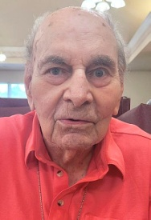
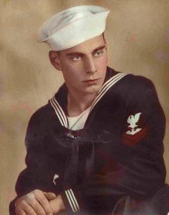
CENTENNIAL HORNOR: August 8th is an important date in the life of JOHN BOVARD STAUFFER since on that date in 1922 John Stauffer was born one hundred years ago in Butler, PA. To celebrate the occasion at Lowrie Place, a Personal Care Home in Meridian, PA where Stauffer resides, the General Ridgway - Pittsburgh Chapter of the Military Order of the World Wars, was invited to share in the occasion. The MOWW attendees included Brig Gen Peter Bellisario, Chapter Commander, and his wife Joan, COL Robert Reese, Vice Commander and MC for the affair, MG George Bauer, Chief of Staff, Cpt Joseph Leech, Recruiting Director, and his wife Ruth Ann, and CAPT Wallace Utley, Chapter Member. Also, joining the MOWW Group, at the invitation of COL Reese, were CAPT Jon Minor, President of the Pittsburgh Chapter of ROA, Attorney Alfred Yates and Attorney Al Lindsay, Chairman of the Butler Republican Party. Carol Warner, Life Enrichment Coordinator at Lowrie Place preformed a yeoman's job of coordinating the affair.
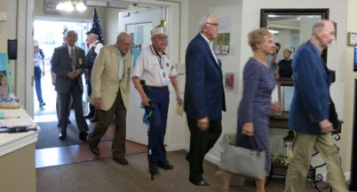
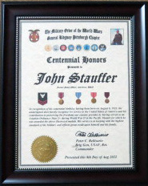
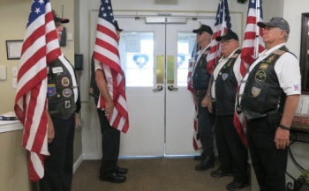

The local Chapter of the American Legion provided an Honor Guard with US flags on either side of the main entrance thus providing a corridor for the MOWW contingent to pass through upon entering Lowrie Place. They then stationed themselves throughout the Reception Hall in honor of Petty Officer Stauffer and the Awards Program, which was organized by COL Reese and Carol Warner. Brig Gen Bellisario presented Stauffer with a Certificate of "Centennial Honor" and CAPT Utley read the following citation contained thereon:

"In recognition of his centennial birthday having been born on August 8, 1922, the undersigned does hereby recognize his service to the United States of America and his contribution to preserving the freedoms our country provides by having served as an Aviation Ordnance Man 2/c during World War II in the Pacific Theater for which he was awarded the above illustrated medals. His service is in keeping with the highest standard of the Military and reflects great credit upon himself and his family"
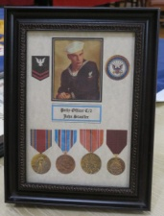


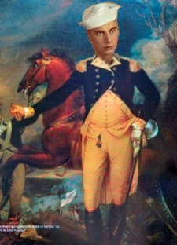
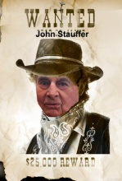
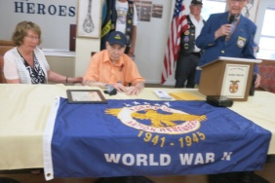
The MOWW Region III Commander, COL Loren Weeks, donated a set of four medals earned by Stauffer during WW II and a flag containing the inscription "A Grateful Nation Remembers". Stauffer's son and daughter pinned the medals on their father and MG Bauer and Cpt Leech draped the flag over the table in front of Stauffer. COL Reese presented Stauffer with a framed picture of his medals, which included the Victory Medal, the American Campaign Medal, the Asiatic Pacific Medal and a Good Conduct Medal. In order to add a little levity to the program COL Reese presented Stauffer with a number of altered photos wherein his head was superimposed on characters, each of which elicited a smile from Stauffer. He then contrived some story about the photos. Attorney Al Lindsay read citations from proclamations received from Thomas Wolf, Governor of Pennsylvania, Scott Hutchinson, State Senator and the Butler County Board of Commissioners, wherein they proclaimed the 8th day of August "Jack Stauffer Day" in Butler County. Unexpectedly, Stauffer received a personal framed letter from the President of the US, Joe Biden, wishing him a happy 100th birthday and thanking him for his WWII service. Attorney Alfred Yates had the honor of presenting the President's letter to Stauffer, after he recited the names of all Presidents, which led to Biden. In advance of the celebration the Public Affairs Office of the Chief of Naval Operations advised COL Reese that Admiral Michael Gilday was writing a letter to Petty Officer C/2 Stauffer which was to be delivered in person by CDR

PITTSBURGH CHAPTER BULLETIN #133, SEPTEMBER 20, 2022

Craig Richardson, Commanding Officer, Naval Reserve Command, Pittsburgh. CDR Richardson's Deputy read the letter allowed after which CDR Richardson presented it to Stauffer. CAPT Jon Minor presented Stauffer with a framed "Certificate of Patriotism" from the Pittsburgh Chapter of the Reserve Organization of America (ROA).

A representative from the Office of Veteran Affairs presented Stauffer with a congratulatory letter together with an encased US flag which had been flown over the Capital Building.
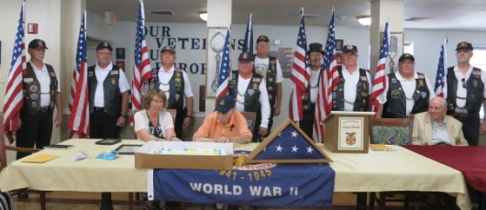

John was married to the late Ellen Matheny Stauffer for 73 years, who passed away in August of 2019. They have two living children, Patricia S. Skornicka and Thomas Stauffer and a second son, John H., who was a Marine in Vietnam and who passed away in September of 2021. John Stauffer joined the Navy in September of 1942 and served in the Pacific Theater during World War II at the Aviation Supply Depot in Guam. He was an Aviation Ordnance Specialist which involved the maintenance, storage and disposition of ammunition and fuel for aircraft. It is with a great deal of pride that the Pittsburgh Chapter of MOWW had an opportunity to honor a World War II Veteran and all who served in the defense of our nation, our form of government and the freedoms we share today.

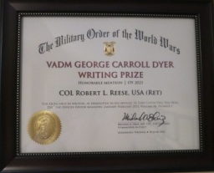
EXCELLANCE IN WRITTING AWARD: Both COL Reese and COL Ehringer will shared in a $500 reward for co-authoring the article published in the Jan/Feb issue of the MOWW Officer Review Magazine titled "If they catch you, you will die", which had to do with Les Banos serving as an Allied Spy in the German SS during World War II. In addition to the VADM George C. Dyer Writing Prize each received a certificate of Honorable Mention for Excellence in Writing, signed by the CINC, LTC Michael Okin. If you wish to read the article it may be accessed on the MOWW National Headquarter's Website under Officer Review Magazine.

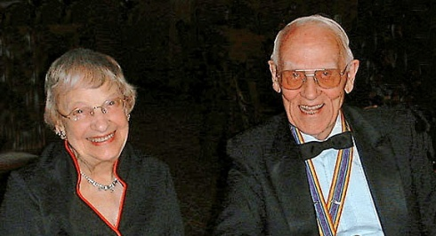
PASSING OF MEMBER: Our dear companion, LTC Paul Schaugheny, passed away on July 14, 2022 at the age of 101. Paul, who served as our Chapter Commander beginning in 1999 also served as the Chapter's Chaplain for a five year period ending in 2015. He was a Regular Member since 1992. Upon reaching his 100th birthday in 2021, MG Bauer and COL Reese presented Paul with a Certificate of Longevity at his resident at Provident Point. Paul was predeceased by his wife of 74 years, Elizabeth (Cathy), in 2018. Elizabeth served as State President of the Daughters' of the American Revolution. During World War II Paul served in Adak, which is part of the Aleutian Island Chain, where is received a Commendation Medal for having located a chaplain and three nurses lost in a snowstorm. He spent his entire civilian career with PPG Industries, retiring after 39 years in 1987. Paul sang in Barbershop quartets, preformed in plays at the Little Lakes Theatre and was very active in community activities. He was highly respected by all who knew him and always had an infectious smile to share with everyone.

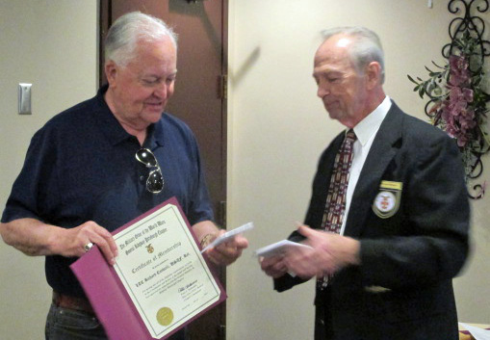
NEW MEMBER: COL George Ehringer had the honor of presenting LTC Richard J. Conwell with a Certificate of Membership as a Regular Member in our Chapter. LTC Conwell is currently assigned as the United States Air Force Academy Deputy Liaison Officer Director responsible for over 400 PA High Schools and colleges, and providing oversight of Admission Liaison Officer's in the Western Region of PA. He is also a USAFA Congressional Liaison Officer representing the 15th, 16th and 17th PA. Districts. LTC Conwell served as the Administrative Services Flight Commander for the 171st Medical Group and completed an overseas deployment to the Afghanistan Theatre of Operations under Operation Enduring Freedom in 2005.

He also served as Deputy Commander and Chief Administrator for the 376th Expeditionary Medical Group located at Manas Air Base in Kyrgyzstan with theatre aeromedical evacuation responsibilities. He holds a number of graduate degrees from six universities and is a graduate of the Air War College. With his 57 years of continuous service with the USAF it is believed that he is the longest serving Airman veteran in US Military history. In civilian life he is a business owner and VP of CORPAR, LLC, a commercial storage corporation for classic automobiles. He also works part time as a

PITTSBURGH CHAPTER BULLETIN #133, SEPTEMBER 20, 2022

Test Driver for the Bobby Rahal Motorcar Company. He is twice a recipient of the Jefferson Award for Public Service for varied volunteer services throughout PA and was recently inducted into Sigma Beta Delta, the International Honor Society in Business, Management and Administration.

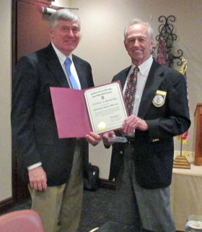
DELAYED INDUCTION OF NEW MEMBER: Although COL Edward Kapron join our chapter in November of 2021 he was unable to attend meetings until recently. COL Ehringer had the privilege of presenting him with a New Member's Certificate issued by MOWW National Headquarters at our May meeting. He is a former member of the 99th ARCOM and is a Financial Planner in civilian life.

PHOTOGRAPHER: A word of thanks goes to Joan Bellesario who assumed responsibility for taking photos during the Stauffer Affair.

MEMBERS ATTENDING THE MAY 2022 LUNCHEON AND STAUFFER AFFAIR IN AUGUST OF 2022:

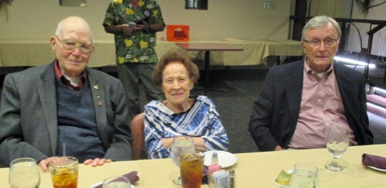
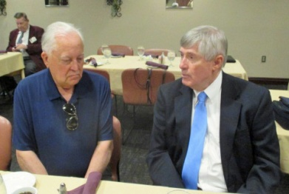
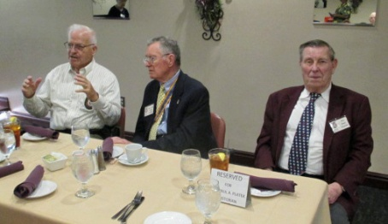

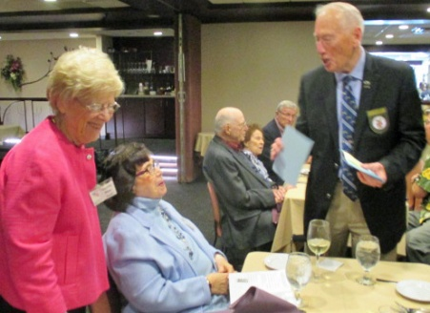
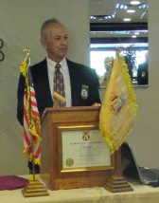
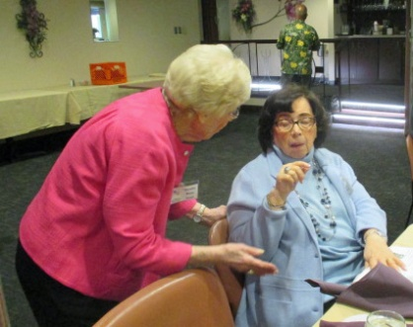
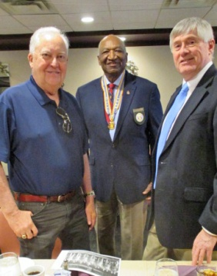

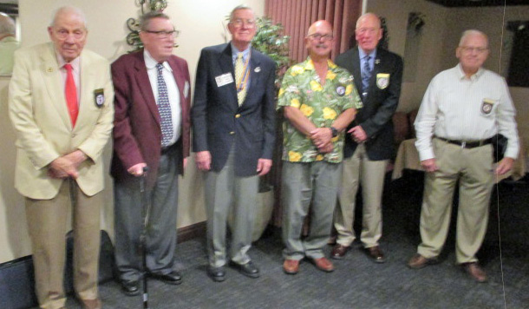
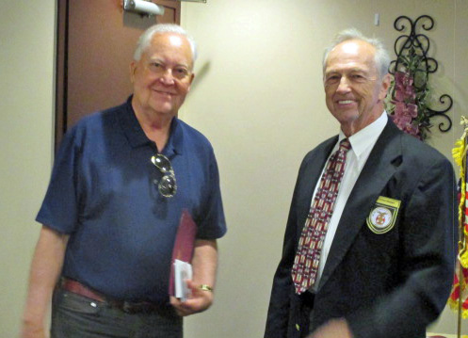

PITTSBURGH CHAPTER BULLETIN #133, SEPTEMBER 20, 2022

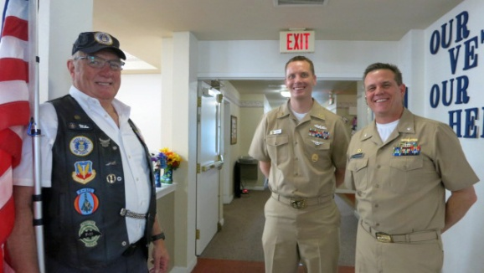
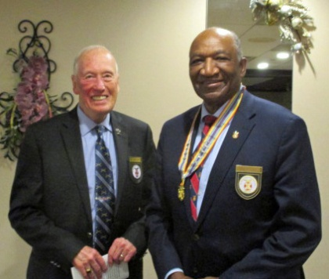
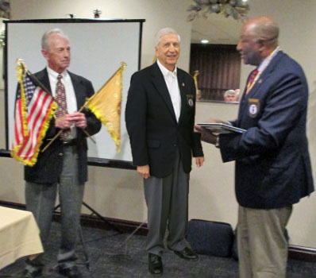

(Brig Gen Bellisario superimposed)
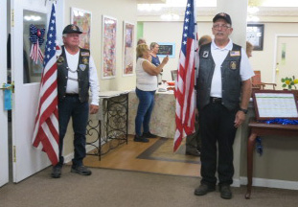
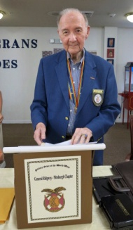
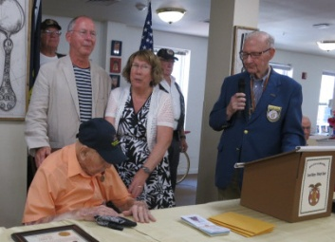
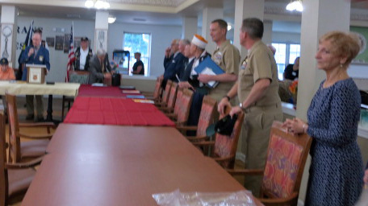
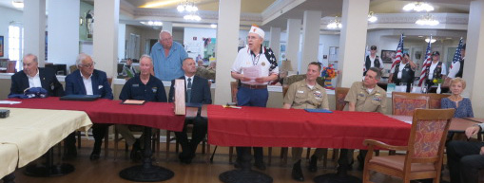
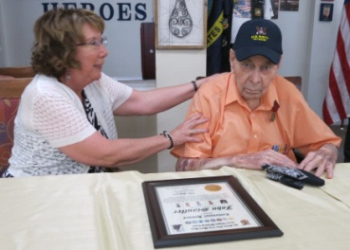
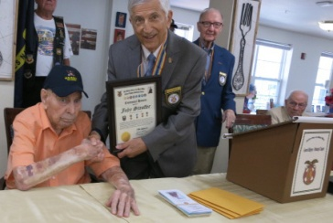

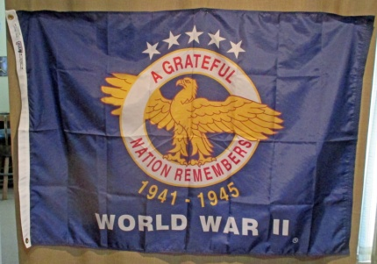
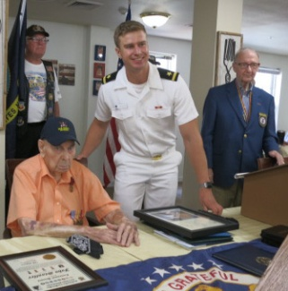
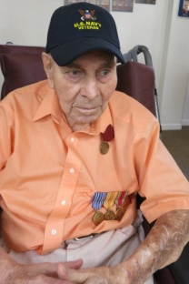
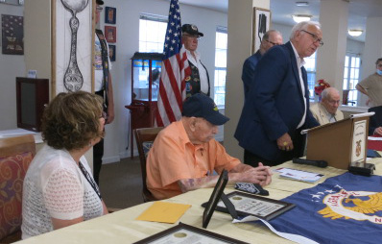
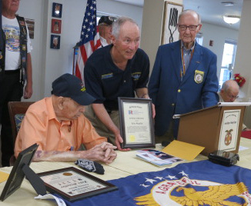
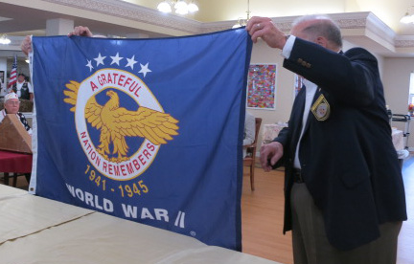
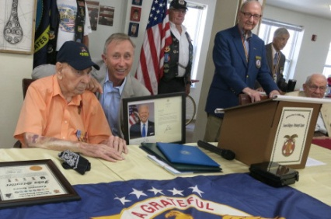
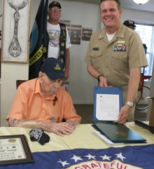

Following are planned dates of meetings during the remainder of the Program Year: 10/18/22, 11/15/22, 3/21/23, 4/18/23 and 5/16/23.

