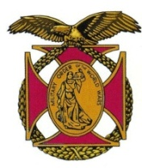

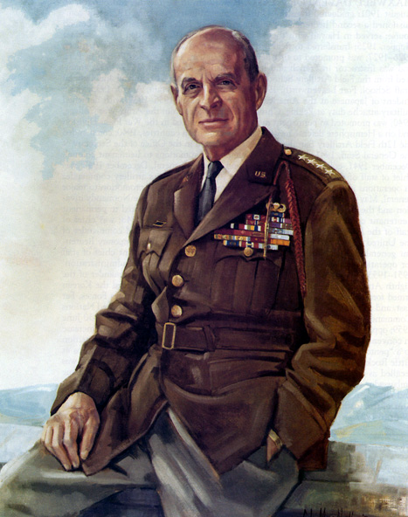

|  |
| --- |
| BG Peter C. Bellisario *Commander*  *COL Robert L. Reese*  *Vice Commander, Adjutant & Editor*  *MG George V. Bauer*  *Chief of Staff & Treasurer* LTC Samuel Wilson *ROTC Awards*  *CAPT Karl D. Ludwig* Surgeon ***LTC Gary Roberson***  *Public Relations*  ***COL Richard Latshaw***  *Veterans Affairs*  ***CAPT Paula Bozdech-Veater*** Deployed Troops ***LTC William Pentecost***  *Judge Advocate*  ***MAJ John Skovran***  *Youth Ldrshp Prog*  **LTC Charles Chasler**  Scouting  **COL Carmen DiGiacomo**  Chaplain |

Bulletin #141

Nov 2023

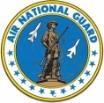

Website: https://mowwpgh.wixsite.com/moww

LUNCHEON MEETING

Tuesday, November 14, 2023

Place: Scoglio’s Greentree Restaurant, Foster Plaza Building #7

Arrival Time: 11:30 a.m., Lunch to be served at 12:00 p.m.

Cost of full course meal, including gratuity, tax and guest speaker: $30.00

MENU: Char-grilled Salmon. Chicken Romano is available for those not wishing to eat fish. So indicate upon making a reservation.

LUNCHEON SPEAKER: Richard DiGiacomo will speak on "The Rule Book" which will explain how we interpret the US Constitution in modern times.

## RESERVATIONS: It is ESSENTIAL that we advise the restaurant in advance of the number of meals. Please call or e-mail your reservation into MG George Bauer at (412) 848-9302 or e-mail jordieb@verizon.net **NLT THURSDAY the 9th of November**. Significant others and guest are always welcome. If for some reason, at the last minute, you cannot attend the luncheon after having made a reservation please call Scoglio's at (412) 921-1062.

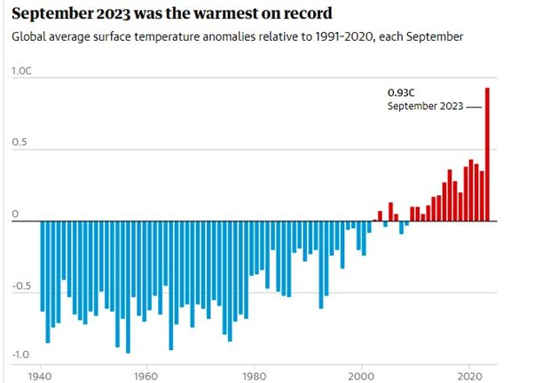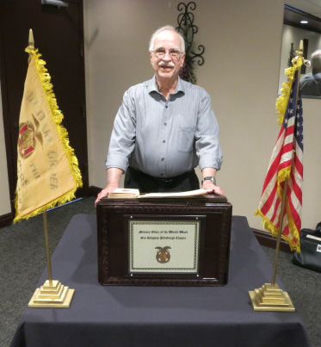REVIEW OF OCTOBER SPEAKER: Rod Elder gave an eye opening presentation before our chapter on the 17th of October dealing with the world climate crisis. Although his professional career was in the field of nuclear reactor and scientific supercomputing, he developed a keen interest in global warming and its effects. His presentation is summarized below with editorial additions. Rod believes that climate change is the most important threat facing all countries and it is happening more quickly than people realize. He pointed out that rising temperatures are fueling natural disasters, weather extremes, economic problems and environmental concerns. The Arctic is melting, sea levels are rising and oceans are acidifying, not to mention that forests fires have taken their toll. It is clear that business as usual is not good enough to address this problem. As the skyrocketing cost of climate change reaches new highs, now is the time for bold collective action. Rod explained that scientists believe that billions of tons of CO2 each year are polluting the air as a result of coal, oil and gas production. Human activity is contributing toward the so called greenhouse gas emissions at a record high without any signs of abating. Greenhouse gases include carbon dioxide, methane, nitrous oxide, ozone and some artificial chemicals generated by humans and other sources. When the Sun’s rays reach the Earth’s atmosphere, some of it is reflected back into space and some of it is absorbed by the earth. The absorbed energy warms the atmosphere and the surface of the Earth. The upper layers of the earth's atmosphere contain Greenhouse Gasses which shield the earth from the Sun’s harmful rays and also provides an acceptable amount of warmth to the earth’s atmosphere. However, an increase in greenhouse gases can cause excessive global warming, which will be harmful to humans if not checked. According to the National Oceanic and Atmospheric Administration

PITTSBURGH BULLETIN #141 NOVEMBER 14, 2023

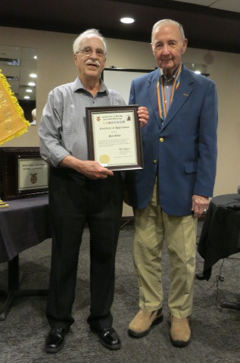(NOAA), 2023 is on track to be the hottest year in almost 175 years of collecting climate data. The average global temperature in September of 2023 was measured at 61.6 degrees, which is 2.59 degrees above the last century’s average of 59.0 and 3.15 degrees above pre-industrial averages. Glaciers are already melting faster than ever, causing sea levels to rise. Almost two-thirds of the world’s cities are located in areas at risk of rising sea levels. If no action is taken major coastal populated cities could find themselves underwater thus displacing millions of people. Rod briefly discussed the so called Doomsday Glacier in Antarctica. A study indicated that the glacier is being eroded causing it to weaken rapidly and become more prone to fracture. Scientist are uncertain when the collapse will occur but they predict that sea levels will rise about 2 feet within 100 years. Rod explained that one state has taken affirmative action when Governor Gretchen Whitmer of Michigan signed an Executive Order in 2020 creating the Michigan Healthy Climate Plan. The plan is intended to protect Michiganders' public health and the environment and help develop new clean energy jobs by becoming fully carbon-neutral by 2050. The Plan creates a Council on Climate Solutions which is charged with recommending opportunities for reducing Greenhouse gases. Rod turned his attention to the Kola Super deep Boerhold undertaken by the Soviet Union which began in 1970 and ended in 1992 due to a lack of funds. It was an attempt to drill a hole as far into the Earth as possible. It reached over 7 miles when the project was halted. Soviet scientists wanted to learn more about the Earth's crust and how it was formed and evolved.

Rod discussed some measures we can take, where possible and feasible, to reduce the advance of global warming.

1. Switch to solar and wind energy to power our homes and buildings.
2. Drive electric vehicles or use mass transit.
3. Better insulating our homes and buildings and purchasing energy-efficient appliances.
4. Planting trees which would absorb carbon dioxide.

Rod Elder was presented with a framed "Certificate of Appreciation" by COL Reese for having made an outstanding presentation.

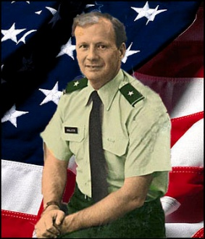

PHOTO OF PAST COMMANDER: Neal Cramer, a guest of LTC Ernie Orsetti at our October luncheon, provided us with a photo of BG John E. McAlister who served as the 56th Chapter Commander during the one year beginning on July 1, 1991. BG McAllister was the Deputy Commanding General of the 99th US Army Reserve Command under MG James Baylor. Among his many accomplishments he was responsible for obtaining General Matthew B. Ridgway's approval to re-name our chapter after General Ridgway. His life was cut short on May 25, 1999 at the age of 53 after having been diagnosed with a cancerous brain tumor.

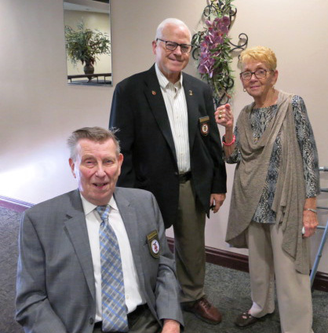PASSING OF COMPANION: We lost a true patriot and friend upon the passing of COL Paul Platek, on October 24th. Paul served as MOWW Chapter Commander during the Program Year 1992/93 and for many years served as Chaplin and Chapter Historian. In 2005 he was awarded the MOWW Chapter's "Outstanding Service Award" for his services to the Order. He enrolled in Duquesne University's ROTC program where he was designated a Distinguished Military Graduate upon being commission a 2nd Lieutenant in the Finance Corps in 1963. He earned a Masters of Liberal studies in 1982. Upon release from active duty he served in a number of reserve units and ultimately served as DCS Personnel & Administration and DCS Resource Management for the 99th ARCOM after which he was appointed Commandant of the 1036th US Army Reserve School in Farrell and Commander of the 475th QM Group in Farrell. He was a member of many Military organization where he held senior positions. In civilian

PITTSBURGH BULLETIN #141 NOVEMBER 14, 2023

life he retired from US Steel Corporation in 2003 as a Staff Supervisor of US Steel's General Accounting Department. He is survived by his wife Ruth.

REGULAR MEMBERS: Regular members may wish to upgrade their membership to Perpetual prior to 1/1/24 when the cost of doing so will increase from $200 to $350, after a chapter co-payment of $150. Concurrent the annual cost of a Regular Membership will increase from $40 to $60. A Perpetual Membership means that you no longer need to pay an annual fee of $60 come 1/1/24. Do the math, in 10 years you will have saved $400 ($600 less $200). If you wish to up-grade your membership prior to 1/1/24 contact COL Reese.



WREATHS ACCROSS AMERICA: The Bethel Park Historical Society will conduct a "Wreaths Across America" Day on Saturday the 16th of December 2023 at 12:00 p.m. The event will take place at the Bethel Cemetery located at 2999 Bethel Church Road, Bethel Park, PA 15102-1253. At the intersection of Broughton Road and Route 88s, Broughton Road turns into Bethel Church Road. Major Michael Bonacci will serve as the Master of Ceremonies as well as the Keynote Speaker. Chapter members are encouraged to attend this symbolic event to honor our deceased military members and support Major Bonacci's contribution.

REGION III CONFERENCE: COL Reese sat in on the Region III Fall Zoom conference on October 28th. Each of the five Chapters making up Region III presented their Annual Action Plan. COL Joe Kirlin, Region III Commander, chaired the meeting. BG Victor Perez, CINC, provided opening remarks and thanked all participants for their devotion to the Order and emphasized the importance of recruiting new members. He informed participants that the Committees studying the renaming of the Order and the adoption of a 501(c)(3) tax status was scheduled to report their findings in February of 2024. Among the topics discussed were (a) marketing and publicity, (b) fund raising, (c) the program for the 2024 National Convention to be held in Philadelphia, and (d) convention tours. The Conference approved an increase in the Region III assessment from $1.00 to $2.00 per living member. If you wish to view our Annual Action Plan which was submitted at the Region III Conference click on the following icon.



YOUTH PROGRAM: Contributions to our 2024 Youth Program clearly indicate that our membership is fully behind this program and appreciate knowing that the students really benefit from being exposed to the offerings of the Freedom Foundation, based upon past student essays. Each donor can be proud of the fact that they will be enabling a high school student to be exposed to an educational program that teaches them how to be a leader, how the entrepreneur system works and how our form of government functions. Since 2005 we have sent 150 students to the Freedom Foundation because of your continued generosity. A word of thanks goes to the following donors who made donations to our 2024 Youth Program: MG Bauer, Brig Gen Bellisario, LTC Berkowitz, MAJ Bonaci, LTC Conwell, COL Cunningham, CAPT Ludwig, LTC Orsetti, COL Reese, LTC Roberson, LTC Shirley, LTC Voigt, LTC Young, Jean Boucek, COL DiGiacomo, COL Latshaw, COL Platek, COL Schano, CAPT Utley, LTC Wilson and MAJ Skovran. If you wish to do so contributions may still be made through MG Bauer.

ATTENDEES AT OUR OCTOBER LUNCHEON:

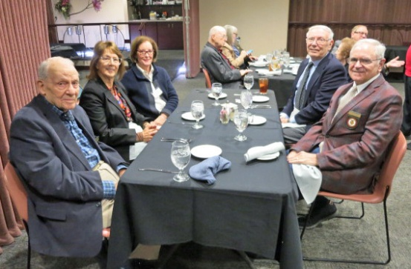

PITTSBURGH BULLETIN #141 NOVEMBER 14, 2023

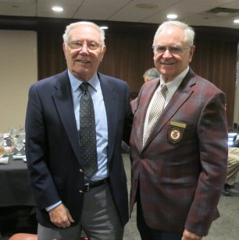

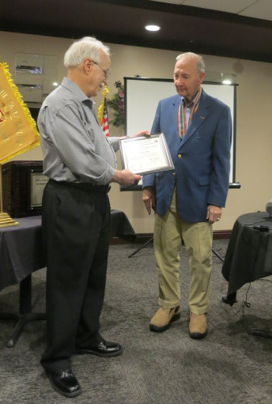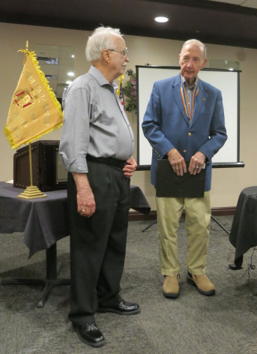

FUTURE LUNCHEON SCHEDULE: 3/19/24, 4/16/24 and 5/21/24.