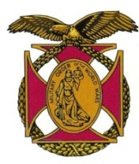
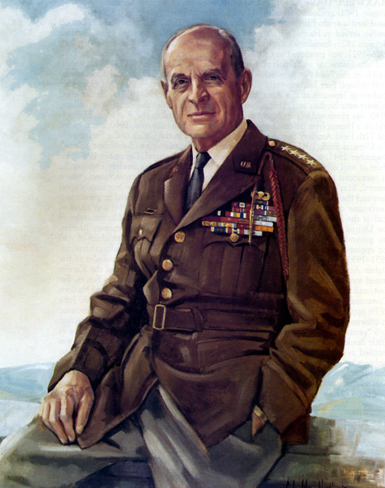

BG Peter C. Bellisario

Commander

COL Robert L. Reese

Vice Commander, Adjutant & Editor

MG George V. Bauer

Chief of Staff & Treasurer

LTC Samuel Wilson

ROTC Awards

Colonel Paul A. Platek

Historian & Chaplain
CAPT Karl D. Ludwig

Surgeon
LTC Gary Roberson
Public Relations
COL Richard Latshaw
Veterans Affairs
CAPT Paula Bozdech-Veater

Deployed Troops
LTC William Pentecost
Judge Advocate
MAJ John Skovran
Youth Ldrshp Prog
LTC Charles Chasler
Scouting

Bulletin #140
Oct 2023
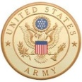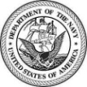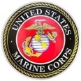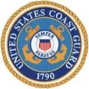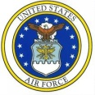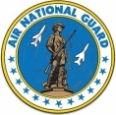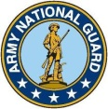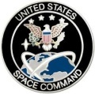

Website: https://mowwpgh.wixsite.com/moww

LUNCHEON MEETING

Tuesday, October 17, 2023

Place: Scoglio’s Greentree Restaurant, Foster Plaza Building #7

Arrival Time: 11:30 a.m., Lunch to be served at 12:00 p.m.

Cost of full course meal, including gratuity, tax and guest speaker: $30.00

MENU: Chicken Romano
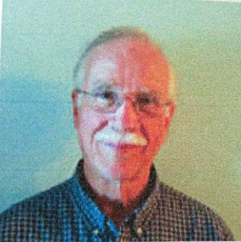

SPEAKER: Our speaker will be Rod Elder, retired Manager of the supercomputer facility at Bettis Atomic Power Laboratory. He is a graduate engineer who served on the Department of Energy's national committee for computing, which dealt with the advanced development of nuclear energy systems and weapons. He will speak on the world Climate Crisis.

RESERVATIONS: It is ESSENTIAL that we advise the restaurant in advance of the number of meals. Please call or e-mail your reservation into MG George Bauer at (412) 848-9302 or e-mail jordieb@verizon.net NLT SATURDAY the 15th of October. Significant others and guest are always welcome. If for some reason, at the last minute, you cannot attend the luncheon after having made a reservation please call Scoglio's at (412) 921-1062.
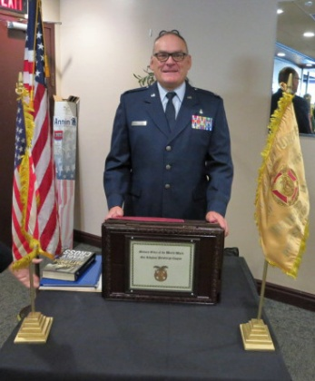
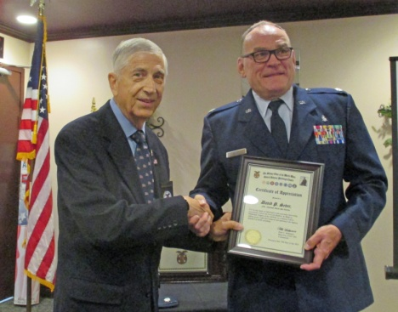
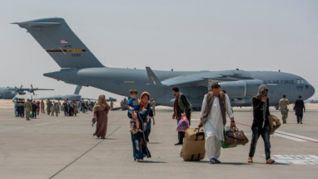
SEPTEMBER'S SPEAKER: LTC David Sever, a Clinical Nurse in the Aeromedical Staging Squadron of the 911th Airlift Wing, shared with us his experience of evaluating civilian and Afghan Refugees from the Airport in Kabul, Afghanistan during October of 2021. The 911th Airlift Wing was given the mission to airlift thousands of refugees and others who were awaiting evacuation. The 911th was one of six Air Wings from around the country to participate in the evacuation to ensure safe passage of Americans and Afghan allies to other locations around the world. The 911th contributed 17 transport and refueling aircraft, which included the C-17 Globermaster IIIs, the C-130 Hercules, the C-5M Super Galaxies and the KC-10 Extenders as well as 73 air crews and hundreds of maintenance, security, medical and support personnel to the operation. The airlift was considered one of the largest in the Reserve Command's history. LTC Sever explained that the logistical requirements of housing,

PITTSBURGH CHAPTER MOWW, BULLETIN #140, OCTOBER 17, 2023
feeding, medical support and registering a contemplated 5,000 refugees expanded to 58,000 by the time the 911th Air Wing's mission was over. This greatly taxed the 911th's capabilities and required innovated solutions. Transporting a high volume of passengers out of a crowded airfield with the possibility of hostile fire presented challenges. Evacuees were transported to American bases in the Middle East and Europe, such as Al Udeid Air Base, Qatar and Ramstein Air Base, Germany, before heading to various points in the U.S. for temporary housing. LTC Sever was presented with a Certificate of Appreciation for his outstanding presentation.
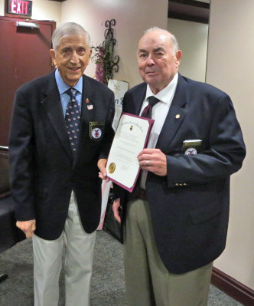
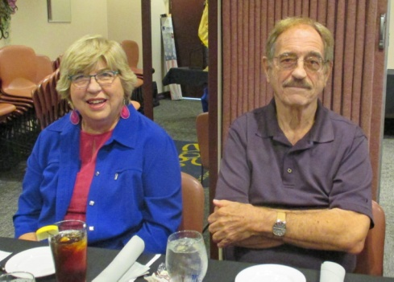
ELEVATION OF MEMBER: Joseph Leech was elevated to become a Perpetual Member of our chapter. Joe is experienced in the field of senior healthcare insurance, with special emphasis on military persons, and is quite willing to answer any questions a member of our chapter might have about the Medicare open enrollment period beginning on October 15th. Comprehending the alternatives available in Medigap coverage, the specific medical procedures covered and the cost thereof are quite complicated and overwhelming for the average person. Joe, at our request, agreed to share his knowledge in this field without any remuneration. For those who may have a desire to know a little more about the topic of integrating and including a Medicare Advantage Plan into their health insurance portfolio, Joe has written an article which may be accessed by copying and pasting into your Internet Web Browser the following URL (Uniform Resource Locator) address: https://leechent.com/TricarePlus.pdf. The article will give you a brief and critical overview of health insurance plans and assist you in understanding their availability.

VISITING GUEST: Rick and Janet Cummings, who currently live in California, were visiting guest of COL Reese . Rick is a retired Chemical Engineer and Janet is a Management Consultant. They plan to permanently relocate to Pittsburgh in the future.

NEW MEMBERS: Please extend to your officer friends an invitation to join our chapter or at lease join us at one of our luncheons. Merely advise COL Bob Reese of his or her particulars and he will handle the details.

ATTENDEES AT SEPTEMBER 2023 LUNCHEON:

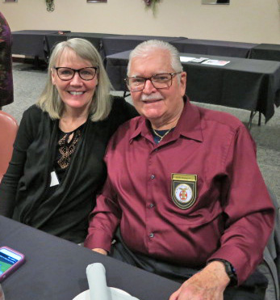
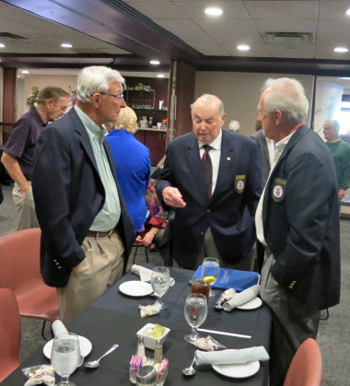
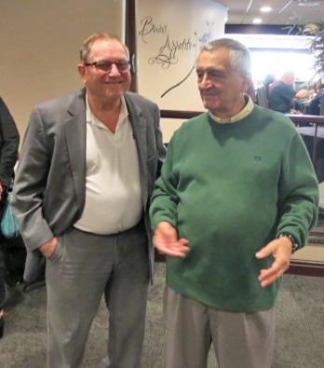

PITTSBURGH CHAPTER MOWW, BULLETIN #140, OCTOBER 17, 2023

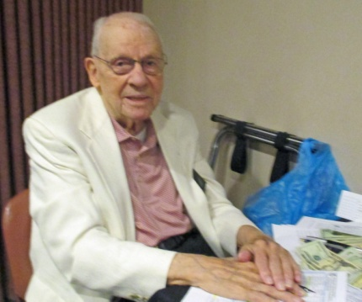
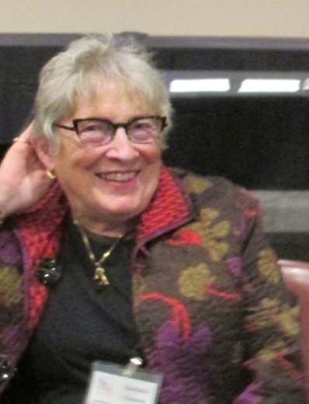
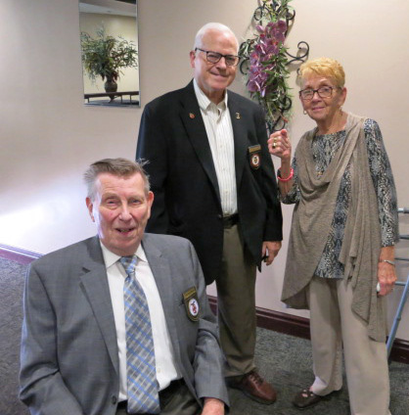
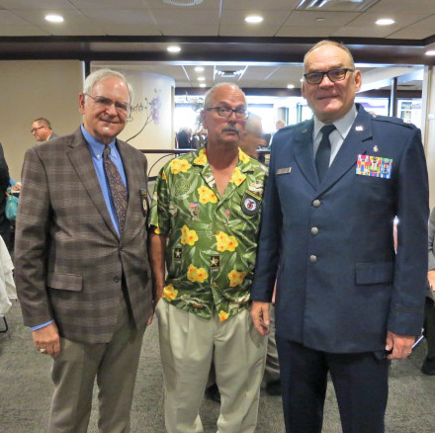
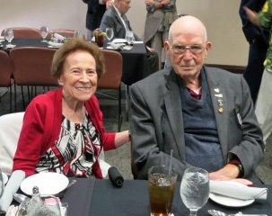

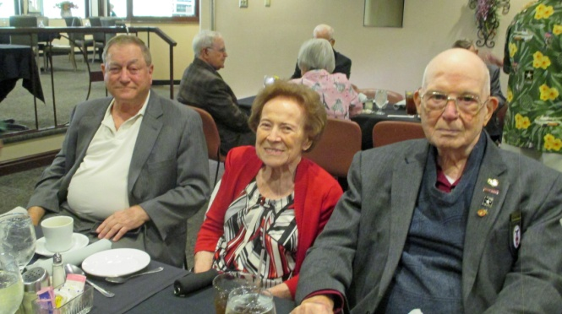
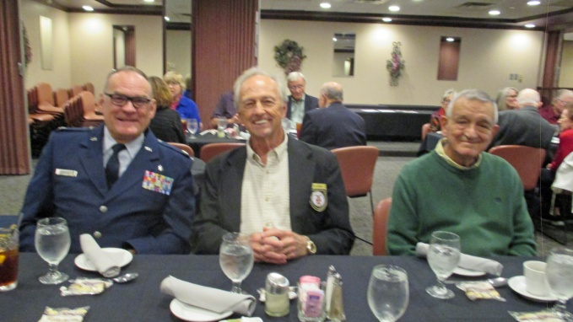

PITTSBURGH CHAPTER MOWW, BULLETIN #140, OCTOBER 17, 2023

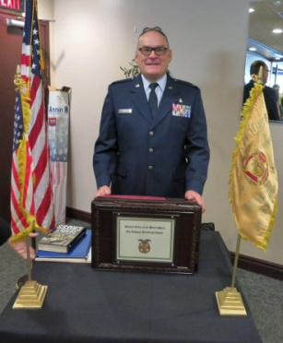
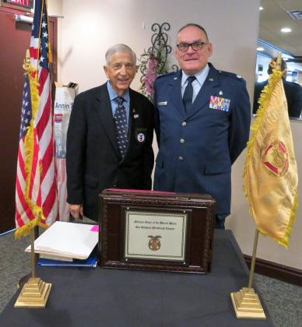
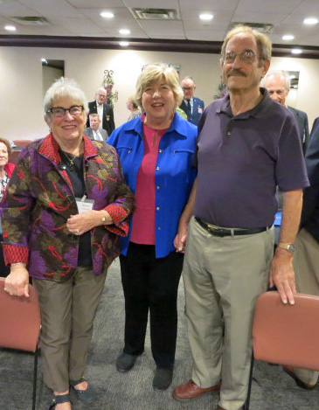

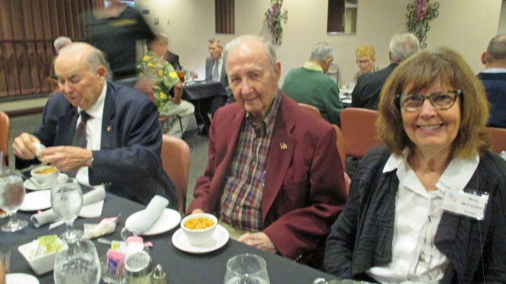
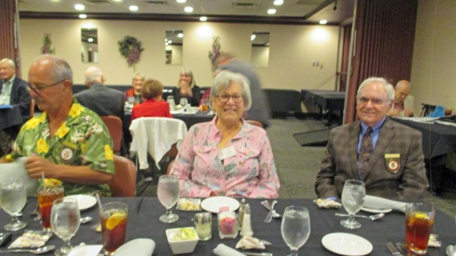

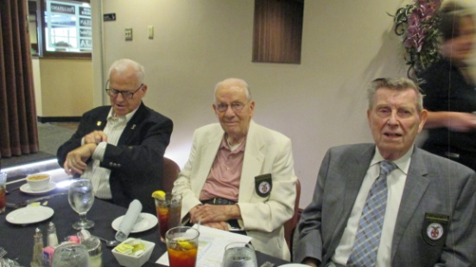

FUTURE LUNCHEON SCHEDULE: 11/14/23, 3/19/24, 4/16/24 and 5/21/24.

