
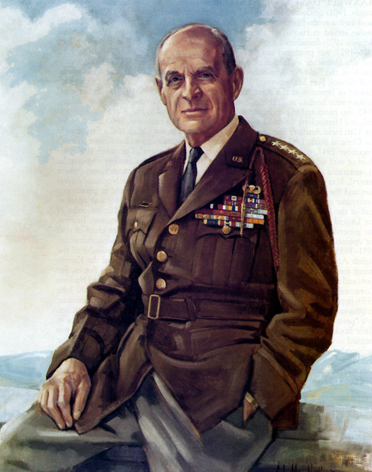

General Matthew B. Ridgway

Pittsburgh Chapter

THE MILITARY ORDER OF

THE WORLD WARS
(Website: http://mowwpgh.wixsite.com/mowwpgh)

Brig Gen Peter C. Bellisario
Commander
COL Robert L. Reese
Vice Commander & Adjutant
MG George V. Bauer
Chief of Staff & Treasurer

LTC Samuel Wilson
ROTC Awards
Colonel Paul A. Platek
Historian & Chaplain
Cpt Daniel McBride
Homeland Security
CAPT Karl D. Ludwig

Surgeon
LTC Gary Roberson
Scouting Programs
COL Richard Latshaw
Veterans Affairs
CAPT Paula Bozdech-Veater

Deployed Troops
LTC William Pentecost
Judge Advocate
MAJ John Skovran
Youth Ldrshp Prog

BULLETIN #111 LUNCHEON MEETING November 2018
Tuesday, November 20, 2018
Place: Scoglio’s Greentree Restaurant, Foster Plaza Building #7
Arrival Time: 11:30 a.m., Lunch to be served at 12:00 p.m.
Cost of full course meal, including gratuity, tax and guest speaker: $26.00

MENU: Broiled Boston Scrod, English Style. Chicken Romano will be available upon request for members not wishing to eat fish. Must specify upon making reservation.

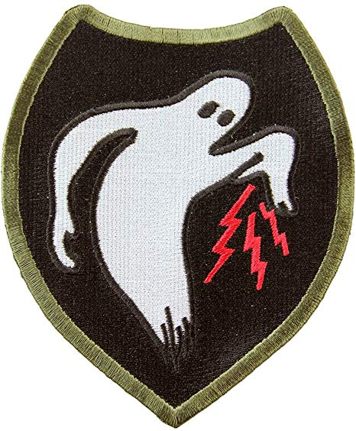
SPEAKER: During WW II the activities of the Ghost Army were classified “Top Secret”. COL George Ehringer, as our speaker, will delve into the evasive measures taken by the 23rd Special Troops Unit charged with carrying out the mission to impersonate other allied army units to deceive the enemy by means of a Ghost Army.

RESERVATIONS: It is ESSENTIAL that we advise the restaurant in advance of the number of meals. Please call or e-mail your reservation into Col Bob Reese at (412) 884-0208 or e-mail rlreese@comcast.net NLT SATURDAY the 16th of November. Significant others and guest are always welcome.

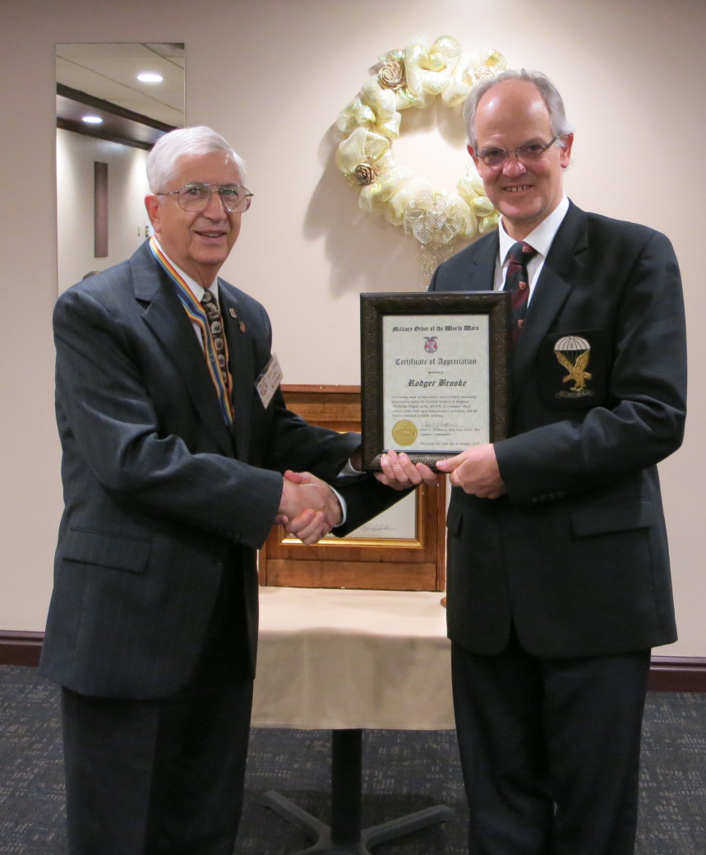
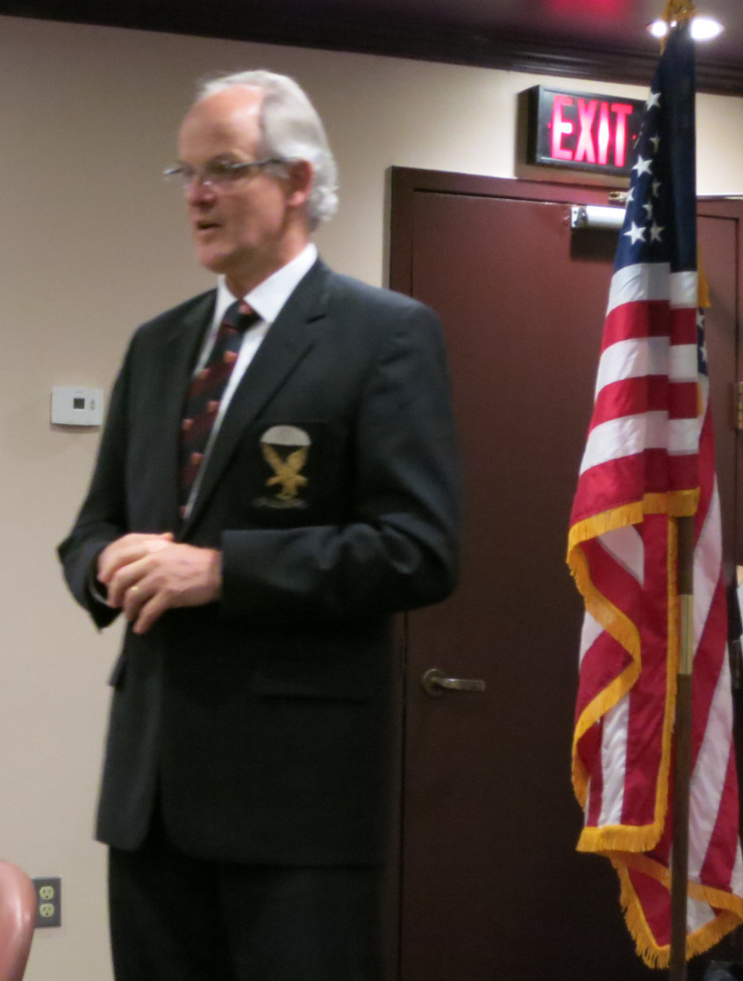
SEPTEMBER LUNCHEON SPEAKER: Professor Roger Brooke, of Duquesne University, spoke on what it means to be a leader in your community after serving in the military. He stressed the importance of passing on to the younger generation the attributes of sound judgment, conservatism and love of your community. He referred to President Jimmy Carter, Nelson Mandela and Field Marshall Jan Smuts who wrote the opening lines to the preamble to the United Nations, as examples of leaders who were concerned with humanitarian issues. Dr. Brooke was recently awarded the PA Psychological Association's Public Service Award for his service to veterans. He was presented with a "Certificate of Appreciation" from our chapter by Brig Gen Bellisario.

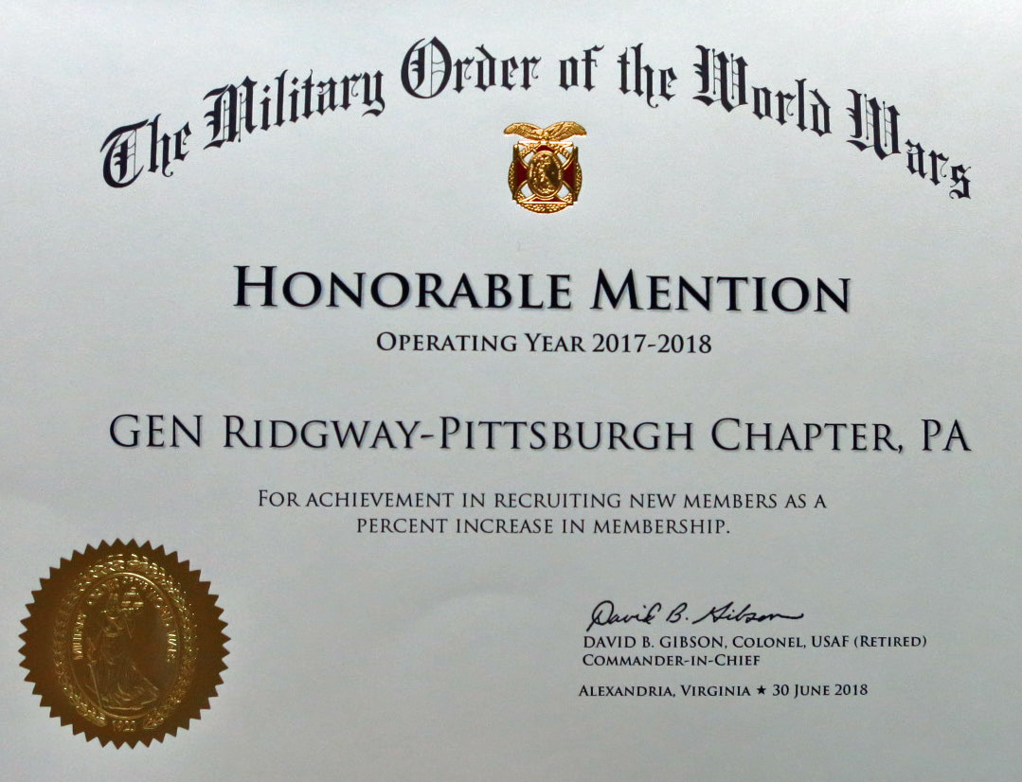
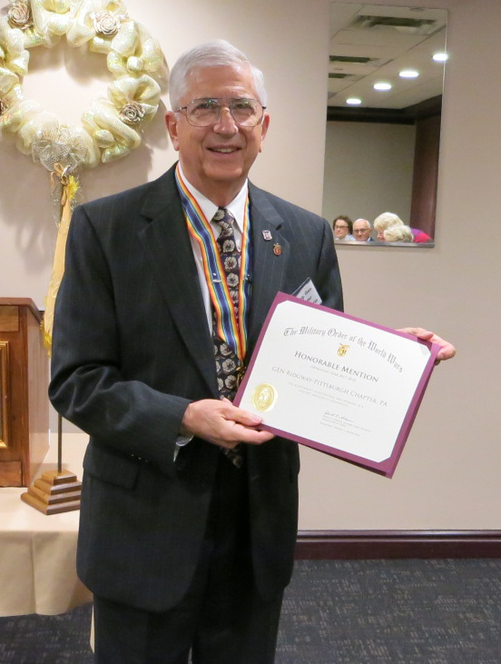
CHAPTER AWARD: The Pittsburgh Chapter was presented with an award by MOWW National Headquarter for its having met its recruiting objective during the Program Year ending in June of 2018.
Two new perpetual members were added during this time frame.

MOWW PITTSBURGH CHAPTER MONTHLY BULLETIN #111, NOVEMBER 2018

SEASON'S GREETINGS: Here is wishing each of you and your families a pleasant and enjoyable Thanksgiving and Merry Christmas. May the holiday season be filled with warmth, comfort and good cheer.

ATTENDEES AT OUR MAY LUNCHEON:

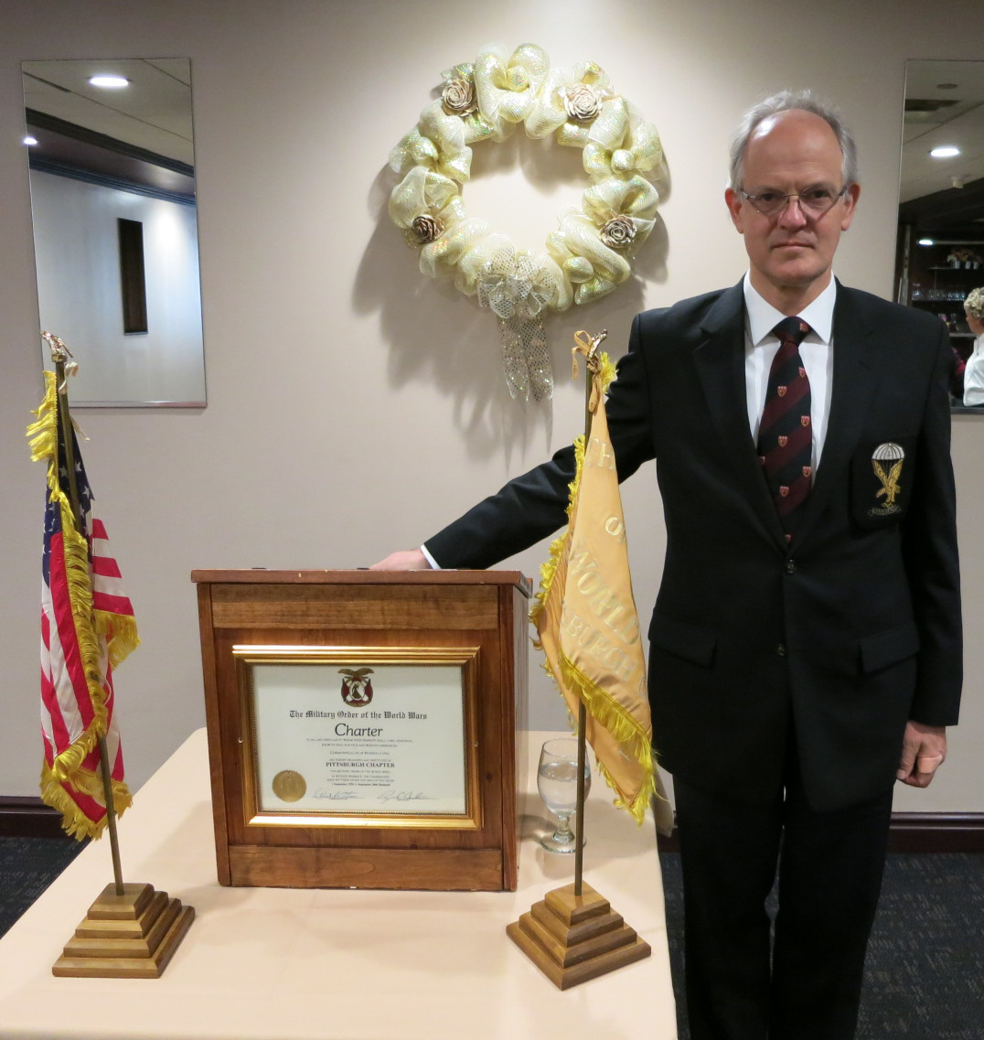
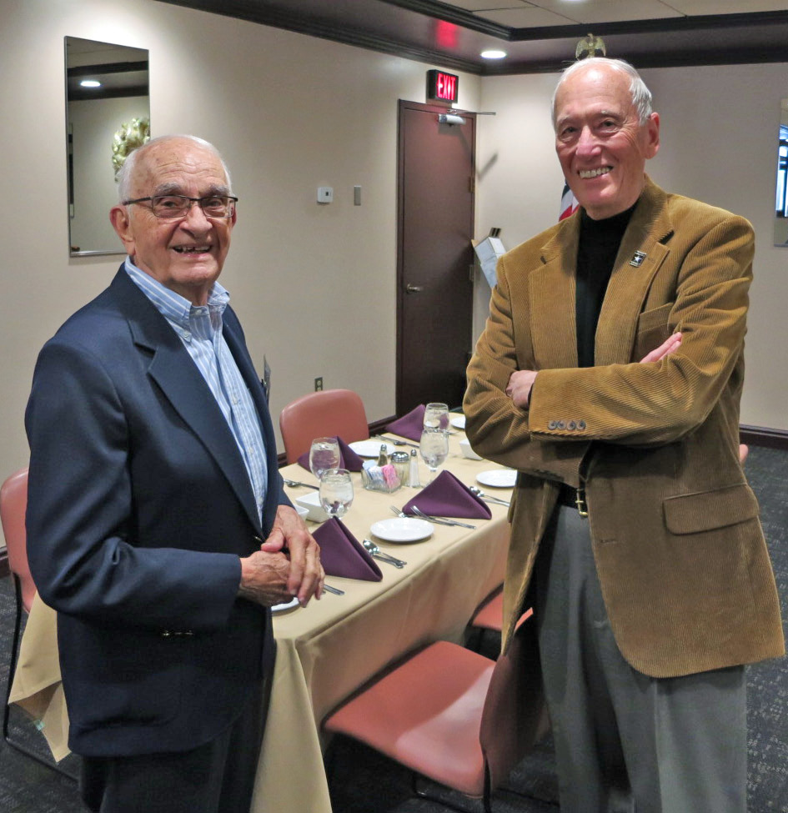
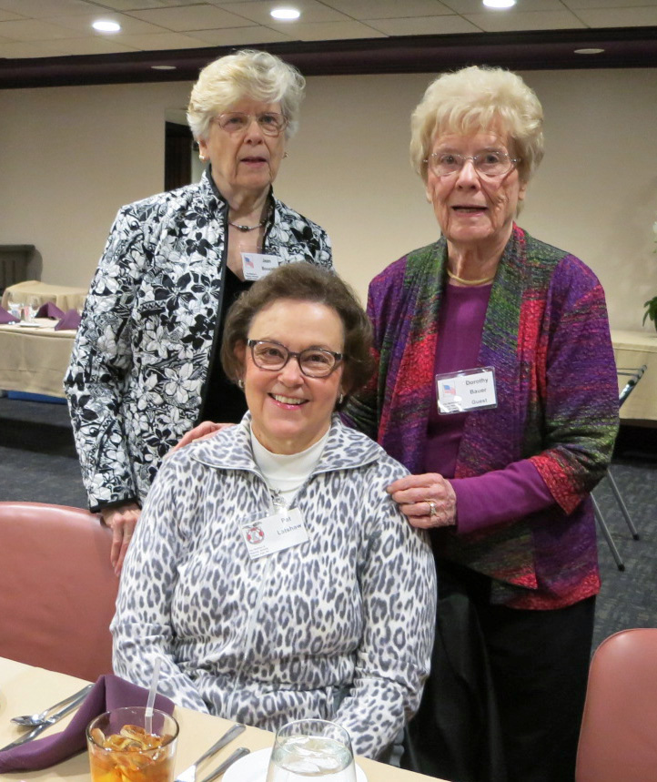

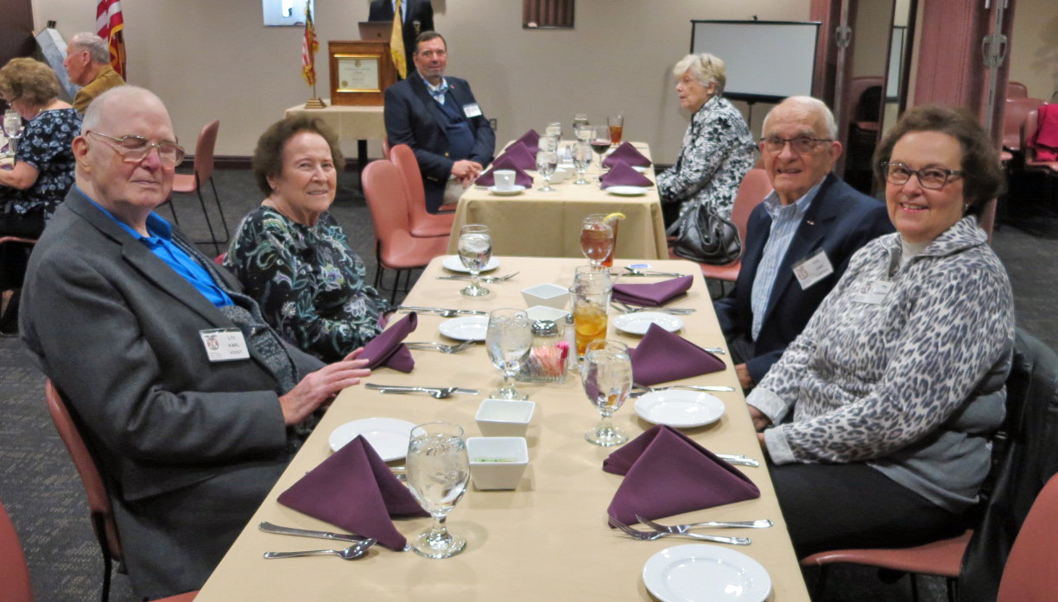
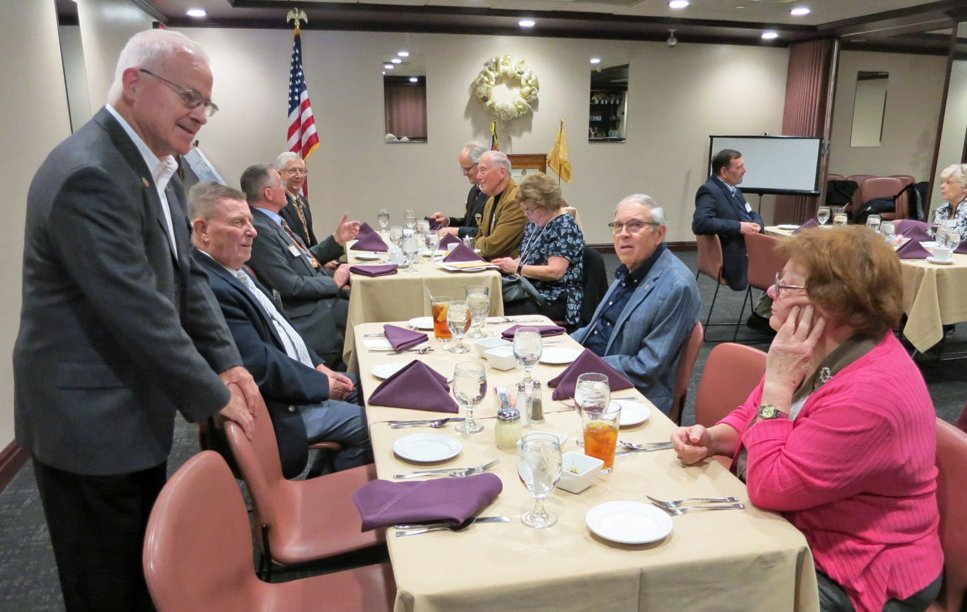
NEW CHAPTER BROCHURE: After 13 years of using the "New Member's Application" contained in our Chapter's brochure National MOWW Headquarters has advised us that we must use the "New Member's Application" contained in their brochure or in their website. Accordingly, we have revised our brochure to exclude the membership application and have included in that space a list of chapter officers. Copies of our previous brochure should be destroyed. Copies of National's and our brochure may be obtained from Brig Gen Bellisario or COL Reese.

WHY DO WE SAY IT: Why is the college degree called a "bachelor's" degree. Because originally a "bachelor" was a soldier not old enough or rich enough to lead his retainers into battle under his own banner. Therefore, the word meant a person of inferior rank. It was applied to the college degree in order to differentiate it from the higher degree of "doctor."

Why do we use the term "take a back seat" when referring to a lesser position? Because those members of the British Parliament who belong to the majority party take front seats. Those who are in the minority "take a back seat", either of their own accord or because they are told to do so.

The following luncheon meetings have been scheduled for the remainder of the program year 2018-19:
(Meetings are scheduled on Tuesdays and are held at Scoglio’s Greentree Restaurant, unless changed)
Dec 2018 thru Feb 2019 No meetings. Mar 19, 2019, April 30, 2019, May 21, 2019 (Installation of Officers)

