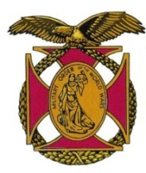
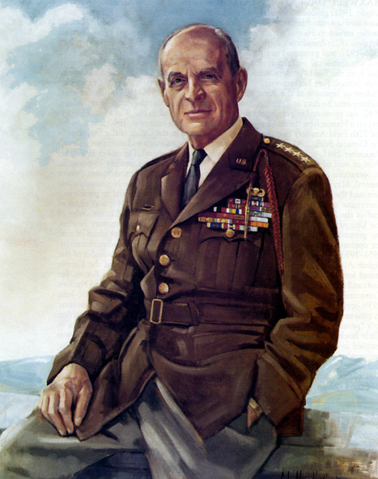

BG Peter C. Bellisario

Commander

COL Robert L. Reese

Vice Commander, Adjutant & Editor

MG George V. Bauer

Chief of Staff & Treasurer

LTC Samuel Wilson

ROTC Awards

COLCarmenDiGiacomo

Chaplain
CAPT Karl D. Ludwig

Surgeon
LTC Gary Roberson
Public Relations
COL Richard Latshaw
Veterans Affairs
CAPT Paula Bozdech-Veater

Deployed Troops
LTC William Pentecost
Judge Advocate
MAJ John Skovran
Youth Ldrshp Prog
LTC Charles Chasler
Scouting

Bulletin #142
Mar 2024
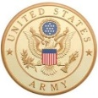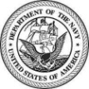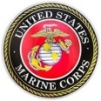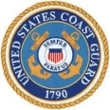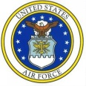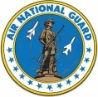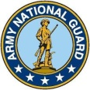

Website: https://mowwpgh.wixsite.com/moww

LUNCHEON MEETING

Tuesday, March 19, 2023

Place: Scoglio’s Greentree Restaurant, Foster Plaza Building #7

Arrival Time: 11:30 a.m., Lunch to be served at 12:00 p.m.

Cost of full course meal, including gratuity, tax and guest speaker: $30.00

MENU: Chicken Breast Valdostana.

LUNCHEON SPEAKER: Cadets who attended the Freedom Foundation will present their essays on what they learned as a result of having attended the Spirit of America Conference.

RESERVATIONS: It is ESSENTIAL that we advise the restaurant in advance of the number of meals. Please call or e-mail your reservation into MG George Bauer at (412) 848-9302 or e-mail jordieb@verizon.net NLT THURSDAY the 15th of March. Significant others and guest are always welcome. If for some reason, at the last minute, you cannot attend the luncheon after having made a reservation please call Scoglio's at (412) 921-1062.

NOVEMBER'S SPEAKER REVIEW: Richard DiGiacomo, Attorney at Law, presented the argument that in order to have a working society a country must have a set of rules by which everyone is governed and in the case of the United States it is the U. S. Constitution or as DiGiacomo put it "The Rule Book." The United Kingdom is one of only five countries without a written constitution, along with Saudi Arabia, New Zealand, Canada and Israel. In the case of the United Kingdom it is ruled by the House of Commons, which formally scrutinizes the Government through its Committees and the questioning of the Prime Minister each Wednesday. Its members are elected by the people and pass laws whereas the House of Lords are appointed and scrutinize legislation, holds the government to account and considers and reports upon public policy. In the case of the United States we have adopted a Constitution which is the nation's fundamental law. It codifies the core values of the people. Courts have the responsibility to interpret the Constitution's meaning, as well as the meaning of any laws passed by Congress. In effect a constitution is the Rulebook for a country's government. The constitution explains what kind of government a country has and how that government functions. It also tells us how a country's laws are made, and it explains the rights and responsibilities of citizens. Rich DiGiacomo went on to explain the preamble to the constitution, which is quoted as follows:

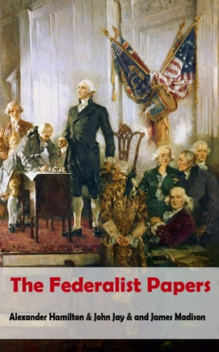
"We the People of the United States, in Order to form a more perfect Union, establish Justice, insure domestic Tranquility, provide for the common defense, promote the general Welfare, and secure the Blessings of Liberty to ourselves and our Posterity, do ordain and establish this Constitution for the United States of America."

Alexander Hamilton played a key role in the adoption of the US Constitution and pointed out its importance to national security. Although the Constitution, as written, differed from his vision, Hamilton thought it "better than nothing," particularly when he compared it to the inadequate Articles of Confederation that were then in effect. He urged every delegate to sign the document. Hamilton's accomplishments included (a) he was a founding father, (b) he served as the first Secretary of the Treasury, (c) he established the First Bank of the United Sates, (d) he advocated for industrial and economic development, (e) he implemented a revenue system through tariffs and taxes, and (f) he implemented a revenue system through tariffs and taxes.

Hamilton published a series of 85 essays known as the Federalist Papers defending the proposed Constitution

PITTSBURGH CHAPTER MOWW, BULLETIN # 142, MARCH 2024

and explaining in detail its principles, thus showing his support of a Rule Book to govern the people.

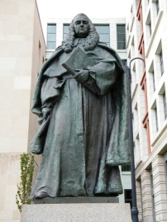
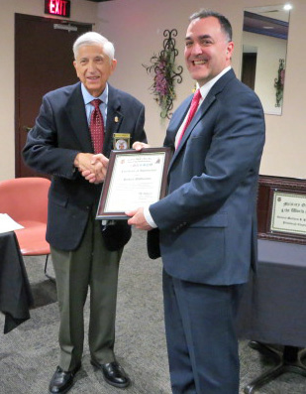
DiGiacomo turned his attention to the Blackstone Ratio as an example of following the Rule Book. William Blackstone was a preeminent English jurist who wrote in one of his opinion "It is better that 10 guilty persons escape than that one innocent suffer?", thus we presume an accused person's innocence until they are proven guilty. This principle can also be found in religious text and in the writings of the American Founders. Blackston's statue is located at Constitution Ave & 3rd St NW, Washington, DC.

Another example of "The Rule Book's" importance may be found in the Supreme Court ruling in the case of Marbury vs Madison (1803) which established the principle of judicial review, that is, the power of federal courts to declare legislative and executive acts unconstitutional. The unanimous opinion was written by Chief Justice John Marshall represented a major clarification in the Rules that the courts play in our judicial system. Richard DiGiacomo was presented with a Certificate of Appreciation for his outstanding presentation. The above summary includes editorial additions.

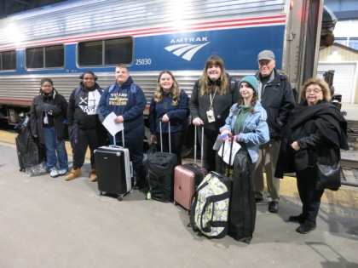
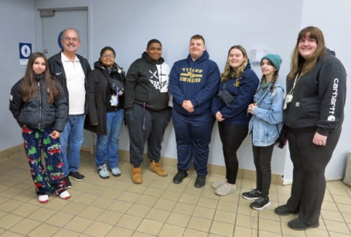
CADETS DEPARTURE FOR VALLEY FORGE: It was a cold dreary morning at 6:30 am on Thursday the 29th of February when CAPT Bozdech-Veater, LTC Chasler and COL Reese arrived at the AmTrak Train Station to see six cadets and their Chaperone, MAJ Skovran, depart for the Freedom Foundation at Valley Forge. Much to our surprise their were an estimated 50 to 60 passengers waiting to board the train at 7:30 am. The Station Master allowed our group to board first which gave us an opportunity for photographs. The six Cadets included Cadets Nyambe and Mobley from Perry Academy, Cadets Mannella and Michalski from West Mifflin High School and Cadets Brandyberry and Straubaugh from West Allegheny High School. Cadet Straubaugh was accompanied by her mother, Amy Stakeley, who planned on joining her daughter at Valley Forge. SFC Holtz, Instructor at Perry Academy, escorted his two cadets to the AmTrak Station. In addition, as in the past MAJ Skovran's granddaughter accompanied him to the Freedom Foundation. The Cadets were given a $20 per diem allowance and invited to attend our March 19th luncheon at which time they would present their essays on what they learned at the Freedom Foundation. It was later disclosed that the AmTrak Train had a three hour delay in arriving at the Philadelphia Station due to engine problems, which added to the normal eight hour trip.

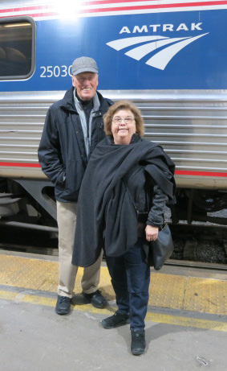

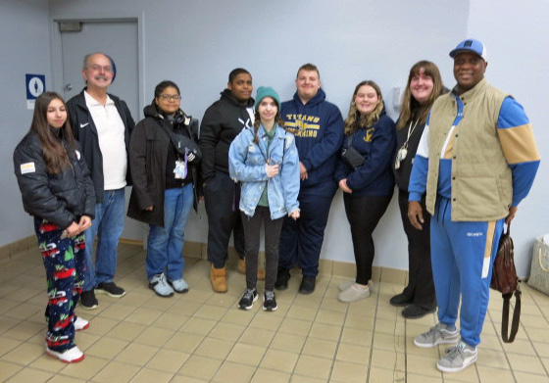

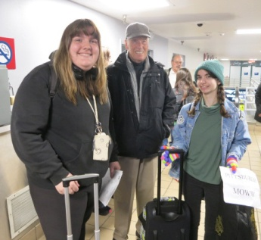
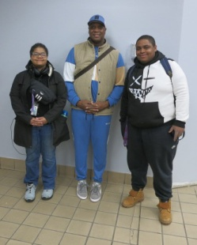

PITTSBURGH CHAPTER MOWW, BULLETIN # 142, MARCH 2024
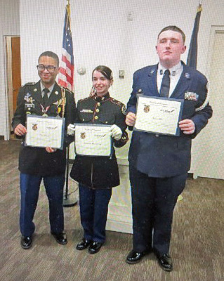

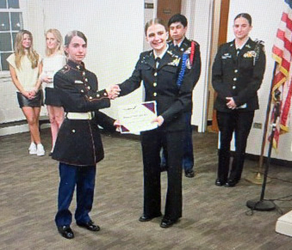
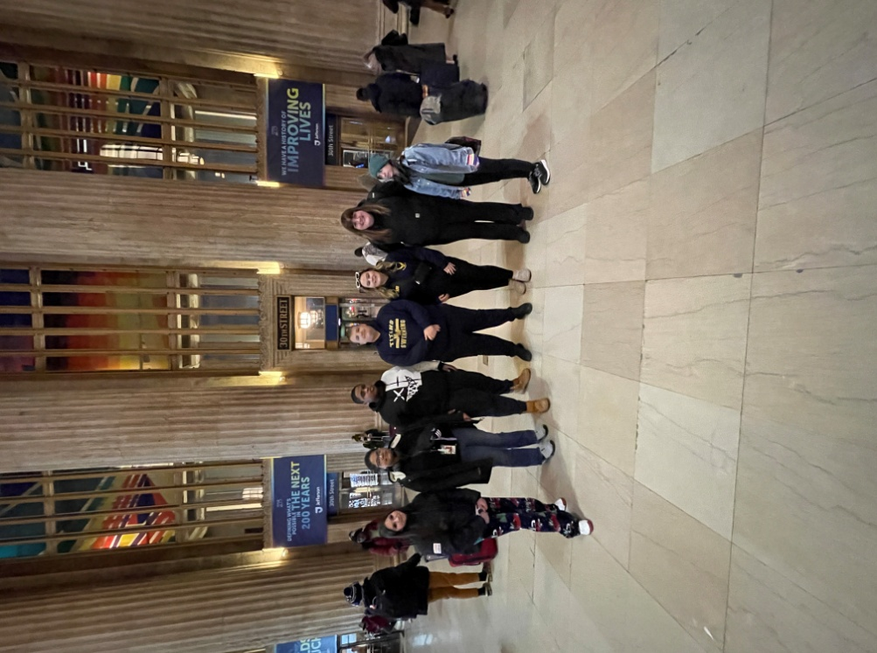
PHOENICIAN ESSAY CONTEST: Cadet Samantha Brandyberry from West Allegheny HS was one of three Cadets awarded the "Pillar of Participation" Award for outstanding student involvement. This will make her eligible to participate in the MOWW Phoenician Essay competition which would result in a cash reward. This contest is an annual patriotic-themed essay contest based on a thought-provoking subject of national interest and requiring a student to take a position and defend it. The contest is open to the top three students of each YLC held in the preceding 12-month period. Samantha was one of 57 students to attend the Spirit of America Youth Conference.

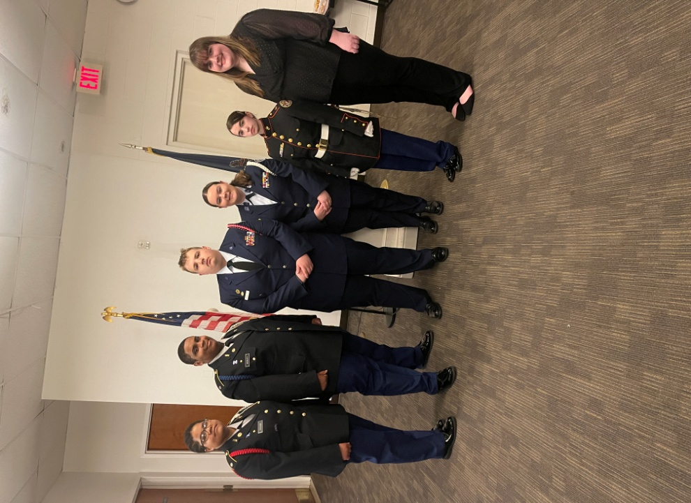
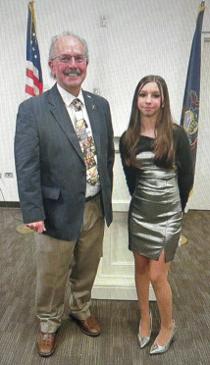
THE CHAPERONE'S CORNER BY MAJ SKOVRAN: From Amtrak’s extended train travel to Independence Hall, the Pittsburgh cadets were rewarded with a visit to historic Philadelphia to celebrate a weekend filled with opportunities to learn, make friends and exchange ideas thanks to the General Ridgway Chapter of the MOWW. Our group was led by the winner of the Outstanding Cadet Award, Cadet Brandyberry of West Allegheny HS. After settling into their dorms and enjoying a well cooked meal, the cadets received an overview of what to expect then closed the evening with a challenging game of Constitutional Jeopardy. The cadets were introduced to Thomas Jefferson and Congressional procedures before taking a short tour of Washington’s encampment at Valley Forge. Upon return to the Freedom’s Foundation they listened to Ben Franklin discuss the Declaration of Independence before they had the opportunity to sign their own copy. Before heading around Horseshoe Curve for home, cadets got to visit the Liberty Bell and spend some change at the souvenir store. They expressed their gratitude to the MOWW for this wonderful opportunity.

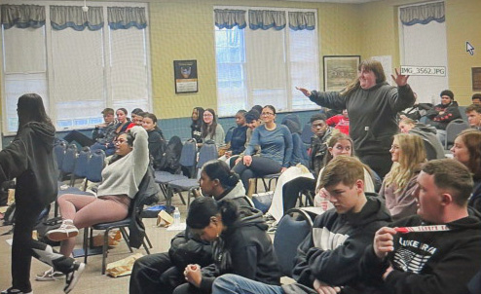

MEMBERS AND GUEST ATTENDING OUR NOVEMBER 2023 LUNCHEON:
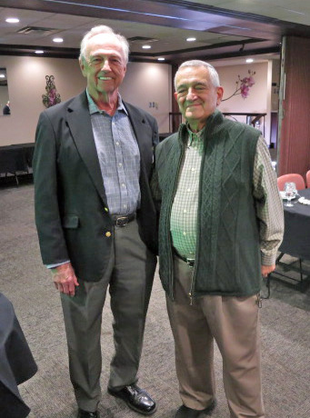
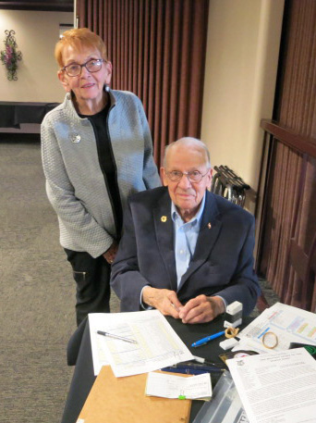
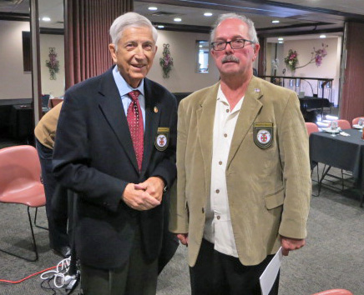
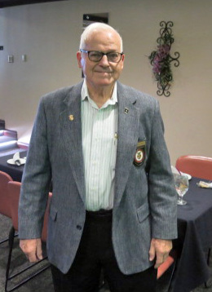

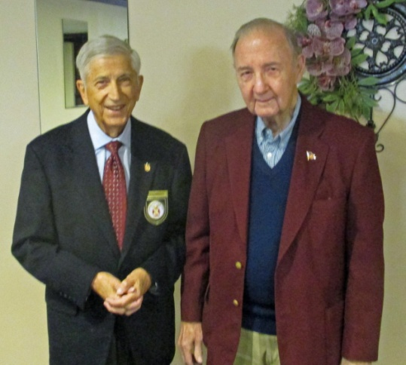
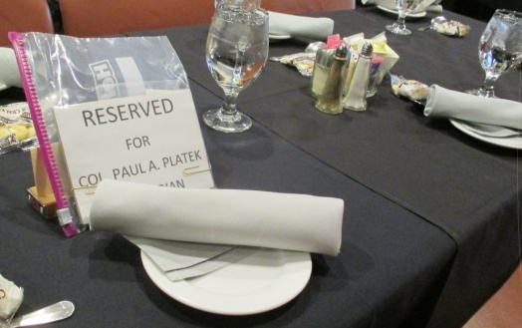

.

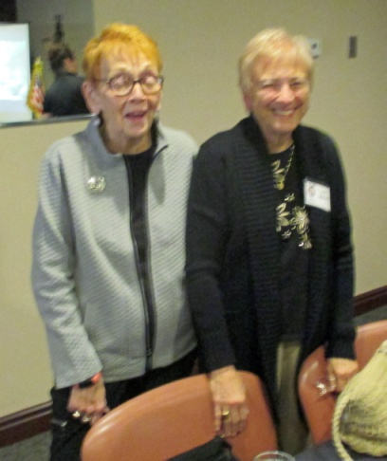
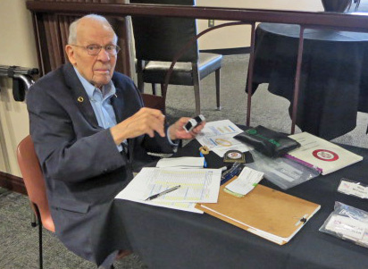
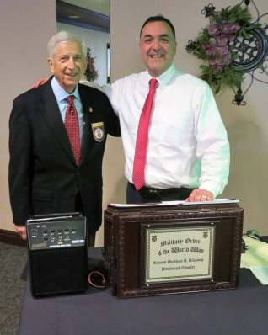
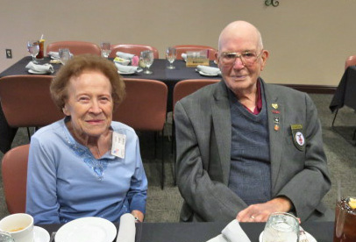

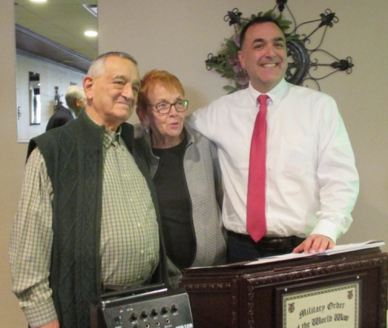
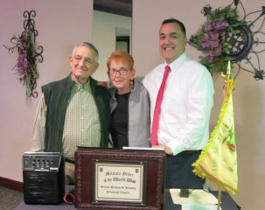

PITTSBURGH CHAPTER MOWW, BULLETIN # 142, MARCH 2024

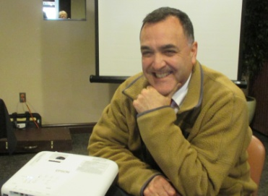
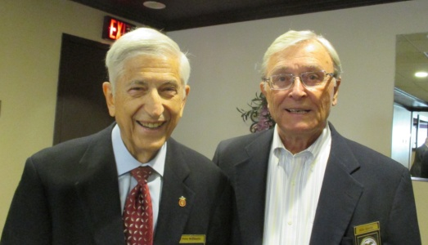


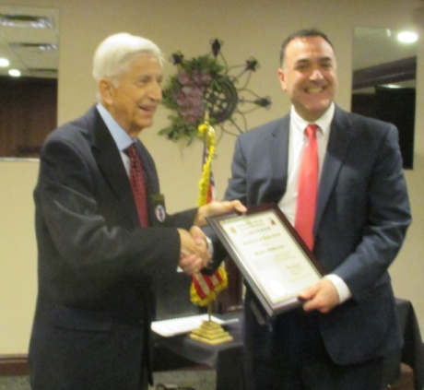
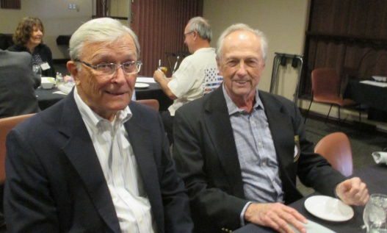
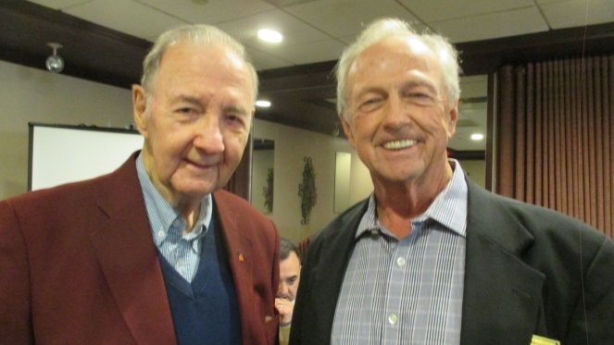

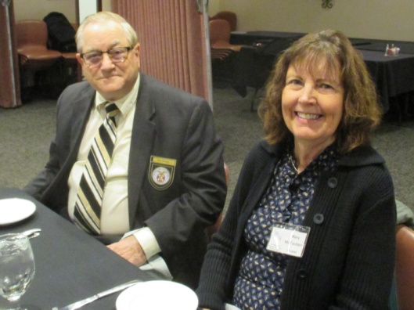
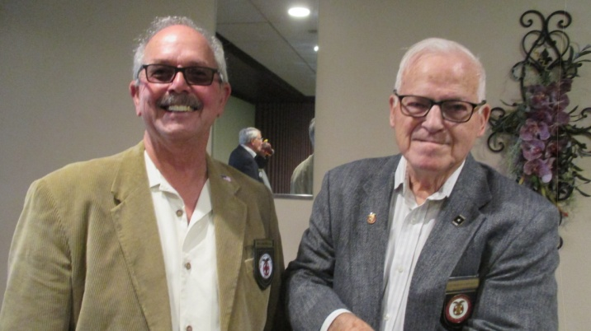

FUTURE LUNCHEON SCHEDULE: 4/16/24 and 5/21/24

