

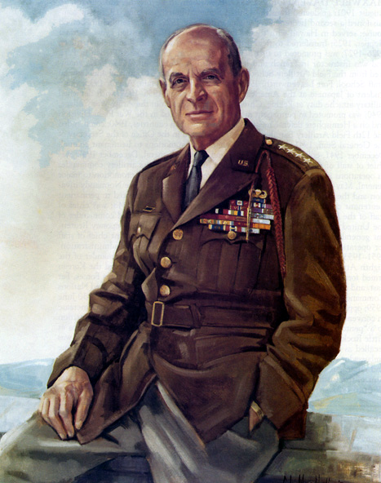

|  |
| --- |
| COL George D. Ehringer *Commander*  *COL Robert L. Reese*  *Vice Commander, Adjutant & Editor*  *MG George V. Bauer*  *Chief of Staff & Treasurer* LTC Samuel Wilson *ROTC Awards*  *COLCarmenDiGiacomo*  *Chaplain*  *CAPT Karl D. Ludwig* Surgeon ***LTC Gary Roberson***  *Public Relations*  ***CAPT Paula Bozdech-Veater*** Speakers ***LTC William Pentecost***  *Judge Advocate*  ***MAJ John Skovran***  *Youth Ldrshp Prog*  ***LTC Charles Chasler***  *Scouting*  ***LTC Tim Young***  *Veterans Relations*  ***Joan Bellisterio***  *Photographer* |

Bulletin #155

April 2025



Website: https://mowwpgh.wixsite.com/moww

LUNCHEON MEETING

Tuesday, April 15, 2025

Place: Gianna Via Restaurant & Bar in Caste Village Shopping Center.

Arrival Time: 11:30 a.m., Lunch to be served at 12:00 p.m.

Cost of full course meal, including gratuity, tax and guest speaker: $30.00

MENU SELECTION: Attendees will have the option to select one of two Entrees each of which include Wedding Soup, Coffee, Tea or Soda and Ice Cream, as follows:

A. Chicken Parmesan, breaded chicken topped with marinara & cheese served atop linguini.

B. Tuna Salad Sandwich, Swiss cheese, lettuce, tomato and onion on grilled Italian bread.

SPEAKER: Thomas Stabile, a former National Football League Referee, all American Baseball player, Educator and Coach will speak before our Group about his experience as a National Football League Referee.

## RESERVATIONS: We must advise the restaurant in advance of the number and kind of meals. Please call or e-mail your reservation into MG George Bauer at (412) 848-9302 or e-mail jordieb@verizon.net NLT FRIDAY the 11th of March. Significant others and guest are always welcome. If for some reason, at the last minute, you cannot attend the luncheon after having made a reservation please call the restaurant on (412) 882-6500, COL Reese at (412) 312-9833 or General Bauer.

YOUTH LEADERSHIP PROGRAM: The students who attended the Founding Forward Foundation, formerly known as the Freedom Foundation, presented their essays on what they learned having attended a four day conference titled the Spirit of America. Although, the speaking conditions were not ideal the Cadets did an admirable job of presenting their essays. The Cadets were presented with Certificates of Appreciation and each of the three schools sending Cadets to the Conference were presented with an Honor Roll Certificate which listed the names of Cadets who attended the Conference since 2004. Members of our Chapter were called upon to present the Cadets with their certificates. Major Skovran, served as Master of Ceremonies and did an outstanding job of maintaining control over the program, since there were a number of unanticipated events that occurred. He also served as Chaperone to the Cadets during their toure. Also, in attendance was JROTC Instructor SFC John Holtz from Perry Academy and GySgt Robert Rainis from West Allegheny High School.

## C:\Adobe Elements Photos\MOWW Youth Prog 2025\MOWW YLP 2025 04-09.JPGC:\Adobe Elements Photos\MOWW Youth Prog 2025\MOWW YLP 2025 04-02.JPGC:\Adobe Elements Photos\MOWW Youth Prog 2025\MOWW YLP 2025 04-01.JPG

## C:\Adobe Elements Photos\MOWW Youth Prog 2025\MOWW YLP 2025 04-07.JPG

PITTSBURGH CHAPTER MOWW, Bulletin #155, April 2025.

MILITARY IDENTIFICATION CARD: The Department of Defense requires all military retirees to replace their old-style Uniformed Services Identification (USID) cards by the end of 2025. The old-styled military cards will no longer be accepted for access to benefits, privileges or military installations. One alternative, Retirees can visit their nearest DEERS/ID (Defense Enrollment Eligibility Reporting System/ID) Card Office to obtain a replacement card. In all cases an advanced appointment is mandatory and two forms of identification are required, such as a drivers license, passport, birth certificate, old-styled military card, etc.

One such office is located in the vicinity of the 316th Sustainment Command on 99 Soldiers Lane, Moon Township, PA 15108, which has on display an "ID Card" office sign. The POC is Dawn Cronin, CAD/DEERS Operator, who may be reached on telephone (910) 598-7350 or (412) 604-8319.

A second DEERS/ID Office is the 911th Airlift Wing, Pittsburgh International Airport Air Reserve Station, located in Building 316, Room 20, Pittsburgh ARS, PA 15108. Open Monday thru Friday, 7:30 am to 3 pm.

Phone numbers (412) 474-8526, (412) 893-1593 and (910) 598-7350.

A third DEERS/ID Office is the 171st Air National Guard, Pittsburgh International Airport Air Reserve Station, located on 300 Tankers Road, Coraopolis, PA 15108. Open Monday thru Friday, 7:00 am to 4 pm.

Phone numbers (412) 776-7485.

A fourth DEERS/ID Office is located with the the 301st RSG, 360 Evans City Road, Butler, PA 16001. Telephone (724) 287-8044.

A fifth DEERS/ID Office is located with the PA Army National Guard, 2nd BCT, located at 125 Goodridge Lane, Washington, PA 15301. POC SFC Holly Dami, telephone (724) 223-4572.

A second alternative is to request a replacement card over the Internet, which requires the creation of a DS Logon Account in order to access the DEERs/ID software. DS Logon requires you to photograph two sides of your selected ID document, for example your Driver's License. This alternative will be quite demanding if you have limited computer skills. You may start the process by going to Google and entering, ID Office on line.

This information was downloaded from the Internet and should be validated when talking with the DEERS/ID POC.

ELECTION OF CHAPTER COMMANDER AND KEY STAFF MEMBERS: The membership in attendance shall elect a Chapter Commander, Vice Commander & Adjutant, Chief of Staff & Treasurer for the coming Program Year, which will begin on July 1st, 2025. Other Staff Members shall be appointed by the Commander.

YOUTH PROGRAM: Below are photos of Cadets displaying Certificates of Appreciation for having presented an essay on what they learned, having attended the Spirit of America Youth Conference. Also, pictured are attendees at our luncheon held on March 18th and pictures taken at the Founding Forward Foundation at Valley Forge.

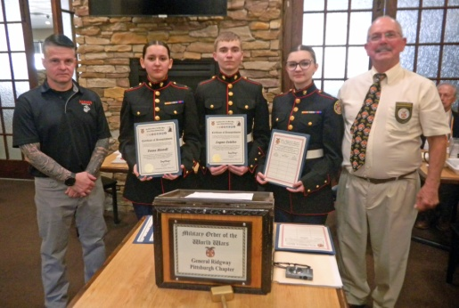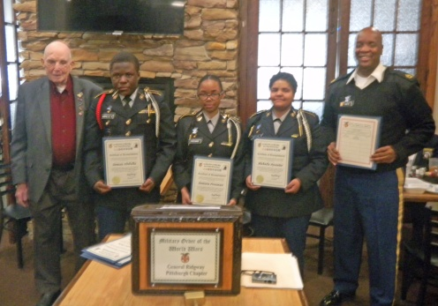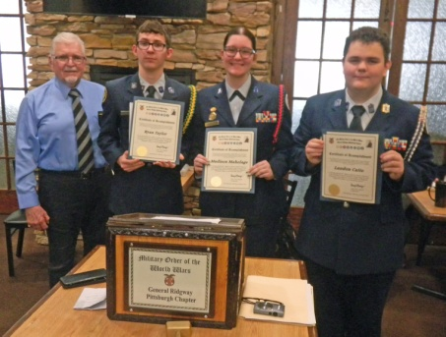

PITTSBURGH CHAPTER MOWW, Bulletin #155, April 15, 2025.

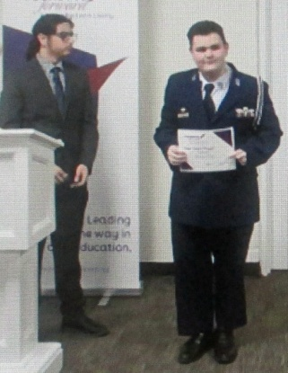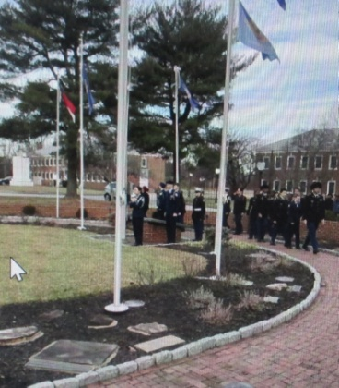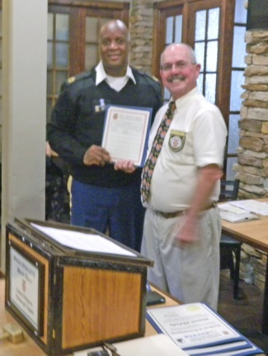

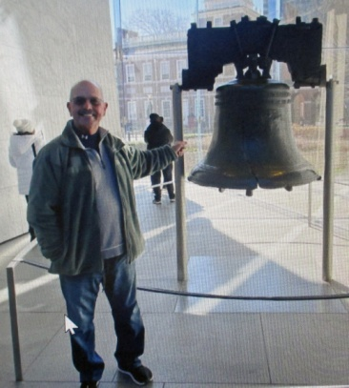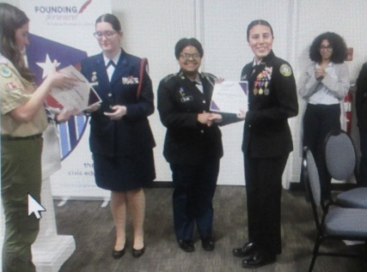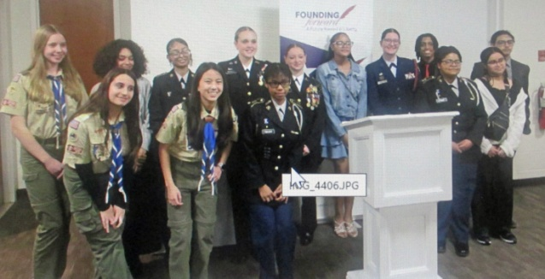

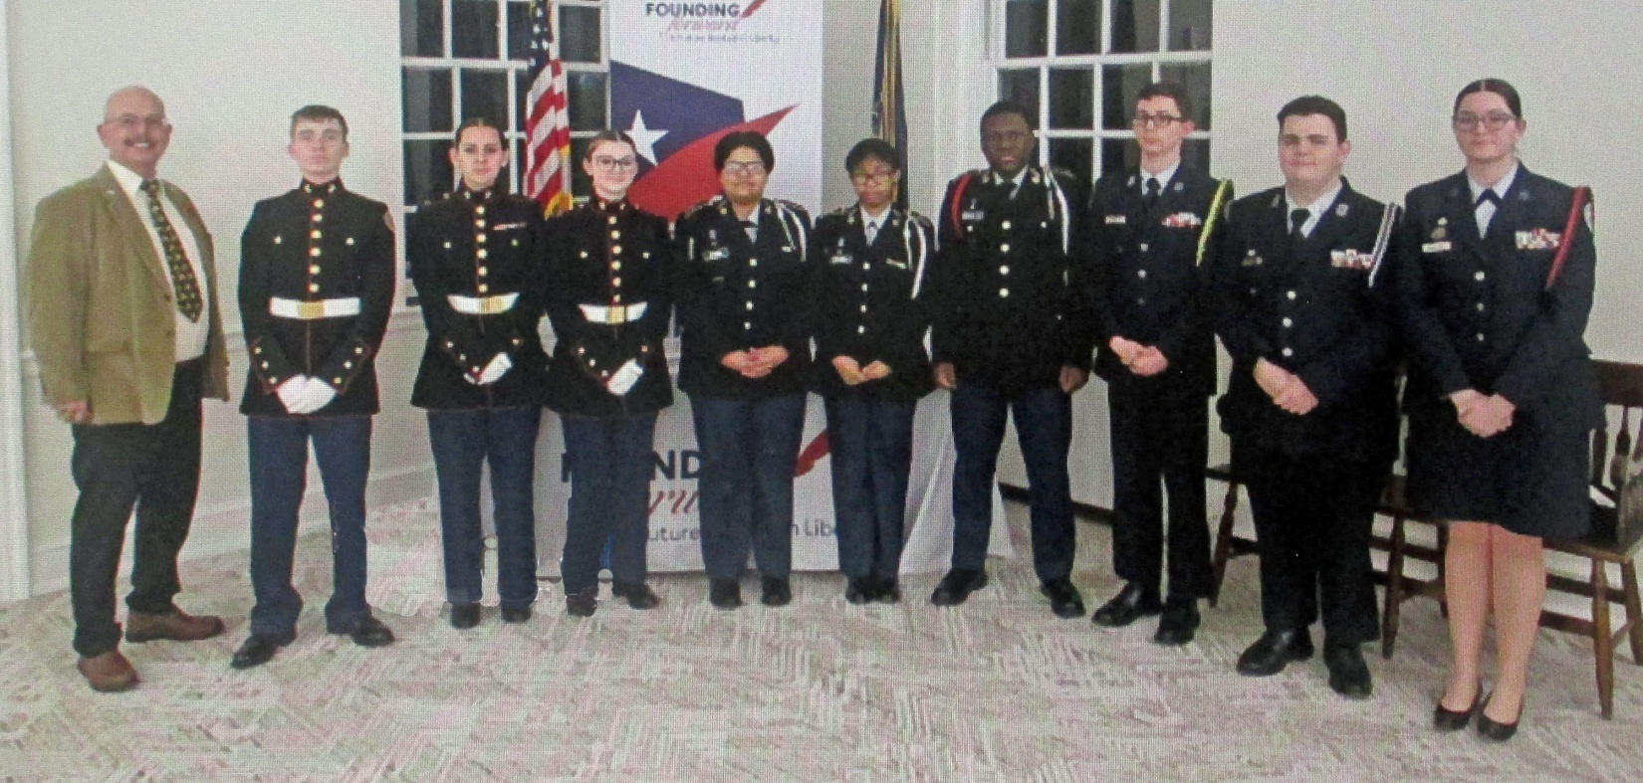

NEXT MEEING: May 20th 2025. Next meeting for program year 2025/26 will begin in September 2025.