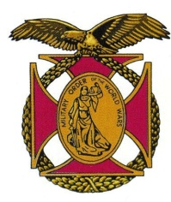
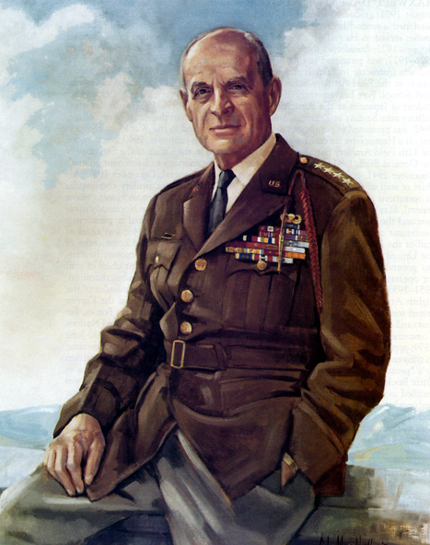
The Military Order of the World Wars
Gen Ridgway Pittsburgh Chapter

Brig Gen Peter C. Bellisario
Commander
COL Robert L. Reese
Vice Commander & Adjutant
MG George V. Bauer
Chief of Staff & Treasurer

LTC Samuel Wilson
ROTC Awards
Colonel Paul A. Platek
Historian & Chaplain
CAPT Karl D. Ludwig

Surgeon
LTC Gary Roberson
Scouting Programs
COL Richard Latshaw
Veterans Affairs
CAPT Paula Bozdech-Veater

Deployed Troops
LTC William Pentecost
Judge Advocate
MAJ John Skovran
Youth Ldrshp Prog

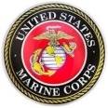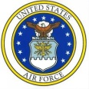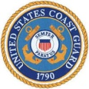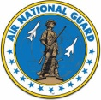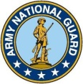
Bulletin # 120
September 2020

Website: http://mowwpgh.wixsite.com/mowwpgh

LUNCHEON MEETING
Tuesday, September 15, 2020
Place: Scoglio’s Greentree Restaurant, Foster Plaza Building #7
Arrival Time: 11:30 a.m., Lunch to be served at 12:00 p.m.
Cost of full course meal, including gratuity, tax and guest speaker: $26.00

MENU: Broiled Spots English Style. Chicken Romano will be available upon request for members not wishing to eat fish. Attendee must specify upon making reservation.

SPEAKER: MAJ John Skovran, former JROTC Senior Instructor at Valley High School and member of our Chapter, will provide us with some insights into the JROTC program and how it functions within high schools.

RESERVATIONS: It is ESSENTIAL that we advise the restaurant in advance of the number of meals. Please call or e-mail your reservation into Col Bob Reese at (412) 884-0208 or e-mail rlreese@comcast.net NLT SATURDAY the 12th of September. Significant others and guest are always welcome. If for some reason you cannot attend a luncheon after you have made a reservation please call Scoglio's at (412) 921-1062.

COVID19 COMPLIANCE: We must comply with the seating arrangements of the restaurant and customers must wear face masks, except when seated to eat, both of which are mandated by the government.

YOUTH PROGRAM: Due to the Covid19 virus our chapter has elected not to sponsor sending students to the Youth Conference hosted by the Freedom Foundation, which was rescheduled to take place on the 29th of October 2020. Donations made by our membership during the fourth quarter of 2019, in support of our Youth Program, will be used for the 2021 Youth Program; therefore, solicitation of funds this year will not be necessary.

PITTSBURGH CHAPTER WEBSITE: The chapter website now includes links whereby you can access Chapter bulletins dating back to March of 2016 as well as a link to our Chapter's history. The website may be launched with URL http://mowwpgh.wixsite.com/mowwpgh.

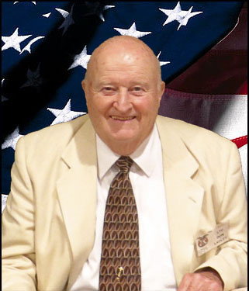
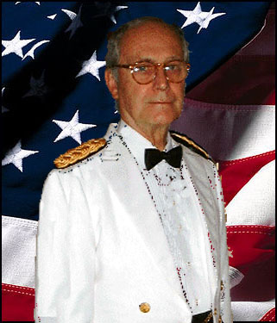
CERTIFICATES OF DEDICATION: Certificate of Dedication have been mailed to the two longest serving officers in our chapter, namely, LTC Donald Ladley, who has been a member for 41 years and COL John Schano, who has been a member for 40 years. In the near future other officers will be recognized for their longevity with our chapter. Both officers served as Chapter Commanders during their tenure.

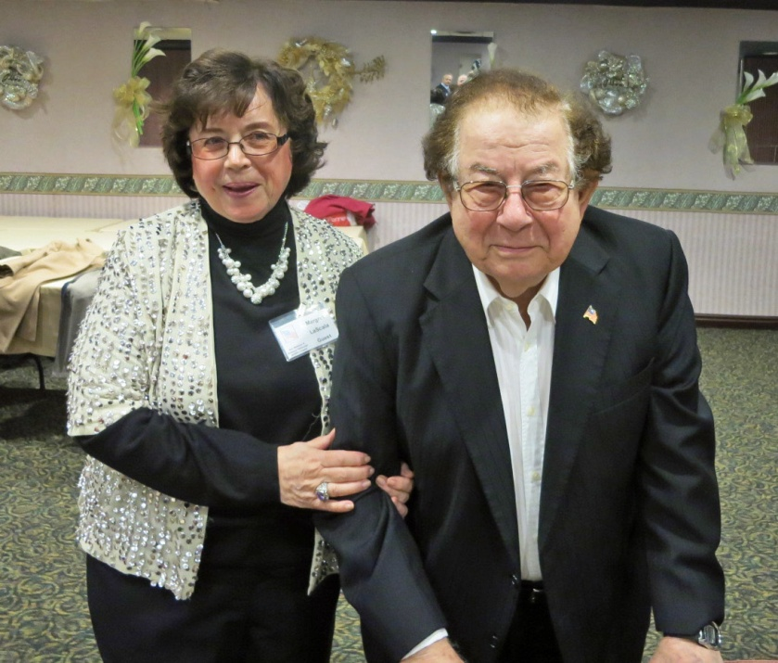

PASSING OF FORMER MEMBER: COL Lou LaScala, who has been in a Nursing Care facility during the past few years, passed away on August 10, 2020. He was a WW II veteran who was active in the Army Reserves having served as the Commander of the 443rd Field Depot and as Chief of Staff of the 99th ARCOM. Our deepest symphony goes out to his wife, Margaret, who has been a faithful attendee at our luncheons.

Pittsburgh Chapter MOWW, September 2020 Bulletin #120

NEW MEMBER: A welcome goes out to Bryan J. Reese, the nephew of COL Reese, upon his submitting an application to become a Hereditary Member of our Chapter. Bryan is a graduate of Penn State University with a Degree in Mining Engineering. He is employed as an Engineer responsible for the facility's ventilation system at Waste Isolation Pilot Plant, located 26 miles East of Carlsbad, New Mexico, which is a nuclear waste depository.

ARCHIVE OF DOCUMENTS WITH THE HOOVER INSTITUTE: A copy of our Chapter History together with copies of our Bulletins dating back to February of 2004,120 in number, have been submitted to the MOWW National Historian General, LTC Arthur Fowler, for archiving with the Hoover Institute at Stanford University. The Pittsburgh Chapter's documents are housed in Box 51. The Institute only accepts hard copies of documents and does not accept for storage digital formatted media. Pictured at the Institute are LTC Fowler, left, and COL Jack Jones, former CINC. LTC Fowler, will also transfer all 120 bulletins to a drop box maintained by National Hdqs so that any member of MOWW can access prior issues of our bulletins. Pictured below is the Hoover Tower and the building which houses the Hoover Institute. Pictured inside is the archival room where you can do your research.

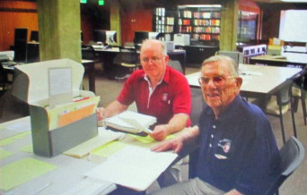
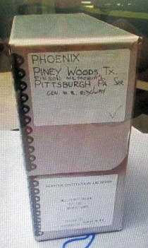
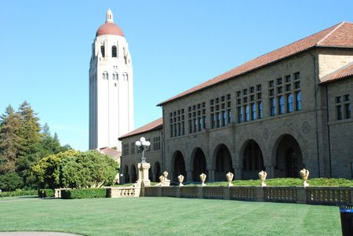

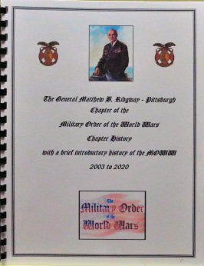
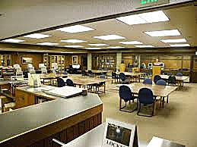

The following luncheon meetings have been scheduled for the remainder of the program year 2020-21:
(Meetings are scheduled on Tuesdays and are held at Scoglio’s Greentree Restaurant, unless changed)
Oct 20, 2020, Nov 17, 2020, Dec 2020 thru Feb 2021 No meetings, Mar 16, 2021, April 20, 2021, May 18, 2021
(Installation of Officers)

