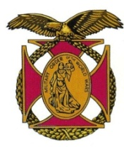

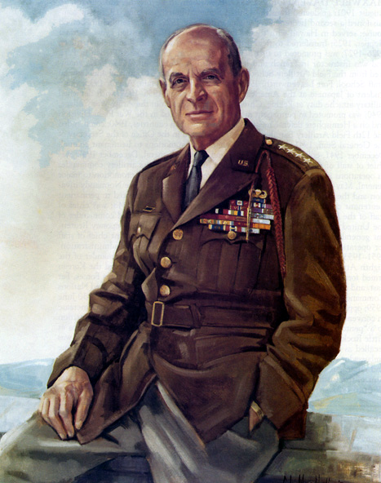

|  |
| --- |
| BG Peter C. Bellisario *Commander*  *COL Robert L. Reese*  *Vice Commander, Adjutant & Editor*  *MG George V. Bauer*  *Chief of Staff & Treasurer* LTC Samuel Wilson *ROTC Awards*  *Colonel Paul A. Platek*  *Historian & Chaplain*  *CAPT Karl D. Ludwig* Surgeon ***LTC Gary Roberson***  *Public Relations*  ***COL Richard Latshaw***  *Veterans Affairs*  ***CAPT Paula Bozdech-Veater*** Deployed Troops ***LTC William Pentecost***  *Judge Advocate*  ***MAJ John Skovran***  *Youth Ldrshp Prog*  ***LTC Charles Chasler***  *Scouting*  ***Cpt Joseph Leech***  *Recruiting* |

Bulletin #136

March 2023

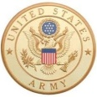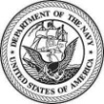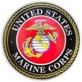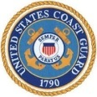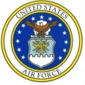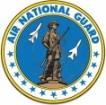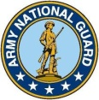

Website: https://mowwpgh.wixsite.com/moww

LUNCHEON MEETING

Tuesday, March 21, 2023

Place: Scoglio’s Greentree Restaurant, Foster Plaza Building #7

Arrival Time: 11:30 a.m., Lunch to be served at 12:00 p.m.

Cost of full course meal, including gratuity, tax and guest speaker: $30.00

MENU: Chicken Breast Valdostana.

SPEAKER: COL F. Dennis DiPerna, former Chapter Commander, will present a Power Point Show on how the Army Intelligence was organized during the Vietnam War and share his experiences as a Military Intelligence Officer during the War.

RESERVATIONS: It is ESSENTIAL that we advise the restaurant in advance of the number of meals. Please call or e-mail your reservation into MG George Bauer at (412) 486-3729 or e-mail jordieb@verizon.net NLT SATURDAY the 18th of March. Significant others and guest are always welcome. If for some reason at the last minute you cannot attend the luncheon after making a reservation please call Scoglio's at (412) 921-1062.

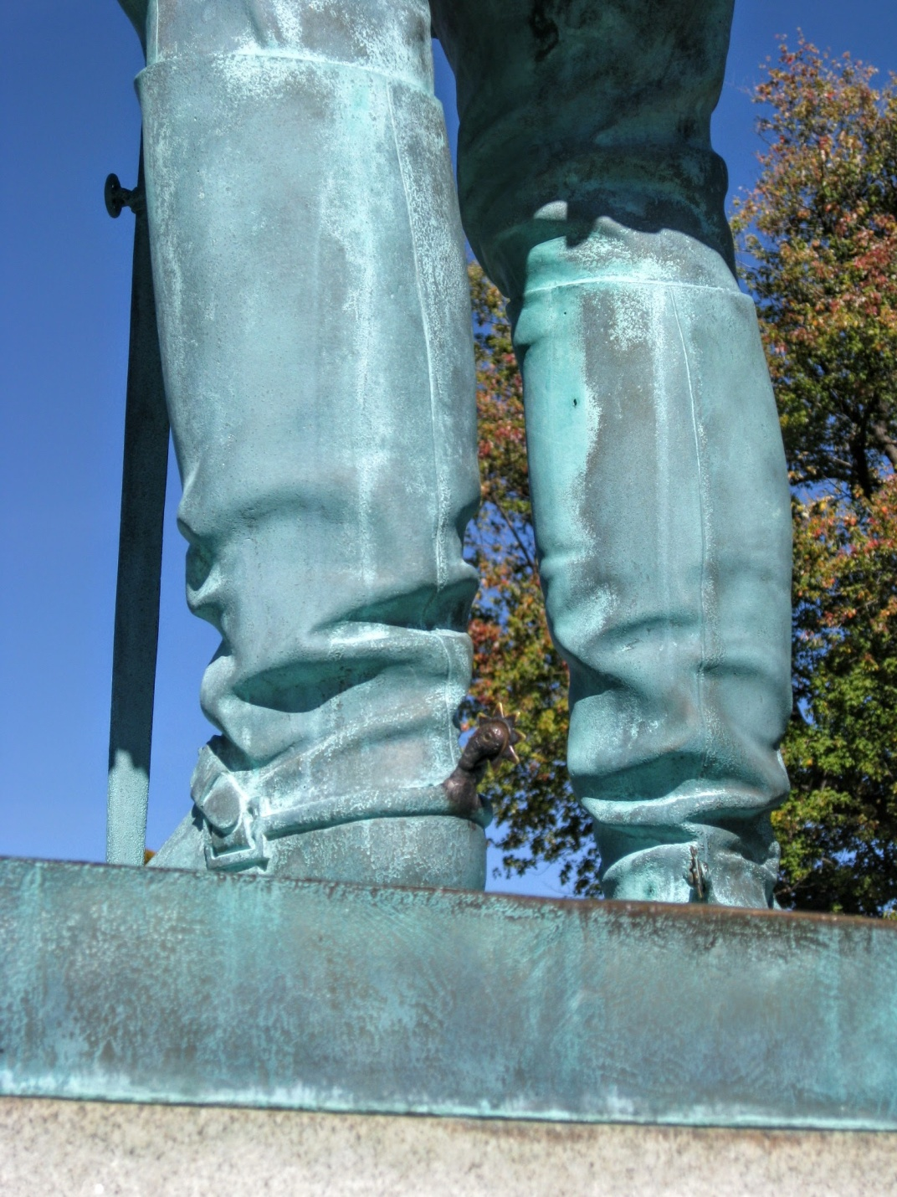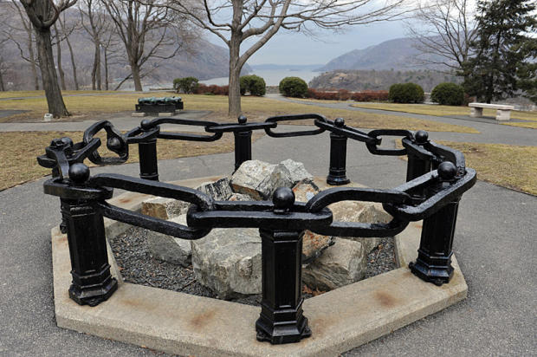NOVEMBER SPEAKERS: Nearly everyone has heard or read about the US Army Military Academy at West Point, but few have ever had the opportunity to visit the Academy. In lieu of visiting the Academy both COL George Ehringer and Brian Ashbaugh treated our chapter to a guided photographic tour of the facility based upon their April of 2022 visit. COL Ehringer, the lead presenter, began by explaining that the Academy is located in the Southeast section of NY State North of Staten Island and semi surrounded by the Hudson River. He explained that the Academy was formally founded in 1802 and graduated its first class in October of that year. There are numerous monuments on the grounds of the Academy the oldest being the Cadet Monument dedicated in 1818 and the newest being the US Grant statue dedicated in 2019. Among the notable statutes is COL Thaddeus Kosciuszko who designed the fortifications of West Point. Another is that of Colonel Sylvanus Thayer, Class of 1808, who served as Superintendent from 1817 to 1833. He is known as "The father of the Military Academy", since he strengthened the faculty and academic standards. Yet another statute is that of Union MG John Sedgwick who was killed during the Civil War. The unique feature about this statue is that students at the Academy prior to taking an exam would rub the spur on his left boot for good luck. As you can imagine the spur has retained its shinny appearance***.*** One of the more interesting monuments is a portion of a 500 yard chain which was stretched across the Hudson River to stop the British during the Revolutionary War.COL Ehringer briefly described BG Benedict Arnold's treasonous act of turning plans to West Point over to the British, the hanging of his British co-conspirator, Major Andre, and his escape to England. He then turned his attention to two great notables who attended the Academy, namely, General Douglass MacArthur and his fair well letter

## PITTSBURGH CHAPTER OF MOWW, BULLETIN #136. MARCH 2023

## C:\Adobe Elements Photos\MOWW 2022\MOWW 2022 11-28.JPGC:\Adobe Elements Photos\MOWW 2022\MOWW 2022 11-04.JPGand General/President Dwight Eisenhower. As for athletic achievement there were three cadets who became famous; namely, Robert "Bobby" Knight who was inducted into the Naismith Basketball Hall of Fame in 1991, Dennis Michie who served as the first head football coach at the Academy in 1890. Michie was killed in the Spanish-American War and the Academy's home football stadium was named after Michie. The third famous athletic was Heisman Trophy winner in 1958 and Rhodes Scholar Peter Dawkins. COL Ehringer went on to explain that the mission of the West Point Post Cemetery is to deliver the final salute to those members of the Corps of Cadets who have dedicated their lives in the service of our nation. Burial is limited to distinguished soldiers, Medal of Honor recipients, astronauts, athletes and family members. Three notables include General H. Norman Schwarzkopf, Frederick Grant, son of General Ulysses S. Grant and BG George Custer. Brian Ashbaugh had on display the uniform he wore while attending the Academy and on occasion provided detailed information about the facilities and history of the Academy. Both COL Ehringer and Brian Ashbaugh were presented with "Certificates of Appreciation" for their efforts.

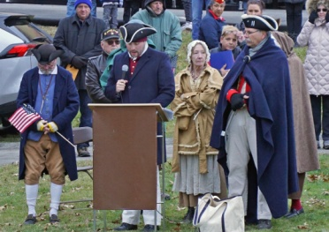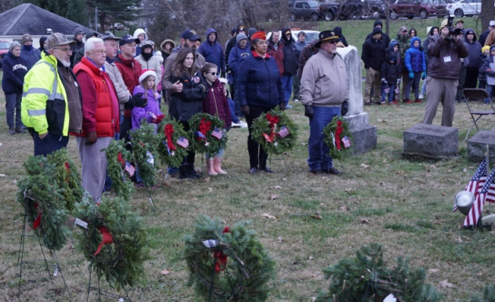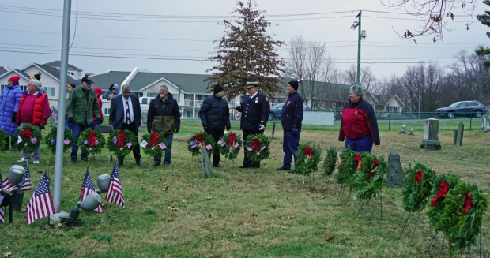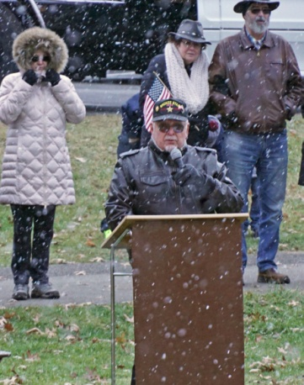WREATHS ACROSS AMERICA: The mission of the Wreaths Across America organization, which in some ways parallels the preamble of the MOWW, is to remember our fallen US veterans, honor those who serve, teach children the value of freedom and coordinate wreath-laying ceremonies at more than 3,400 locations across the US, at sea and abroad. It was a cold wintery day on December 17th of 2022, with a chill factor of 20 degrees, when MIKE BONACCI served as the Keynote Speaker at a Wreaths Across America ceremony held at the Bethel Cemetery. Also, attending were Mike's wife, Susan, and COL Reese. The event was covered by TV Channel 4 news and Bethel Park TV as 20 representatives from such organizations as the "Sons of the American Revolution", the "Daughters of the American Revolution", each branch of the military services, Boy and Girl Scout Troops, the local police force and others placed wreaths in a circle around a flag pole. Volunteers will lay 700 wreaths on veteran's grave sites. The intent was to show their respect and remembrance of those who have given their lives in the defense of our country and our way of life. It was a solemn event which entailed the "Pledge of Allegiance to our Flag" and the singing of the National Anthem. Mike Bonacci's Keynote Speech was both inspirational and warmly received by the estimated 200 attendees.

ELECTION OF CHAPTER COMMANDER AND STAFF: In accordance with the Chapter By-Laws the following named officer have been selected to serve in the positions so indicated for the program year beginning July 1st, 2023: Brig Gen Peter C Bellisario, Chapter Commander, COL Robert L. Reese, Vice Commander and Adjutant and MG George V. Bauer, Chief of Staff and Treasurer. Any chapter member wishing to serve in one of these positions should submit his or her name to COL Reese who will publish the candidate's names and position desired in the April Bulletin at which time all candidates shall be voted upon by the membership in attendance. Lacking any new candidates at our March meeting the three officers listed above shall be voted upon to serve another term in office.

## PITTSBURGH CHAPTER OF MOWW, BULLETIN #136. MARCH 2023

## OFFICER REVIEW ARTICLE: The March/April issue of the MOWW Officer Review Magazine contains an article written by COL Reese titled "Lincoln's Controversial Cabinet", beginning on page 8. The article will give you an appreciation of the difficulties Lincoln faced in dealing with his cabinet members who in most cases were highly educated and previously held high positions in government. Lincoln, who had less than a month or two formal education, had to gain their respect and support.

ATTENDEES AT OUR NOVEMBER 2022 LUNCHEON:

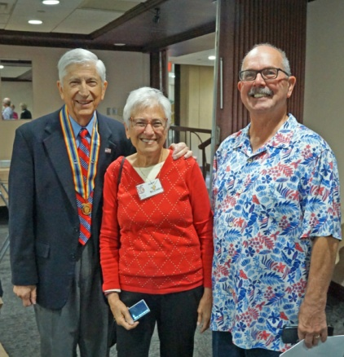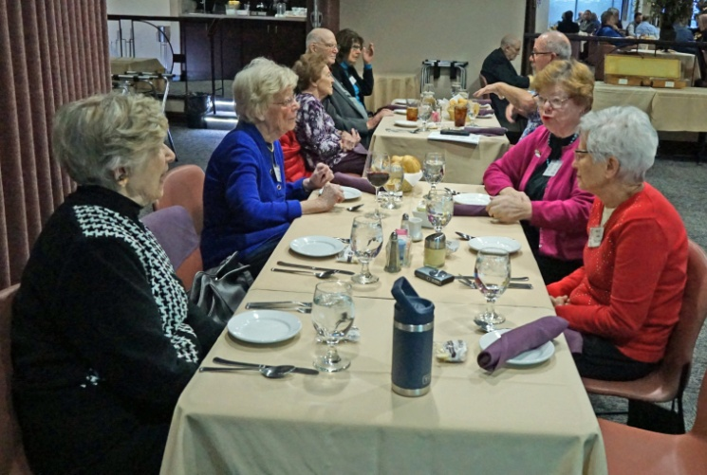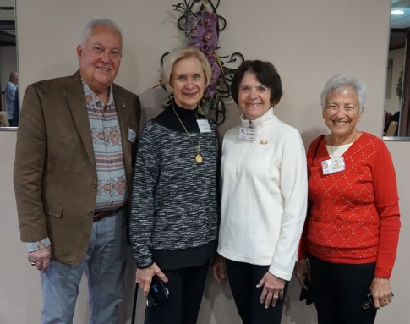

## C:\Adobe Elements Photos\MOWW 2022\MOWW 2022 11-13.JPGC:\Adobe Elements Photos\MOWW 2022\MOWW 2022 11-09.JPGC:\Adobe Elements Photos\MOWW 2022\MOWW 2022 11-18.JPGC:\Adobe Elements Photos\MOWW 2022\MOWW 2022 11-06.JPG

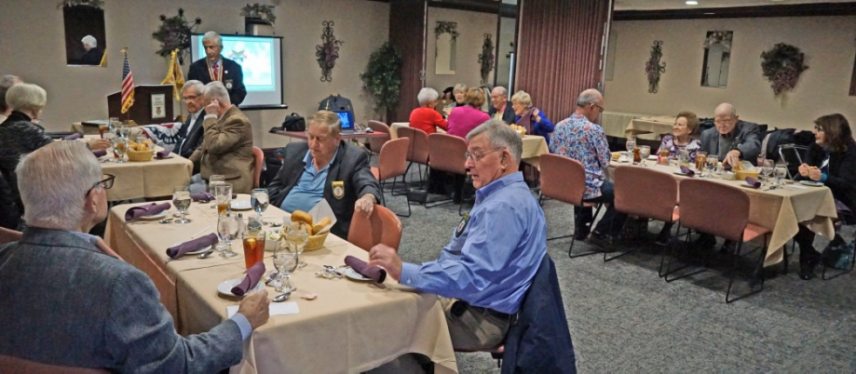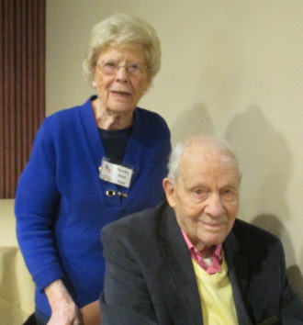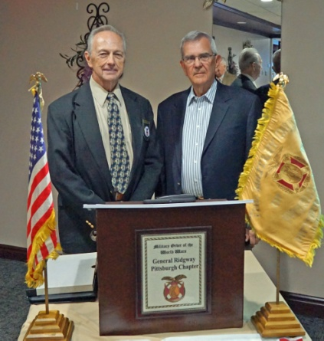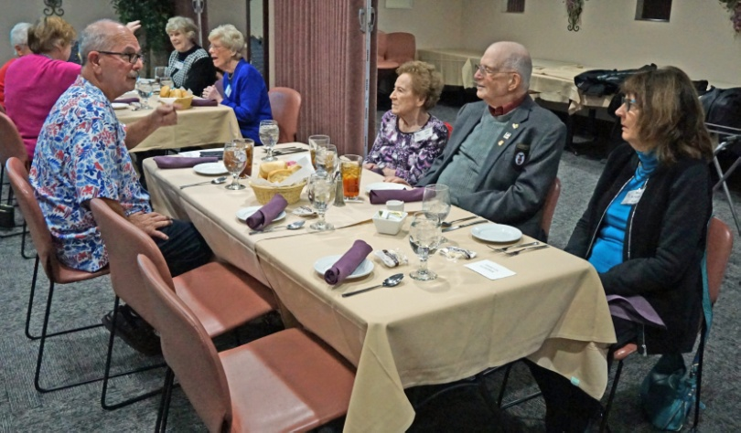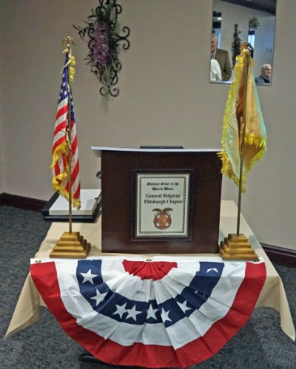

Following are planned dates of meetings during the remainder of the Program Year: 4/18/23 and 5/16/23.